

BSc in Automotive Engineering

THESIS PROJECT

«Vehicle Electronic Control

Modules And CANbus

Communication System»

BY: ADESUYI OLUWATOBILOBA

Reg. Number: 17237

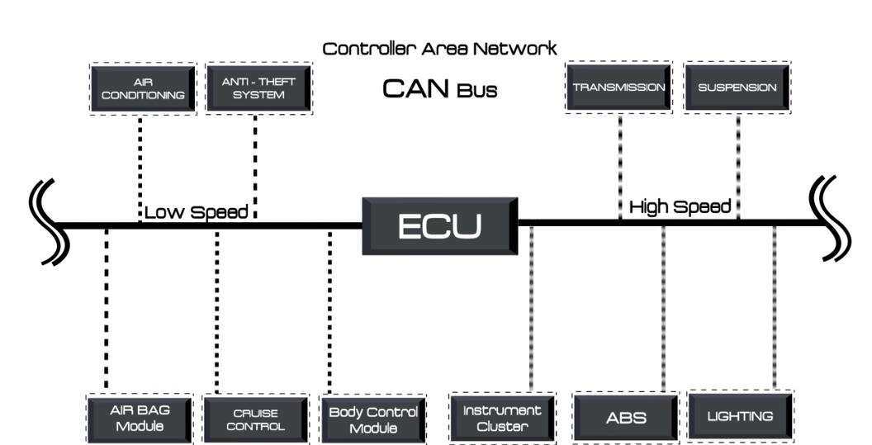

**Dr. Evagoras Xydas**

TABLE OF CONTENT

**CHAPTER ONE**

1. Sensors and actuators in Automotive
   1. Characteristics of sensors in Automotive
      1. Integration of sensors to the ECU
      2. Importance of sensor reading in the vehicle system
      3. Types of sensors in automotive
   2. Actuators
      1. Major Automotive actuators
   3. A/D & D/A conversion
      1. A/D conversion And Conversion of decimal and binary numbers to HEX
      2. Steps in converting analog signal to digital values
      3. Pulse code modulation
   4. Microcontrollers
      1. How microcontroller is made
      2. Types of memory
      3. Microcontroller programming numbering
   5. CAN Bus communication system
      1. CAN data transfer process
      2. Example of Bitwise Bus arbitration in CAN

**CHAPTER TWO**

1. Electronic Control Module And Engine Management System
   1. Electronic control unit with CAN Bus system
   2. Vehicle architecture network And Automotive Transformation
      1. Trends towards in-vehicle architecture
      2. Gateway And Domain Control Unit
      3. Types of other ECUs in Automotive
   3. Engine management system (ECU wiring)
      1. wiring process and Installation
   4. How programming works on ECU
      1. Why reprogram

**CHAPTER THREE**

1. CAN Bus system Demonstration using E-block on flowcode
   1. How to operate on flowcode
      1. Keywords and parameters
      2. How to use the keywords and parameters in a program using the flowchart Analysis Table
      3. Troubleshooting Exercise
   2. CAN Training on Flowcode
      1. Major Parameters Definition and Notes
      2. How to setup CAN component using the CAN component Table
   3. Project Example 2
      1. Project analysis
      2. Troubleshooting Exercise
      3. Flowchart analysis
      4. Troubleshooting Exercise
   4. Kvazer
      1. Functions and purpose of diagnostic in Automotive
      2. How to use diagnostic

# CHAPTER FOUR

4.0 Conclusion

# CHAPTER FIVE

5.0 Recommendation

**References**

INTRODUCTION

This is a well explanatory, detailed project with the aim of giving the reader a proper understanding of what and how the break down of the components that comprises of the vehicle digital system with CAN Bus communication system works. In vehicle electronic system, the electrical components consists of electronic control modules(microcontrollers), sensors and actuators, communication Bus system(CAN Bus), wiring harness and analyzing the CAN messages

We will look into what, how and the working principles of these vehicle electrical components consecutively and how they are integrated into each other. And the most interesting part of this project is getting to know how to program microcontrollers and also how to integrate other components into the controller with CAN Bus using flowcode to carry out our practical demonstrations.

CHAPTER ONE

This chapter covers the electronic digital components that we use in our vehicles. Here we will get to have the knowledge of the behind the scene of how vehicle digital electronics operate.

The Digital electronic components that this chapter will cover ARE; the sensors & actuators, A/D converter, microcontrollers and CAN Bus which are all covered to give us the insight of how these components operates and introduction to CAN Bus with experiment-like example for illustration.

1. SENSORS AND SENSOR SYSTEM IN AUTOMOTIVE
   1. Characteristics Of Sensors In Automotive

* Sensors in vehicle body control units are devices that gather data on various aspects of the vehicle's physical state, such as its speed, direction, and acceleration. These sensors use a variety of different methods to measure these variables, including accelerometers, gyroscopes, and magnetometers. Once this data is collected, it is sent to the vehicle's electronic control unit (ECU) where it is used to make decisions about how the vehicle should respond to different driving conditions.
* The functioning of these sensors primarily depends on their type and purpose, with some operating on the principle of resistance or capacitance, while others use magnetic or optical properties. Overall, sensors play a critical role in ensuring efficient vehicle operation and control
* The ECU is the brain of the vehicle body control system which processes the information received from the sensors and initiates appropriate actions to control the various components of the system, such as the suspension, brakes, throttle, and steering.
* The process of integrating sensors into the ECU involves connecting the sensor’s output signal to the appropriate input channel on the ECU. The ECU then receives the signal and analyzes it to determine the control action to take
* In most modern vehicles, the ECU is programmed with complex algorithms that can make decisions based on the input received from multiple sensors and can adjust the various components of the vehicle body control system to ensure safety, stability, and comfort while driving
* The integration of sensors into the ECU has significantly improved vehicle performance and efficiency. For instance, the introduction of sensors in the fuel injection system has made it possible to monitor the air-fuel ratio in real-time, resulting in better fuel efficiency and reduced emissions. Additionally, integrating sensors such as ABS (Anti-lock Braking System) and ESC (Electronic Stability Control) has improved safety by preventing skidding and loss of control in vehicles.

1.1.1 Integration of Sensors to the ECU

* the most effective approach for interpreting the output pin data provided by the sensor in the vehicle system is to carefully analyze the voltage levels and signal patterns in order to identify any anomalies or irregularities that may indicate a problem with the sensor or the vehicle system as a whole
* The process of integrating sensors into the ECU involves several steps. First, the type of sensor needed for the specific application must be selected. Once the appropriate sensor has been chosen, it must be connected to the ECU using appropriate hardware such as wiring and connectors. The sensor must then be configured to communicate with the ECU using specific software protocols and parameters
* In order to integrate sensors effectively, it is important to have a strong understanding of the specific requirements of the vehicle system and the sensors being used. Adequate software and hardware resources must also be available to properly integrate the sensors into the ECU.
* Once the sensor is properly connected and configured, the ECU can begin to receive and process the data provided by the sensor. This data is used by the ECU to make real-time adjustments to the vehicle's operation, such as adjusting fuel injection timing and shifting gears.
  + 1. Importance of Sensor Reading In The vehicle System
* Sensors work by either sending a voltage or resistance signal to the ECU. The sensor takes measurement in analog form which is referenced to respective voltage (according to the bit size of the controller) in which the digital to Analog converter(DAC) (which is embedded in the controller) converts to binary combination for the controller to understand. [SEE A/D converter for more information about this].
* So basically, what the programmer of the controller does for example in the case of temperature sensor, is set a voltage value(s) that will be used for a particular or numerous task in the program algorithm , so when the sensor starts taking measurement and it reaches the closest voltage reference equivalent to the voltage set in the program, then the respective task will be executed. That’s how the ECU is responsible for processing this information and controlling various aspects of the vehicle's operation.
* the most effective approach for interpreting the output pin data provided by the sensor in the vehicle system is to carefully analyze the voltage levels and signal patterns in order to identify any anomalies or irregularities that may indicate a problem with the sensor or the vehicle system as a whole
* It is also important to compare the sensor output with other data points, such as engine speed or vehicle speed, in order to identify any correlations or trends that may provide additional insights into the performance of the vehicle and the underlying systems
* By adopting a rigorous and systematic approach to interpreting sensor output, it is possible to optimize the performance of the vehicle and ensure that it operates at peak efficiency and safety levels at all times.

NOTE:

Identifying sensor locations in different car models, would require the need to conduct research on the design and specifications of various car models and their sensors

1.1.3 TYPES OF SENSORS IN AUTOMOTIVE

Engine Sensor types And their OBD2 code

Since we have some sensors with same characteristics but does different thing, we are going to group the engine sensor types into 5 groups

1. Position
2. Airflow
3. Pressure
4. Temperature
5. AFR, emissions and others

|  |  |
| --- | --- |
| SENSOR | CHARACTERISTICS / OBD2 code |
| Crankshaft position sensor | * It tells the ECU the position of the crankshaft * because the position of the the piston is fixed in relation to the position of the crankshaft * by knowing the position of the crankshaft, the ECU also knows where the distance is inside the bore and by knowing this, it can initiate fuel injection and spark ignition events at the correct time * Crankshaft position sensor are mostly Hall effect with 3 wires or variable reluctance with 2 wires. Both relies on the basic principle of electromagnetism to read the trigger wheel made from a ferrous metal * The trigger wheel will have one or two missing tooth and whenever a missing tooth passes in front of the sensor, its going to change the signal that the sensor sends to the ECU * The position of the missing tooth in relation to the sensor is going to be fixed to a certain position of the crankshaft and by seeing the changes in signal, the ECU can tell exactly where the crankshaft is at that particular moment in time * The ECU is also configured to the total number of teeth on the trigger wheel and by knowing the total number of teeth and measuring how often the missing tooth passes in front of the sensor, the ECU can calculate engine speed or RPM   **Location** : For the sensor to be able to read the trigger wheel must be located very near it and the trigger wheel must be installed on something that rotates at the same speed as the crankshaft and that can the crank pulley, timing gear or the flywheel  **Faulty Problem** : If the sensor fails completely then the   * engine will not start or hard start * starts but stalls soon after * uneven acceleration * misfiring * rough idle * poor mileage  ERROR CODE : P0335 |
| Camshaft position sensor | * The camshaft position sensor does the same thing as the crankshaft position sensor but for camshaft * In theory, the engine can run with a crank sensor alone but adding a camshaft position sensor paints a more picture for the ECU and also it’s a layer of rectification for information coming from the camshaft sensor * It lets the ECU know what each cylinder is doing and when its doing it and that’s why it can be used for operations like cylinder selective knock control, sequential injection and other cylinder selected system * The cam sensor works with same principle as the crank sensor. The only different is that it reads a much smaller trigger wheel with fewer teeth due to the size of the camshaft   **Location** : usually somewhere on the cam cover or on the back or front of the camshaft or along the axis of the camshaft  **Symptoms**:   * No start or hard start * Starts but stalls soon after * Misfiring * Rough idle * Poor mileage  Error code : P0340 |
| Throttle position sensor | * This measures the position of the throttle plate. When you are operating the throttle pedal, you are also operating the throttle plate that is usually at the entrance of the intake manifold * When you floor the throttle pedal, the throttle plate gets fully opened allowing maximum air into the engine for maximum acceleration * By knowing the position of the throttle plate, the ECU can know the load placed on the engine and then does vary the ignition and injection time accordingly * This sensor works by relying on a variable resistor. A variable resistor is an electric component which changes its electrical resistance output base on its position. It contains a movable part and different position of this movable parts will have different resistance output * The throttle plate shaft is connected directly to the variable resistor, so different position on the throttle plate will have different position outputs which are then measured and converted into a useful signal for the ECU by the onboard electronics of the throttle position sensor   These days we use hall effect, induction to do the same job as a variable resistor  **Location**: It is located on the throttle body itself and this is where you will always find the sensor Failure symptoms  * Unpredictable acceleration * Idle too high or too low * Hard starting  Error code : P0122, P2135 |
| Mass airflow sensor(MAF) | * To know the position of the pistons so as to know when to inject the fuel, the ECU must also know how much fuel to inject and to know how much fuel to inject, it must know how much air is coming into the engine so that inject the corresponding amount of fuel * It basically tells the ECU how much air is coming into the engine * Most MAF sensor are either hot film or got wire but they both rely on the same principle of the very high temperature coefficient of resistance of certain metals such as platinum or tungsten * Which means even with a minute change in the temperature if these metals, it will change their resistance. So when air flows over this metals, it changes their temperature * The more air flows over, the more resistance changes and the onboard diagnostic of the MAF sensor measures this and converts the signal to useful data for the ECU   **Location:** located right after the air after the air filter housing and before the throttle body  **Failure symptoms**  No start, Poor mileage, Poor acceleration, engine hesitating or stumbling  **Error code : P0101, P0102** |
| Manifold airflow pressure sensor(MAP) | * This measures how much air is coming into the engine but unlike MAF, it doesn’t measure the incoming air mass directly. Instead, it measures the pressure inside the engine intake manifold and calculate the air mass base on that * The logic is the more air molecules in an equal space, the greater the pressure that air is going to exert on the wall of that equal space * By measuring the pressure, it can calculate how much air is coming into the engine   **Location:**  it is located in the intake manifold  **Failure symptom:** the same or very similar failure symptoms as MAF  **Error code: P0106** |
| Oil pressure sensor | * This measures oil pressure inside the engine. It is very simple but one of the most vital sensors for the engine because without enough oil pressure, the engine is going to sustain catastrophic damage very quickly * The oil pressure is basically a piezoresistive pressure transducer. The basic version contains diaphragm which When it flexes, it causes an electric circuit and report that there is enough oil pressure * If there is no enough oil pressure, the diaphragm wont flex enough which wont be able to cause electric circuit and the oil pressure light is going to pop out warning the driver that the engine should be shut down   **Location:** It is usually located on the engine block near the oil filter  **Failure symptoms:**  Failure has no effect on how the engine runs unless oil pressure is actually low  False low oil pressure reporting can trigger newer cars into limp home mode  **Error code: P0520, 0521, 0522** |
| Fuel pressure sensor | * This measures fuel pressure. * By knowing the fuel pressure inside the engine rail, the ECU can know how long to open the injectors in order to ensure that the correct amount of fuel is injected into the engine   **Location:** In order to measure fuel pressure right inside the fuel rail, the fuel pressure is always located somewhere directly on the fuel rail  **Failure symptoms**:  Hard starting, poor acceleration, poor mileage  **Error code : P0193, 0190** |
| Intake air temperature sensor(IAT) | * This measures the temperature if the intake air. Its important to do this because air density is influenced by air temperature. The hotter the air, the less dense its going to be and the less molecules in a given space * This works together with the MAF so as to give the ECU a more complete picture of the air coming into the engine which helps reduce emissions and improve power and efficiency * Just like every other temperature sensors in the car, the IAT sensor is thermistor meaning that resistance is going to change in response to the changes in its temperature and then the resistance is measured and converted into a useful data for the ECU   **Location:** It is usually integrated into the MAF or AFM or somewhere in the duct, around the throttle body  **Failure symptoms**:  Very mild if sensor just a bit dirty, rough running, stumbling, stalling, power surges  **Error code: P0113** |
| Coolant temperature sensor | * This is very important for ECU because it tells it how warm the engine is which is important because the cold engine needs a different amount of fuel when compared to a hot engine. * The coolant temperature sensor is also needed to trigger a various action such as for example starting the radiator of the fans or if the engine is overheating, it can tell the ECU to trigger the limp home mode or refuse to start the engine.   **Location:** This must come in contact with the fluid is trying to measure  **Failure symptoms:** a cold engine needs more fuel than a hot engine. This means that if the coolant temperature sensor is more functioning and telling the ECU that the engine is cold instead of hot, the ECU is going to eject extra fuel which will result in rich-lean condition, poor mileage, black smoke from the exhaust in severe cases and if it’s the other way round, it will result to a lean-rich mixture which causes engine misfiring or even knocking  **Error code: P0116, 0117, 0118** |
| Fuel temperature sensor | This must be measured because fuel density. Hot fuel is less dense which means it burns easily so a bit more of it must be injected to compensate for this  **Location:** it is located somewhere around the fuel tank or part of the fuel pump assembly or anywhere along the fuel lines  **Failure symptoms:** failing emissions test, decreased mileage and performance  **Error code: P0183** |
| Oil temperature sensor | * Although many cars oil pressure sensor and not oil temperature sensor but using this sensor is an additional layer for protection * If the oil overheats, its going to affect the viscosity negatively and the oil wont be able to do its job. Now the ECU by seeing the oil temperature can refuse to start the engine or trigger the car into limp home mode before the temperature is normalized again * It can also relay information into a gauge or display visible to the driver and the driver can take action   **Location:** the sensor must come in direct contact with the oil inside the engine which can be found in the engine block or cylinder head and in news cars, it is integrated with oil temperature sensor  **Failure symptoms:**   * Does not impact how the engine runs * If it falsely reports too high temp ECU can falsely trigger limp home mode * If its failed and ignored it cant save your engine   **Error code: P0196, 0197, 0198** |
| Oxygen 02 sensor | * This measures the amount of air present in the exhaust gases which directly corresponds to the amount of air burnt inside the combustion chamber * By measuring the oxygen, the oxygen sensor can actually tell the ECU the A/F fuel ratio the engine is currently running * The A/F ratio inside the combustion chamber is critical for both engine performance and emissions and must be constantly be monitored to ensure it is where it needs to be * We have two types of o2 sensor- narrow band and wide band. Narrow band sensor can tell if the engine is running on a lean-rich mixture but cant tell how rich or lean the engine is running while on the other hand, wide band sensor covers a wide range of A/F ratio and can tell the ECU how rich or lean the engine is running * The amount of oxygen measured at the sensor tip correspond to the voltage produced by the sensor so what the ECU does is to adjust the stichometry to the ideal ratio   **Location:** Most catalytic converter equipped cars are going to have a minimum of 2 oxygen sensor(upstream is used to see the exact A/F ratio at which the engine is running and downstream is sued to monitor if the catalytic converter is actually doing its job)  **Failure symptoms:**   * More noticeable in new cars * Engine may run roughly * Power loss and poor mileage   **Error codes: P0131, 0132, 0133, 0135, 0138, 0420, 014 1, 2238** |
| Nitrogen oxide [NOx] sensor | * It measures the amount of nitrogen oxide in the exhaust gas. They are used in diesel vehicles * Their main role is to verify the correct operation of the Selective catalyst reduction. This is an active emission system in diesel vehicles which eject NH3 directly into the exhaust gases and then convert the nitrogen oxide into nitrogen, water and minute amount of CO2   **Location:** they are two of these in a diesel vehicle. One before(measures the amount of nitrogen coming in) and one after(measures the amount of oxygen coming out) the selective catalyst system  **Failure symptoms:** limp home mode, erratic idle, poor mileage  **Error codes: P2202, 2200, 229F62, 229E** |
| Knock sensor | * This is abnormal combustion inside the engine. If it is strong enough or consistent enough, it can cause a catastrophic engine damage * Knock sensor is basically a microphone tuned to listen to a specific frequency of knock inside the engine * This frequency depends on the engine(the bore and stroke of the engine cylinder) * If this detects knock, its going to relay this information to the ECU and the ECU is going to respond by either by retarding ignition timing or increasing the injected fuel to prevent the knock from occurring again   **Location:** it is always located on the engine block and many engines with 6 and more cylinders have 2 or more knock sensor  **Failure symptoms:**  Only a check engine light on older cars  Limp home mode on newer cars  **Error code: P0325** |
|  |  |

1.1.4 ACTUATORS

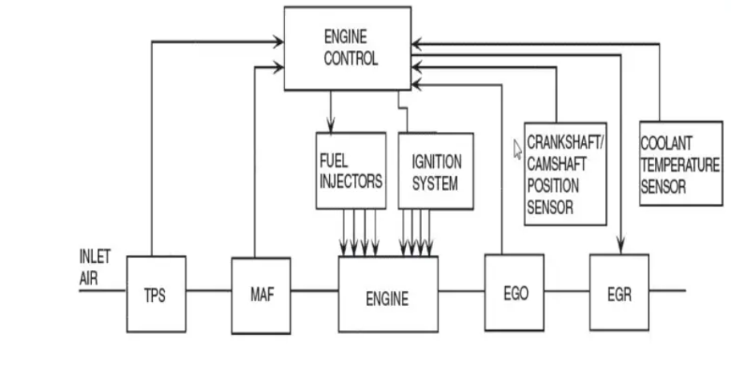

* From the Figure above, we can see how the ECU receives the measurement from the various types of sensors and uses that to control the operation of the actuators which controls the respective component like the engine and the EGR
* Automotive actuators are electronic components that are responsible for controlling various mechanical functions in a vehicle. They are designed to move or control a specific part of the vehicle, such as the engine, transmission, or brakes
* There are various types of automotive actuators, including electric, hydraulic, and pneumatic. Each type has its own unique working principle that enables it to perform its designated function. Electric actuators, for example, utilize electrical signals to convert the signal into mechanical movement. Hydraulic actuators, on the other hand, use pressurized fluid to create motion.
* Characteristics of automotive actuators include their power sources, efficiency, noise levels, and durability. Power sources can include electrical, pneumatic, and hydraulic systems
* The purposes of automotive actuators are to provide control and automation to various systems in a car. For example, in engine management, actuators can control the fuel injection and ignition timing to optimize performance and efficiency. In the transmission system, actuators can shift gears in an automatic transmission. In the braking system, actuators can control the amount of pressure applied to the brake pads. In the steering system, actuators can control the direction and angle of the wheels.

1.1.5 Major Automotive Actuators

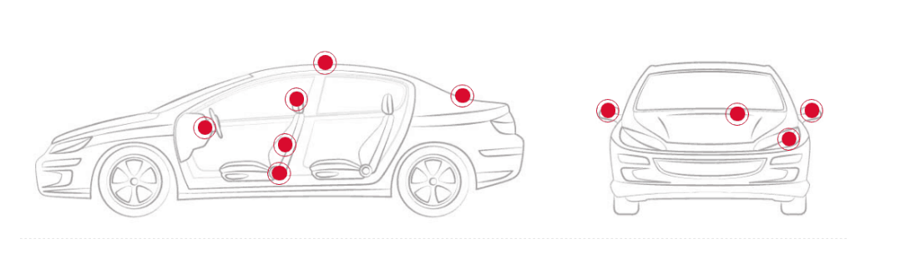

List of Actuators in the vehicle interior

|  |  |
| --- | --- |
|  | Characteristics |
| Steering wheel | The regulation of the steering wheel position according to the driver, is a widespread movement which improves the comfortableness of driving. Through a linear actuator, is possible to draw the steering wheel closer or further in search of the most suitable position. |
| Seats | Here we can find rotational actuators for the lumbar regulation of the seat and actuators for the automatic regulation of its height and position. |
| Headrest | Rotational actuators for the automatic adjustment of the headrest |

Actuators present in the body work of a vehicle

|  |  |
| --- | --- |
|  | Characteristics |
| Rear view mirror | Actuators for the folding of the mirror in a space as small as a rear view mirror, is necessary to design of a gear motor able to offer potency of more than 4 N-m at an angular velocity of 18º per second |
| Sunroof | Automotive actuators for opening and closing the sunroof or roof panel. We are talking about movable panels coupled onto a moving flap that allows, through a translational movement, to move the roof. The mobile panel moves driven by two control cables located on the sliding shoe. This movement of the sunroof is once again provided by the gear motor. |
| Headlights | * Headlights washing systems: lineal actuators that allow the displacement of the cleaning mechanism of the lights. * Height regulation systems: gear motor that performs an angular movement. This adaptative headlights can be used a for the regulation of the height of the lights or for the orientation of the blades of the air conditioning |
| Engine block | Automotive actuators for activating control valves of gases and fluids. This drive mechanism can be found on the windshield and tends to have an internal relay inside its engine. This mechanism closes or opens the contacts that provide voltage to the wiper’s motor. Some wiper systems have intermittent relays that relay on a timer to help manage the movements. |
| Trunck | The number of brands that incorporate automated drives for opening and closing the tailgate is increasingly growing. To operate this movement, it is usual to opt for mechanical transmission from hydraulic actuators. These products offer superior durability, since there is no wear by friction between its components. |

Types of Actuators

|  |  |
| --- | --- |
|  | Characteristics |
| Pneumatic | they generate a force or resistance through air pressure. We could find them in the systems of tailgate lifting. |
| Hydraulic | they are actuators that generate the movement from the displacement of fluids (valves of a variable suspension system) |
| Electromagnetic | those based on electromagnetism, either through a magnet or an electromagnet. These are usually used in those mechanisms of the vehicle operating with electric current. |
| Gear motors or electric | drives where a motor intervenes: brushless, broom, step by step |

**1.2**  **A/D & D/A Conversion**

Analogue Data

Many electronic sensors provide signals in analogue form. For example, a microphone provides an electrical 'copy' of a sound wave. Another - the temperature sensor! Here is the circuit diagram for one type of temperature sensor. The output voltage increases when the temperature increases. It is an analogue signal because the voltage copies the behaviour of the temperature. An electrical analogue signal can have any voltage value, limited only by the power supply used. In this case, the output of the temperature sensor could, in theory, go as high as 5V, or as low as 0V. Over a period of time, the output voltage could change as shown in the diagram. This is an analogue signal.

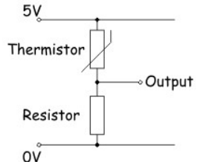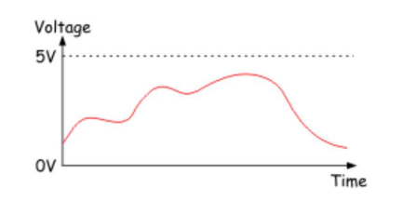

Digital Data

A digital signal carries its information in the form of of a number. Electronic systems usually employ the binary number system, which uses only the numbers ‘0’ and ‘1’, coded as voltages. We could decide on the following code: '0' = 0V, '1' = 5V, for example. Digital signals, then, have only two possible voltage values, usually the power supply voltage, or as close to it as the system can get, and 0V. How can we enter these numbers into an electronic system? One (very slow) way would be to use a switch (an example of a digital sensor.) The circuit diagram shows such a digital sensor.

• When the switch is open (not pressed,) the output is 'pulled down' to 0V by the resistor. This output could represent the binary number '0'.

• With the switch closed (pressed,) the output is connected to the positive supply, 5V in this case. This could represent the binary number '1'. (Note - if the positons of the switch and resistor were reversed, pressing the switch would put a logic 0 signal on the pin etc.) The following diagram shows a more complex digital signal.

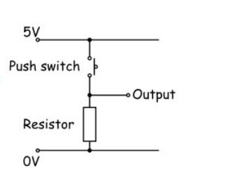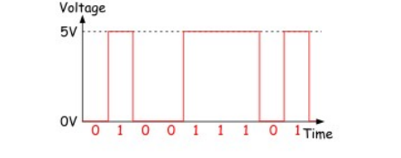

The nine bit binary number represented by the signal is given under the waveform.

1.2.1 A/D conversion

Much of our 'real world' data is analogue, but computers (including microcontrollers) can only process digital data. Fortunately the microcontrollers often contain a subsystem that can convert informaƟon from analogue format to digital format. This is called an Analogue-to-Digital Converter - usually shortened to 'ADC' or 'A/D'.

The ADC inside the a microcontroller divides the range of possible analogue voltages into equal steps. The lowest step is given the number ‘0’, and the highest step is given the highest number that the A/D converter can handle.

This highest number is determined by the resoluƟon of the ADC, which, in turn, depends on number of 'bits' the internal circuitry of the ADC can handle. The resolution of PIC ADCs is 8, 10 or 12 bit.

For example, if the biggest analogue voltage is 5V, and the PIC has an 8-bit ADC: the highest 8-bit number is 1111 1111 (= 255 in decimal);

the first step is 0000 0000 (= 0 in decimal) ;

meaning that there are 256 voltage levels;

so stepping from one level to the next involves a voltage jump of 5V/256, or about 20mV.

When this microcontroller processes an analogue signal, it first divides it by 20mV, to find out how many steps the signal includes. This gives the digital equivalent of the analogue signal.

The next graph illustrates this process.

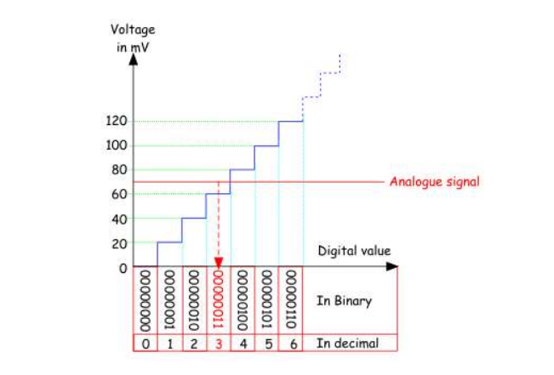

FIG.

In our example, the converter outputs '0000 0000' for any analogue signal up to 20mV, outputs '0000 0001' for analogue signals between 20 and 40mV, and so on. The analogue signal shown in the graph produces an output of '0000 0011'.

Exclusive explanation on how A/D converter works

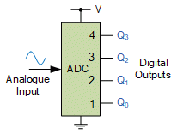

Parameters of A/D converter

Resolution : number of bits

Sample Period : = 1s, 1ms

Voltage reference : = 0-5v, 5-10v, -10-10v

Frequency : 100Hz

Pictorial illustration of how to convert analog signal(input) to decimal language its binary combinations with its irrespective voltage reading

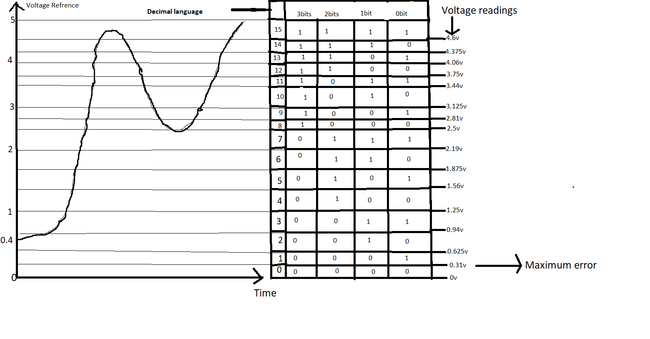

From the figure above, It shows how the conversion of analog signal is converted into bits using the combination table and how that is converted into voltage for the digital reading which is the output. We can see how the grapgh which is the analog input from the sensor reading is converted into bits and how each combination of the bits carries its own voltage measurement.

The digital reading(s) which is also we referred to as digital language, is the output and which results to the digital signal being read by the computer(microcontroller)

Note : Digital language can also be referenced to as the number of combinations

Parameters of the A/D converter used according to the fig above;

Resolution : 4bits = $2^{\left(number of bits\right)}$ = $2^{4}$ = 16combinations

Sample period : 1s

Voltage reference : 5v

Frequency : 100Hz

Things to note from the figure above

Resolution : This varies in numbers depending on the type of A/D converter being used. It varies from 3bits- 64bits

Combination : This is the number of values in the resolution of the A/D converter. This can be calculated by

number of combination = $2^{\left(number of bits\right)}$ = $2^{4}$ = 16 combinations(rows)

Which means the ADC will have 16 decimal language and also the number of columns is dependent on the number of bits

1.2.2 Steps in converting analog signal to digital signal

Firstly,you know the resolution of the A/D you are working with and then calculate the combination

Secondly, you do the conversion

For the distribution of 0s and 1s , first establish the number of the combination and number of columns using the number of resolution of the ADC

For the first column ( $C1$)--> $\frac{number of combination}{2}$ = $\frac{16}{2}$ = 8 (i.e 81s and 8 0s)

Second column($C2$) --> $\frac{C1}{2}$ = $\frac{8}{2}$ = 4 (I.e 4 1s and 4 0s * 2times)

Third column($C3$) --> $\frac{C2}{2}$ = $\frac{4}{2}$ 2 (I.e 2 1s and 2 0s * 4times)

Fourth column($C4$) --> $\frac{C3}{2}$ = $\frac{2}{2}$ = 1 (I.e 1 1s and 1 0s * 8times)

NOTE : the measurement of the combination starts with 0 and the numbering of the bits columns also ends with 0 which still equate to the total number of combinations and number of bits(resolution)

Next is to calculate and know the measurement of the voltage of each combination

= $\frac{\left(number of decimal reading\right)}{\left(number of combination\right)}⋅Vref$

Conversion of decimal language to bits (binary numbers)

Lets use number 13 from the reading as an example

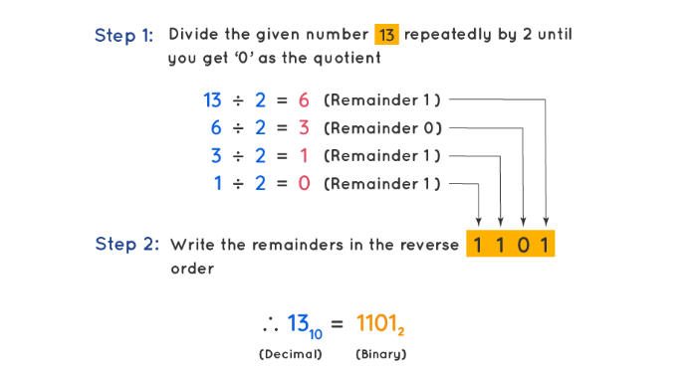

Maximum value : This is the maximum number of voltage can reach in reference to their number of resolutions

--> $V\max{}$ = $\frac{2^{number of bits}-1}{2^{number of bits}}⋅Vref$

Maximum Error = $\frac{1}{2^{number of bits}}⋅Vref$

Conversion of Binary and Decimal Number to HEX

1.2.3 Pulse code modulation

This is a technique which is used to convert an analog signal into digital signal. In PCM, an analog signal is sampled and converted to a series of binary bits

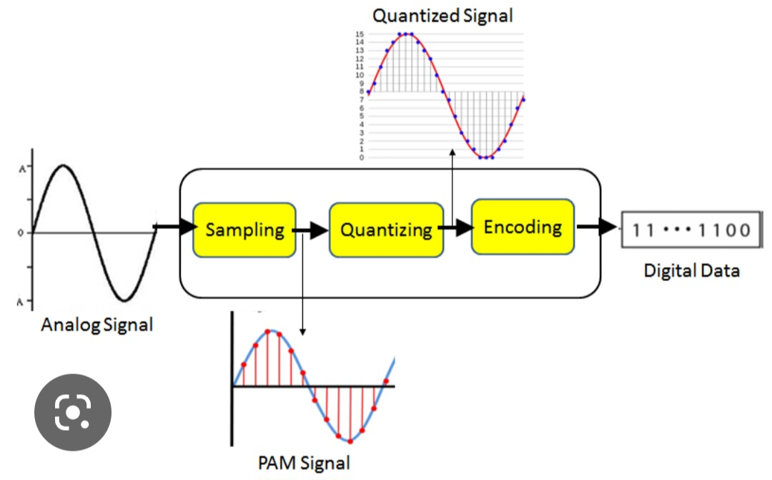

Sampling

Quantization

Coding

Sampling: this is the process of measuring instantaneous values of a Continuous signal in a discrete form. Discretization of analog is called Sampling.

And we have three different types namely

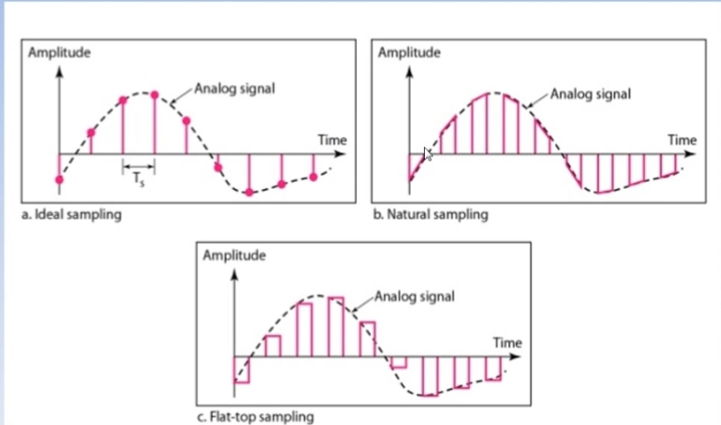

Ideal samples

Natural samples

Flat-top samples

We will be discussing about the flat-top samples because it has same principle as pulse amplitude modulation(PAM)

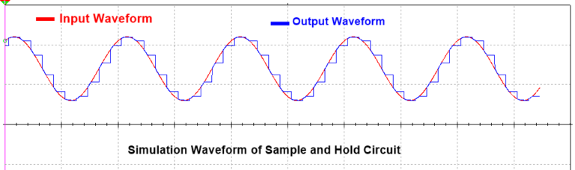

* It uses sample and hold circuit
* It is practically possible like natural Sampling but flat top Sampling is easier compared to natural Sampling
* It has very high noise interference

Sample and hold circuit is an electronic circuit which makes the samples of input voltage signals and holds these samples signal for some very small time duration.

Sample and hold circuit is basically is an analog to digital converter circuit. Input voltage signals to be sampled and hold for some duration (in microseconds) using the capacitor and give the output in the form of digital pulse. Because this works by the holds the sampled analog input signal this is called the sample and hold circuit. Holding of the signal is done using a capacitor called holding capacitor, capacitor has the ability to store the voltage by charging until it will discharge. This charging and storing property of the capacitor is used here for the holding of the signal.

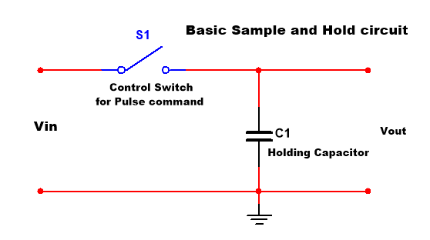

When the switch is closed the connected capacitor charged and when the switch is opened the capacitor will not get discharged because there is no path for discharging and then the capacitor takes to hold the signal.

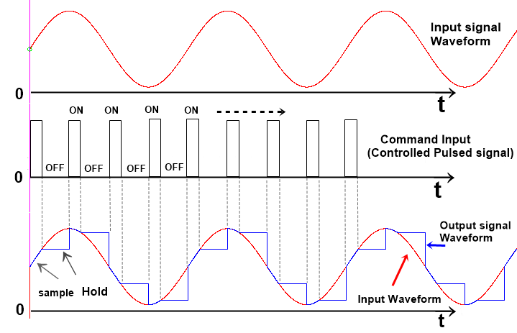

QUANTIZATION

The purpose of a PCM system is to transmit to the distant end the value of a voltage sample at a certain moment in time. The next step is to assign a binary sequence to each of those voltage samples, this step is called quantization.

Quantization is the process of mapping continuous infinite values to a smaller set of discrete finite values. In the context of simulation and embedded computing, it is about approximating real-world values with a digital representation that introduces limits on the precision and range of a value.

The quantizing of an analog signal is done by discretizing the signal with a number of quantization levels. Quantization is representing the sampled values of the amplitude by a finite set of levels, which means converting a continuous-amplitude sample into a discrete-time signal.

The following figure shows how an analog signal gets quantized.

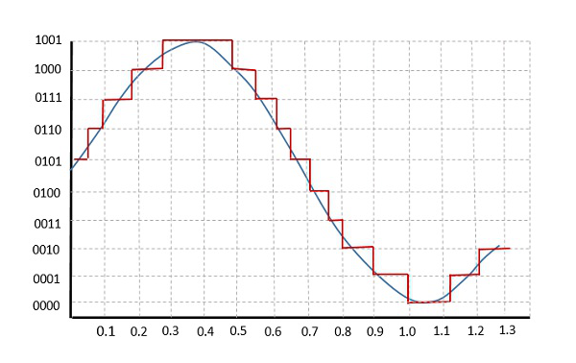

Both sampling and quantization result in the loss of information. The quality of a Quantizer output depends upon the number of quantization levels used. The discrete amplitudes of the quantized output are called as representation levels or reconstruction levels. The spacing between the two adjacent representation levels is called a quantum or step-size.

Types of Quantization

There are two types of Quantization – Uniform Quantization and Non-uniform Quantization.

The type of quantization in which the quantization levels are uniformly spaced is termed as a Uniform Quantization. The type of quantization in which the quantization levels are unequal and mostly the relation between them is logarithmic, is termed as a Non-uniform Quantization.

There are two types of uniform quantization. They are Mid-Rise type and Mid-Tread type. The following figures represent the two types of uniform quantization

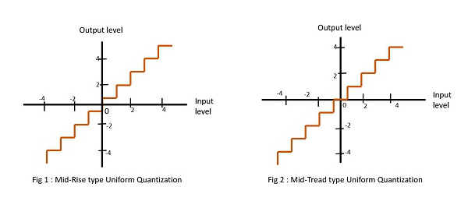

The Mid-Rise type is so called because the origin lies in the middle of a raising part of the stair-case like graph. The quantization levels in this type are even in number.

The Mid-tread type is so called because the origin lies in the middle of a tread of the stair-case like graph. The quantization levels in this type are odd in number.

Both the mid-rise and mid-tread type of uniform quantizers are symmetric about the origin.

**Successive Approximation Register ADC**

Working Principle

Here, we are going to use an example for illustration

EXAMPLE – To find digital equivalent of Voltage input,Vin =3.5v for 4-bit ADC of Vref = 5v

Task Objective

Aim is to get the digital voltage equivalent to the analog input voltage, Vin where the digital equivalent voltage is the output voltage in the ADC system while the analog input voltage is the input

Analysis

* Draw the block for 4-bits and name them

|  |  |  |  |
| --- | --- | --- | --- |
| B3 | B2 | B1 | B0 |

* B0 is the least significant bit(LSB) and B3 is the most significant bit(MSB)
* Basically, Successive Approximation Register uses trial and error logic counting to turn ON and OFF each testing step for each bit. And the decision is based on the logic where the result of the voltage is being compared to the input voltage and when the calculated voltage attached to each bit is higher than the input voltage, Vin, register 0 and when it is vice-versa, register 1 in the block accordingly to the testing steps.
* Note that in the system, 1 = ON AND 0 = OFF and also we use binary numbering system. And in carrying out the testing steps successively, after the step for the MSB, you add the Vcal which is ON (I.e 1) to each successive voltage calculation for each bit as seen in the table below
* Incase the successive voltage registry is 0, we omit that and select the Vcal that is 1 from the previous calculated testing steps and in our example that is V1 has as it can be seen under the calculation column in the table below

Step 1- do the calculation of the voltage attached to each bit, compare the result with the input voltage and mark the comparison result in the block. The table below will be used for the illustration

|  |  |  |
| --- | --- | --- |
| Testing steps | Calculation & Comparison | Block registry |
| 1  V1- B3 | Calculation: $V1=\frac{Vref}{2^{1}}$ = $\frac{5}{2}$ = 2.5  Comparison :  Vcal1 < Vin = 2.5 < 2.3 = 1 | |  |  |  |  | | --- | --- | --- | --- | | 1 |  |  |  | |
| 2  V2- B2 | Calculation : $V2=V1+\frac{Vref}{2^{2}}$ = $2.5+\frac{5}{4}$ = 3.75  Comparison :  Vcal 2 > Vin = 3.75 > 3.5 = 0 | |  |  |  |  | | --- | --- | --- | --- | | 1 | 0 |  |  | |
| 3  V3- B1 | Calculation : $V3=V1+\frac{Vref}{2^{3}}$ = $2.5+\frac{5}{8}$ = 3.125  Comparison :  Vcal3 < Vin = 3.125 < 3.5 = 1 | |  |  |  |  | | --- | --- | --- | --- | | 1 | 0 | 1 |  | |
| 4  V4- B0 | Calculation: $V4=V1+\frac{Vref}{2^{4}}$ *= $2.5+\frac{5}{16}$* = 2.8  Comparison :  Vcal4 < Vin = 2.5 < 2.8 = 1 | |  |  |  |  | | --- | --- | --- | --- | | 1 | 0 | 1 | 1 | |

The result which is 1011 indicates the approximate binary bits combination for the voltage input

Step 2 Now we convert the binary combination in the block to decimal number

Convert 1011 to decimal

=(1 $2^{3}$* ) + (0 $2^{2}$* ) + (1 $2^{1}$* ) + (1 $2^{0}$* ) = 11

Step 3 Next step is to find the digital equivalent voltage using this formula

$$\left(Vout\right)=\frac{Vref*decimal input}{2^{n}}$$

Where n = number of resolution bit which 4 for this example

Vout = $\frac{5*11}{2^{4}}$ = 3.43 as you can confirm this using the binary combination table which can be found under A/D conversion

**1.3**  **Microcontrollers**

what is a microcontroller?

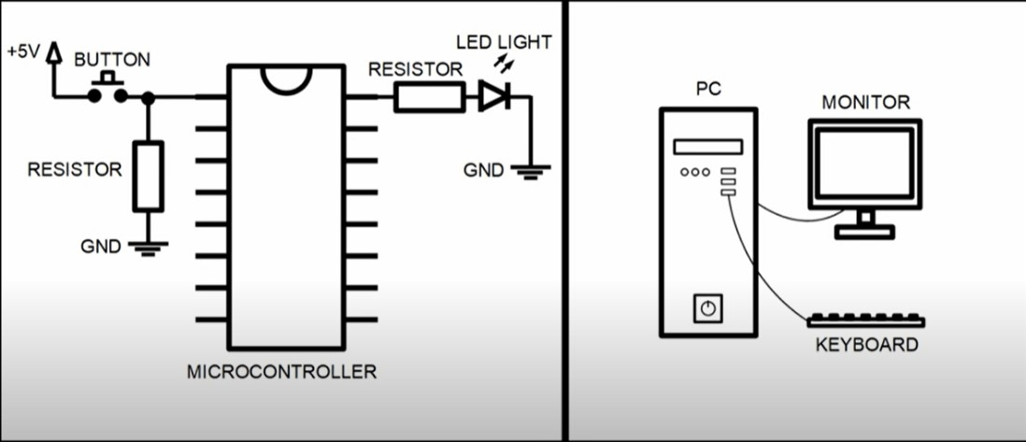

Basically, you can think of a microcontroller as a personal computer because they both have similar structure. The only difference is the whole system is integrated into the microcontroller whereas they are seperated in personal computer.

same way you connect the keyboard and the monitor and other devices to the computer to

input and output some information, you can also do that with microcontroller only in the case using for example using buttons and LED lights.

today, microcontroller production counts are in the billions per year uh the controller are integrated into many appliances we have grown used to like

* household appliances (microwave, washing machine, coffee machine)
* Telecomunication(mobile phones)
* automotive industry(fuel injection, ABS)
* aerospace industry
* industrial automation

How do microcontrollers work?

A microcontroller is embedded inside of a system to control a singular function in a device. It does this by interpreting data it receives from its I/O peripherals using its central processor. The temporary information that the microcontroller receives is stored in its data memory, where the processor accesses it and uses instructions stored in its program memory to decipher and apply the incoming data. It then uses its I/O peripherals to communicate and enact the appropriate action. Microcontrollers are used in a wide array of systems and devices. Devices often utilize multiple microcontrollers that work together within the device to handle their respective tasks.

For example, a car might have many microcontrollers that control various individual systems within, such as the anti-lock braking system, traction control, fuel injection or suspension control. All the microcontrollers communicate with each other to inform the correct actions. Some might communicate with a more complex central computer within the car, and others might only communicate with other microcontrollers. They send and receive data using their I/O peripherals and process that data to perform their designated tasks. What are the elements of a microcontroller?

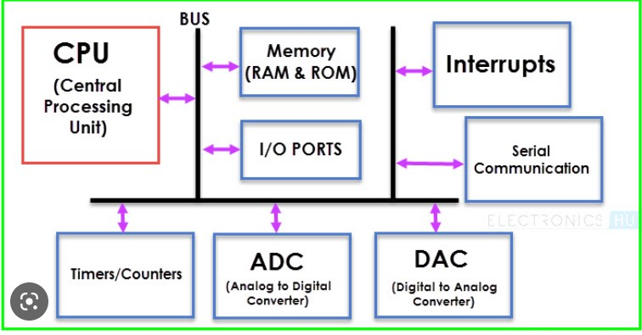

The core elements of a microcontroller are:

* The processor (CPU) -- A processor can be thought of as the brain of the device. It processes and responds to various instructions that direct the microcontroller's function. This involves performing basic arithmetic, logic and I/O operations. It also performs data transfer operations, which communicate commands to other components in the larger embedded system.
* Memory -- A microcontroller's memory is used to store the data that the processor receives and uses to respond to instructions that it's been programmed to carry out. A microcontroller has two main memory types:

1. Program memory, which stores long-term information about the instructions that the CPU carries out. Program memory is non-volatile memory, meaning it holds information over time without needing a power source.
2. Data memory, which is required for temporary data storage while the instructions are being executed. Data memory is volatile, meaning the data it holds is temporary and is only maintained if the device is connected to a power source.

* I/O peripherals -- The input and output devices are the interface for the processor to the outside world. The input ports receive information and send it to the processor in the form of binary data. The processor receives that data and sends the necessary instructions to output devices that execute tasks external to the microcontroller. While the processor, memory and I/O peripherals are the defining elements of the microprocessor, there are other elements that are frequently included. The term I/O peripherals itself simply refers to supporting components that interface with the memory and processor. There are many supporting components that can be classified as peripherals. Having some manifestation of an I/O peripheral is elemental to a microprocessor, because they are the mechanism through which the processor is applied.

Other supporting elements of a microcontroller include:

* Analog to Digital Converter (ADC) -- An ADC is a circuit that converts analog signals to digital signals. It allows the processor at the center of the microcontroller to interface with external analog devices, such as sensors.
* Digital to Analog Converter (DAC) -- A DAC performs the inverse function of an ADC and allows the processor at the center of the microcontroller to communicate its outgoing signals to external analog components.
* System bus -- The system bus is the connective wire that links all components of the microcontroller together.
* Serial port -- The serial port is one example of an I/O port that allows the microcontroller to connect to external components. It has a similar function to a USB or a parallel port but differs in the way it exchanges bits.

1.3.1 How microcontroller is made

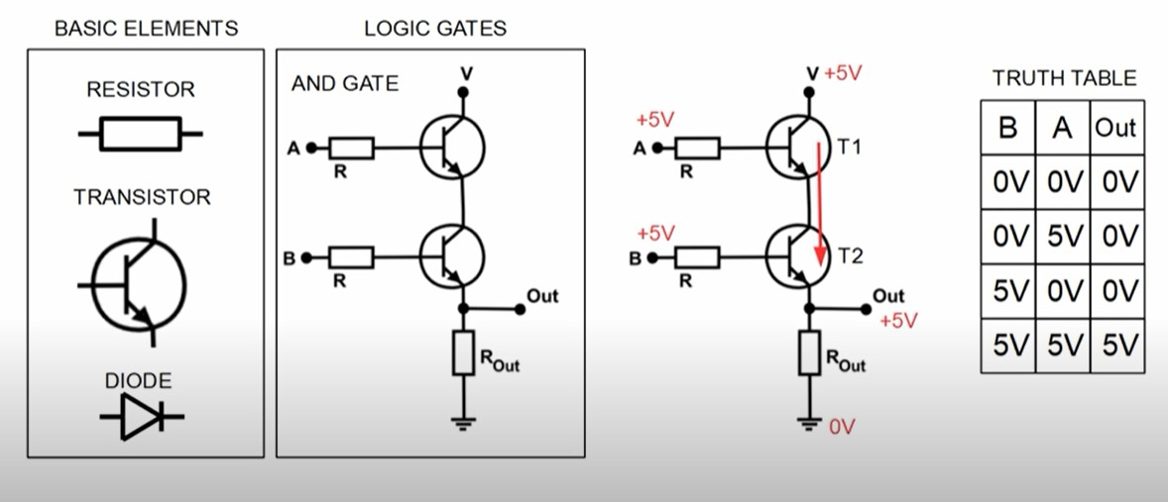

To fully understand this, you need to have basic knowledge of electronics

* Resistor - this limits the current that is flowing through a circuit or to create a voltage drop
* Transistor- think of this as a tap, you are controlling the volume of the flow
* Diodes- this allows the current to flow in One Direction and also does not allow you to flow back

Using these basic elements, we can create something called **logic gates.**

Logic Gates - this is the link that allows us to go from analog electronics to digital electronics.

TRUTH TABLE- this is where digital electronics starts. In digital electronics, there are only high and low logic levels and those are the zeros and ones(0,1).

what is interesting is that we can describe the truth table using an equation and in this case we can

use the equation input A * input B= output. in digital electronics, there are multiple logic gates and each gate has its own truth table and its own equation now using this logic gates, we can create more complex structures that are capable of adding and subtracting, multiplying and even storing digital information. These are the driver structures that are inside the microcontroller and it is possible to control the driver structures by using something called program. programs are stored inside microcontrollers internal memory and can be transferred into microcontrollers through programming pins that are specially made for this purpose

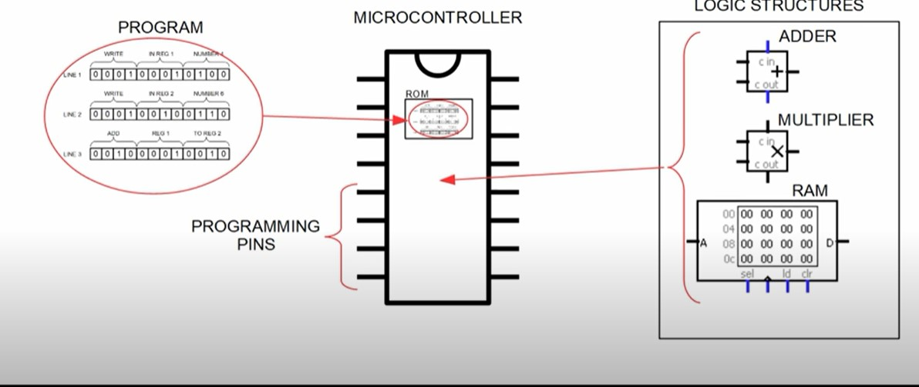

you can think of program same as you will think of lines of zeros and ones. Each line of the program has a predefined length and each part of the length as its own meaning

Now let's go through one example. This one being a natural program but it should serve as a good example to better understand how the program is read by the microcontroller because lies of the codes are always red in certain sequence by the microcontroller.

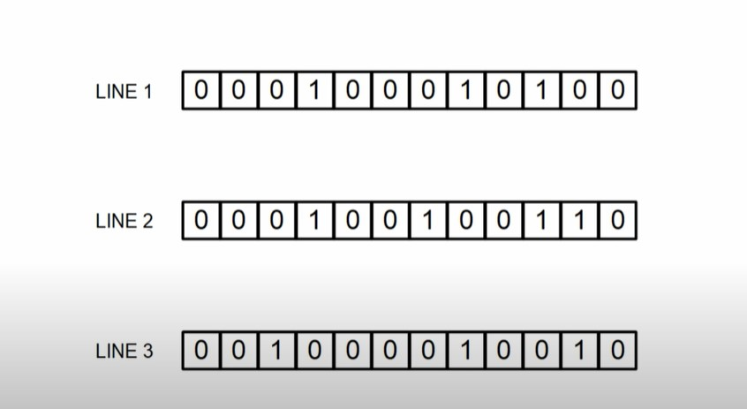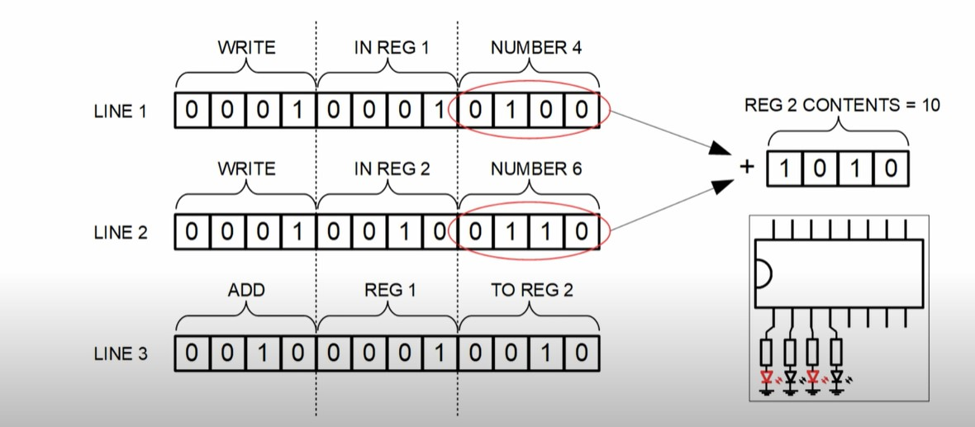

We will go through the program starting from line 1 followed by line 2 followed by line 3

first let's split the lines into three parts. The first part of the first line will be write operation. So it means we will write some information somewhere.

The second part of the line will tell us where we will write this information and in this case, we will write in Reg1. If you are wondering what is a register. A REGISTER is simply a memory cell that is capable of storing some information.

Now we come to the third part of this line and this tells us what kind of information we want in Reg1 and in this case we want to write number4.

If we convert 0100 From binary to decimal numbers, then it will be #4. So if we go one more time over this first line code and what it says to the microcontroller, it says ‘write in Reg1 #4’ And so we come to the second line of the code.

And in this case, it will start with the write operation,The second part of the code will tell us the register we want to write this information and in this case we want to write this information in The third part of the code will again tell us what kind of information or number you want to solve in register2I need in this case it will be #6. if we convert 0 from binary to decimal, it will be #6.

As for line 3,It is different operation. What is does is what we call add operation and what will it will add is number in register1 To the number and register2 Add the result will be stored in register2.

Executing these lines of code, we get the sum of #4 and #6 in Reg2 which is #10. If we convert binary

1010 to decimal number, then it will be #10

Now what we can do if we want want for example, we could display the result using LED lights that are connected to the microcontroller.

NOTE, this is not actual program but approximate example of these lines of code are executed by a microcontroller. Now let’s remove this binary codes an leave only those written word, what we get here is something similar to ASSEMBLY LANGUAGE.

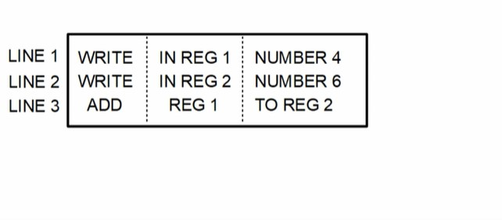

As we can see it is difficult to write or memorise these codes because it’s full of zeros and ones. To make the programming job more easier to replace the zeros and ones with words that a more meaningful for human, we used assembly language.

Each driver structure/component has its own LOGIC GATE and we can control these structures by programming their LOGIC GATES

1.3.2 Types of memory

There are several types of electronic memory, each with a slightly different job to do. We can divide them into two main groups, ROM and RAM,:

READ ONLY MEMORY(ROM) :

These devices are normally only read (i.e. the contents are accessed but not changed ‘written’,) during the running of a program.

• The contents are not volatile. (The data remains stored even when the power supply is switched off.)

• They are often used to store the basic programs, known as 'operating systems', needed by computers.

• The group includes: • PROM (Programmable Read Only Memory),

• EPROM (Erasable Programmable Read Only Memory),

• EEPROM (Electrically Erasable Programmable Read Only Memory)

A PROM is a one-shot device, which arrives blank, ready to receive data. Data can then be 'burned' into it, but only once. After that it behaves like a ROM chip that can be read many Ɵmes but not altered. With an EPROM, shining ultraviolet light through a window in the top of the chip erases the contents. New data can then be 'burned' into the memory. Some older PIC devices operate in this way. The EEPROM devices work in a similar way to an EPROM, except that the contents are erased by sending in a special sequence of electrical signals to selected pins. 'Flash' memory is a form of EEPROM, widely used as the storage medium in digital cameras, (the memory stick) and in home video games consoles

READ ACCESS MEMORY(RAM)

RAM allows both read and write operations during the running of a program.

• The contents are volaƟle and disappear as soon as the power supply is removed. (The exception is NVRAM, Non -Volatile RAM, where the memory device may include a battery to retain the contents, or may include an EEPROM chip as part of the memory to store the contents during power loss.)

• They are often used for the temporary storage of data or application programs.

Programming

Microcontrollers are programmable devices. They do exactly what they are told to do by the program, and nothing else! A program is a list of instructions, along with any data needed to carry them out.

The only thing microcontrollers understand is numbers. There's a problem! We don't speak in numbers, and they don't understand English!

There are two solutions, and both need some form of translator:

• Write the program in english, or something close to it, and then have the result translated into numbers.

• We can think through the program design in English and then translate it ourselves into a language that is similar to numbers, known as 'assembler'. From there, it is a swift and simple step to convert into the numerical code that the microcontroller understands.

These two extremes are known as programming in a high-level language (something close to English) or in a lowlevel language (assembler).

The first is usually quicker and easier for the programmer, but takes longer to run the program, because of the need to translate it for the microcontroller.

The second is much slower for the programmer, but ends up running very quickly on the microcontroller.

If you think that this sounds very complicated, you are right. It is! Fortunately, Flowcode works using flowcharts - the easiest, and highest level, of programming and then takes care of all translation needed.

**Outputting data**

The microcontroller is a digital device - we have said that several Ɵmes already! It outputs a digital signal. In most cases, we use this to turn something on and off - '0' = 'off' and '1' = '0n', for example. Suppose that we set up port B as the output port. There are eight pins on port B, so we can switch eight devices on and off. It is important to plan how we connect these devices, as otherwise they might work the opposite way round!

1.3.3 Microcontroller Programming Number

Weve seen under A/D conversion how the number of bits is used to generate the combinations(decimal numbers) and the binary numbers. The jump from decimal to binary can be a hard one. We have hexadecimal which is a good way of representing binary values in short hand without having to write/count all the 1s and 0s but again converting between Hex and Decimal can be tricky.

**Understanding Bits, Bytes And Binary Numbering**

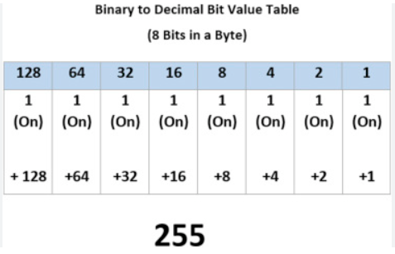

* From FIG above, we can see the power of 2 sequence in a byte which means its simply a doubling system. powers of two, which are important in the binary number system used internally by computers. They are comparable to the powers of ten—1, 10, 100, 1000—used in the decimal number system preferred by people.
* computers are based on the binary (base 2) system, and each power of 2 corresponds to a bit position in a binary number. A power of two is a number of the form $2^{n}$ where n is an integer while the integer is decimal number known to us. Below is the binary numbering system of byte(8bits).

Binary numbering of a Byte (8 bits) Natural(decimal) corresponding numbering

$2^{0}=1$ 0

$2^{1}=2$ 1

$2^{2}=4$ 2

$2^{3}=8$ 3

$2^{4}$ = 16 4

$2^{5}=32$ 5

$2^{6}=64$ 6

$2^{7}=128$ 7

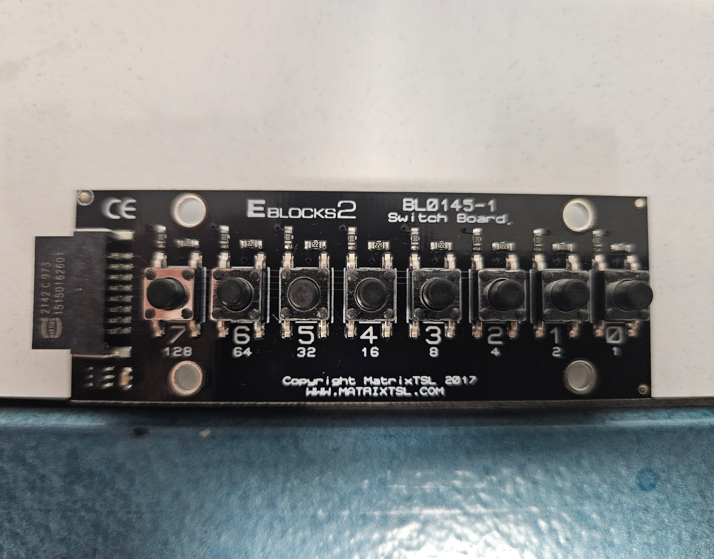

* Using this switch board as seen above as illustration which 8 bits (1 Byte) setup which we can see in the bit-electronic output pins. The numbering 0- 7 represents natural(decimal) numbering and 1 – 128 represents binary numbering. From this we can easily define binary numbering as 2 to power of natural numbering i.e $2^{integer}$, where integer is the natural numbering.
* Note that any input going into the controller for example from this switch above, will be programmed with binary numbering where as you can use natural numbers as your output if you use the component macro but if you use it directly in your output icon, you use binary numbers as that it is the language the computer understands.
* In computer systems, a bit is the smallest unit of data. It can only have two possible values, either 0 or 1. A byte, on the other hand, is a group of 8 bits. It is the basic unit of data storage and processing in a computer
* Binary numbering system is used in computers, which consists of only two digits, 0 and 1. These digits are also known as bits or binary digit, which are the smallest unit of data that a computer can store or manipulate. A bit can represent two values, either a 0 or a 1. A sequence of eight bits is known as a byte.
* Bytes are used to represent characters, numbers, and other types of data in a computer. In summary, binary numbering system is essential in computers as it allows data to be represented and processed in a digital format using bits and bytes
* Because of its straightforward implementation in digital electronic circuitry using logic gates, the binary system is used by almost all modern computers and computer-based devices, as a preferred system of use

.

**1.4**  **CAN-Bus Sytems**

The control area network(CAN Bus) is a vehicle bus standard designed to allow Electronic control units and devices to communicate with each other in applications without a host computer. So you think of it as human nervous system.

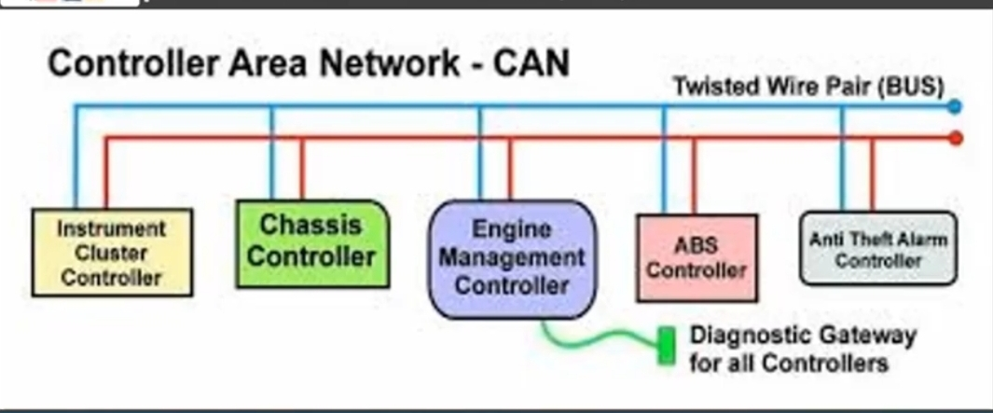

As an alternative to conventional multi wire looms, CAN bus allows various electronic components (such as electronic control units,microcontrollers,devices,sensors,actuators and other electronic components throughout thr vehicle) to communicate on a single or dual-wire network data bus up to 1Mb/s.

The CAN bus is a message based protocol, designed originally for multiplex electrical wiring within motor vehicles, but also can be used in many other contexts.

CAN system schematic diagram shows some of the possible units or devices that can be connected onto the CAN Bus.

CAN Bus output Signal

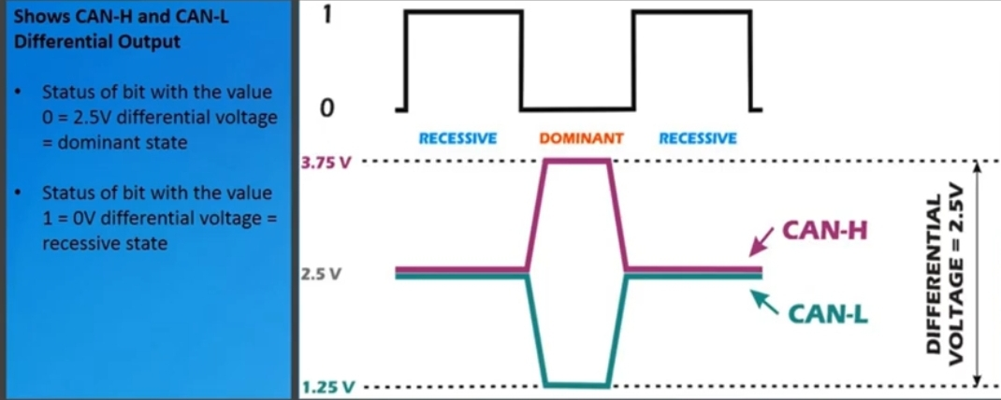

This shows CAN high and CAN low different output

• Status of bit with the value 0 = 2.5v ; differential voltage = dominant state

• Status of bit with value 1= 0v; differential voltage = recessive state

Typically, the CAN Bus is made up of two wired, CAN -H and CAN-L which connect to all the devices in the network

• The signal on the two CAN lines have the same sequence of data,but their amplitudes are opposite, so if a pulse on the CAN-H line goes from 2.5v to 3.75v then the corresponding pulse on the CAN-L line goes from 2.5v to 1.25v ( opposite than CAN-H)

• By sending the data in equal and opposite ways like this, allows in equal and opposite ways like this allows being corrupted.

CAN Bus Components

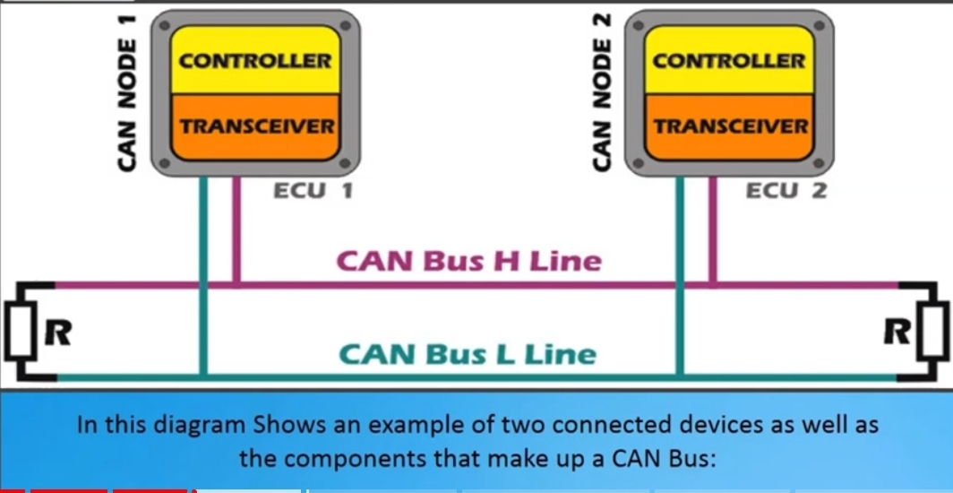In this diagram, it shows an example of two connected devices as well as the components that make up a CAN Bus:

• CAN controller

• CAN transceiver

• Two data bus terminals (R) and two data bus lines( CAN high and CAN low lines)

CAN controller : this receives the transfer data from the microcomputer integrated in the control unit or device( also known as CAN node)

The CAN controller processes this data and relays it to the CAN transceiver. Also, the CAN controller receives data from the CAN transceiver, process it, relays it into the microcomputer integrated in the control unit or device( CAN node).

CAN transceiver : this is a transmitter and receiver in one. It converts data which the CAN controller supplies into electrical signals and sends this data over by lines. Also , it receives data and converts this data for the CAN controller

CAN data bus terminals: this is a resistor(R) typically 120ohms. It prevents data sent from being reflected at the ends and returning as an echo.

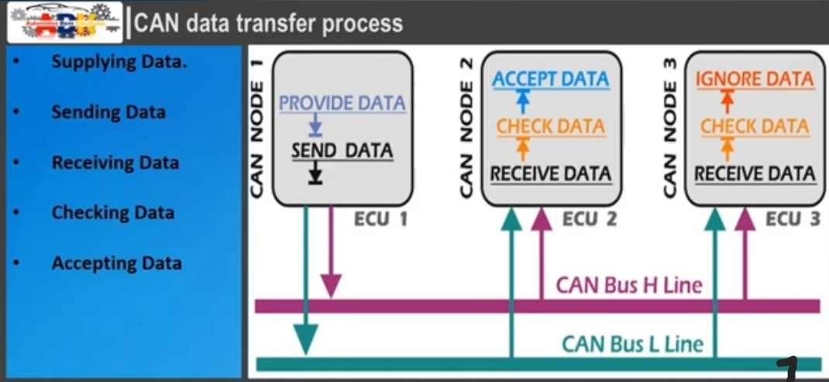1.4.1 CAN Data Transfer Process

This consists of the following stages

• Supplying data

• Sending data

• Receiving data

• Checking data

• Accepting data

Supplying data : the CAN node provides data to the CAN controller for Transfer

Sending data : the CAN transceiver receives data from the CAN controller, converts it into electrical signals and send them back into the network

Receiving data : All other CAN nodes networked with the CAN data bus become receiver

Checking data : the CAN node checks whether they require the data they have received for thier functions or not.

Accepting data : if the received data is important, it is accepted and processed. If not, the received data is ignored.

There are two different ISO standards for CAN system that relate to the physical layer : ISO 11898-3 low speed up to 125kb/s ( distance up to 500m)

ISO 11898-3 high speed CAN up to 1Mb/s( distance up to 40m)

The CAN system is further divided into two formats for the message frames 2.0A and 2.0B, the two standards differ in the size of the identifier(ID)

Standard CAN-( version 2.0 A) uses 11bit identifiers in the arbitration field

Extended CAN ( version 2.0B) supports a length of 29bits for the identifier, made up of the 11bit Identifier ( base identifier) and an 18bit extension.

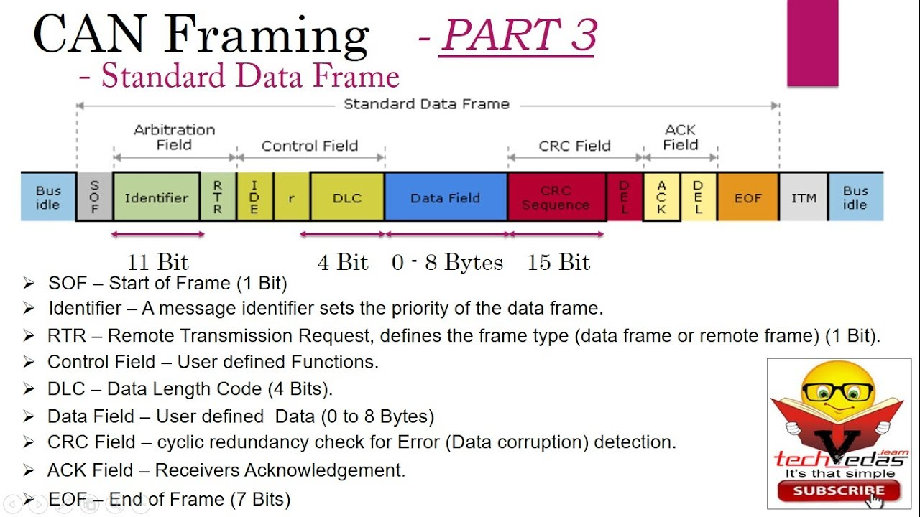 CAN bus data structure

SF- start field – this indicates the beginning of a message with a dominant bit. So this field marks the start of the data protocol.

A bit with 3.75v (depending on the used system) is sent over the CAN- high line and a bit with 1.25v is sent over to the CA-l line I.e the differential voltage is 2.5v

Message identifier: this defines the level of priority of the data protocol. If ,for instance, two CAN nodes want to send thier data protocol simultaneously, the CAN node with the higher priority takes thr precedence. The lower the value, the higher the priority of the message

As stated earlier, depending ok the standard being used,the length of the frames can be in two formats;

• Standard, which uses an 11bit arbitration ID and

• Extended which uses a 29bit arbitration ID.

Control or check field: this displays the number of items of information contained in the data field. The field allows any receiver to check whether it has received all the information transferred to it.

Data field : in this field, the information is transferred to the other CAN nodes

CRC : cyclic redundancy check or safety field : this contains 15bit cyclic redundancy check code and a recessive bit. The CRC field is used for transfer faults detection

ACK : acknowledge field or confirmation field : in this field, the receivers signal to the transmitter that they have correctly received the data protocol.

If an error is detected, the receivers notify the transmitter of that immediately. The transmitter then sends the data protocol again

EF: this field marks the end of the data protocol. This is the last possibility to indicate errors which lead to a repeat transfer.

NOTE : The higher the number of bits,the more items of information can be transferred. The number of possible item of information doubles with each additional bit.

Summary

When a CAN node is ready to transmit data,it checks to see if the bus is busy and then simply writes a CAN frane(message) onto the network.

The CAN frames that are transmitted do not contain address of either the transmitting node or any of the intended receiving node(s). Instead ,an arbitration ID that is unique throughout the network labels the frame.

All CAN nodes in the CAN network receive the CAN frame and depending on the arbitration ID of the transmitted frame, each CAN node on the network decides whether to accept or ignore the received frame.

If multiple CAN nodes try to transmit a message onto the CAN Bus at the same time,the node with the highest priority (lowest arbitration ID) automatically gets bus access. Lower- priority nodes must wait until the bus becomes available before trying to transmit again. In this way, you can implement CAN network to ensure deterministic communication among CAN nodes.

NOTE

In a low speed CAN, each device should have a 120ohms resistor. In a high speed CAN bus(>199kbit, used in automotive ) only each end of the main loop should measure 60ohms over these 2wires because there are two 120ohms resistors in parallel( parallel resistance calculator).

Most automotive cables are single wire. If you take the wired typically used in a car and twist them into a pair,we will get an impedence of 120ohms.

The CAN communication protocol is a carriee-sense, multiple-access protocol with collision detection and arbitration on message priority (CSMA/CD+AMP)

CSMA means that each node on a bus must wait for a prescribed period of inactivity before attempting to send a message.

CD+AMP means that collisions are resolved through a bit-wise arbitration, based on a programmed priority of each message in the identifier field of a message.

The higher priority identifier always wins bus access.

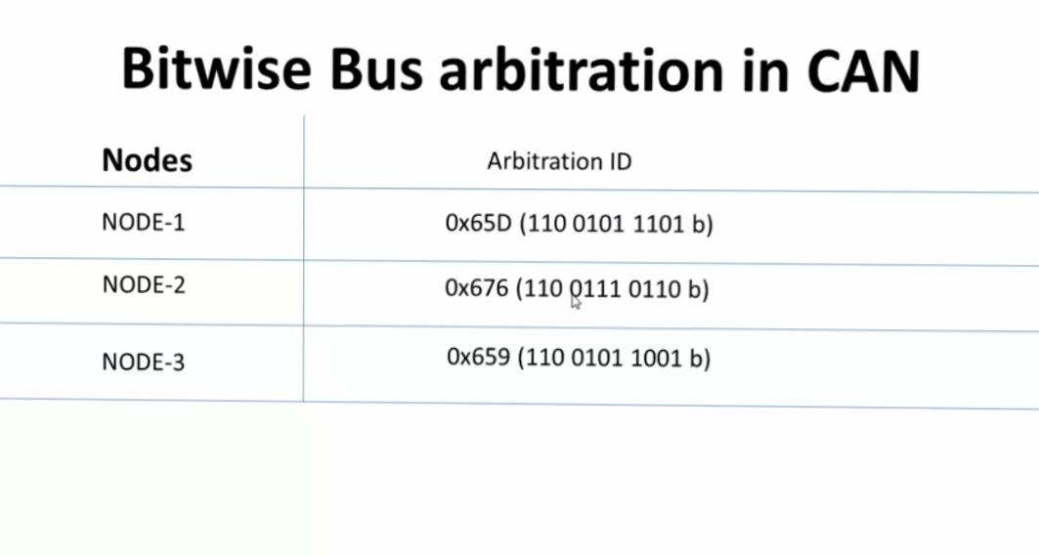1.4.2 Bitwise Bus arbitration in CAN Example

Now let’s consider 3nodes here, arbitration ID means it’s 11bits identifier. From the figure above, we can see that 659 is the lowest one which means node3 is going to win the arbitration because it has the lowest 11bit Identifier and also when these three nodes compete for a bus at the same time.

So the lower the arbitration ID number,the higher the priority.

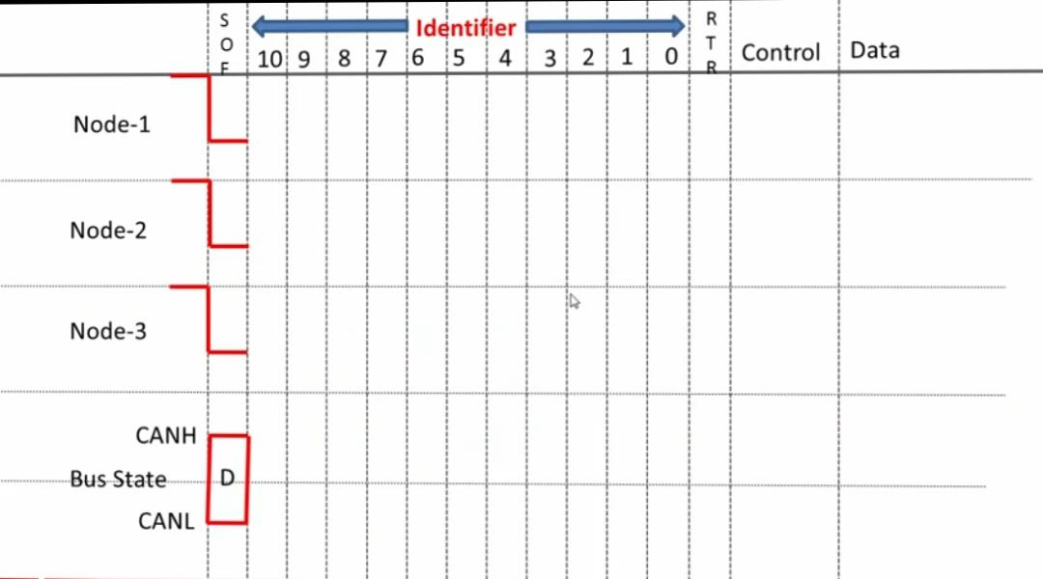From the above figure, from the left hand side, we can see node 1,2,3 are all trying to send a message at the same time and here at the bottom is the bus state. The resultant per state kanna-chan can loop and here is the identifier field which is a collection of 11bit identifier and the RTR bit

1. Note that every frame starts with dominant bit that is SOF. So all the nodes are aware that the bus is idle and they try to send message so they first put the SOF bit which will always be dominant bit
2. After that, they all put the first bit of the arbitration ID

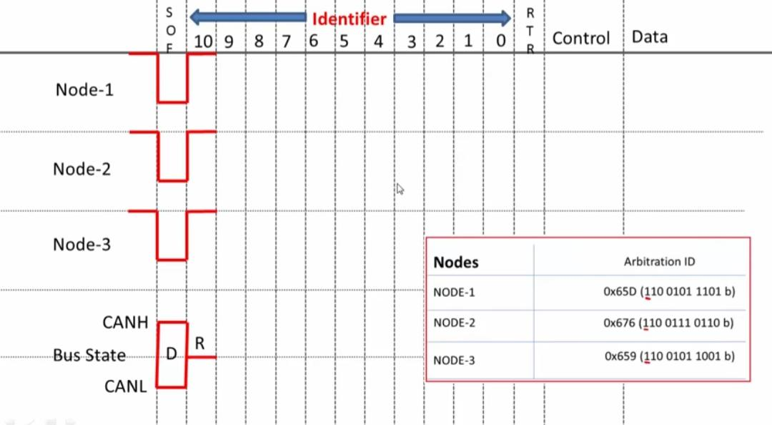

From this figure, the first (most significant bit) MSB in this case, this happens to be 1,1,1 in all cases(ie in all the three nodes). So the bus state is this case becomes recessive because all three nodes have put the recessive bit.

1. 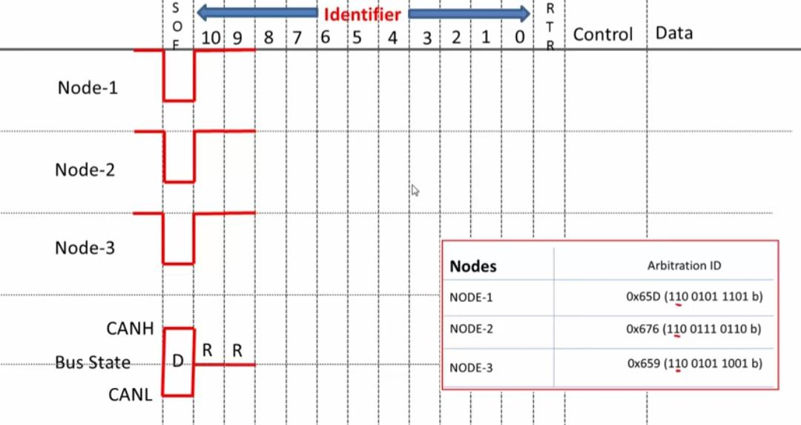 Now after that,again we have 1,1,1 which means that the state will be at recessive state and after that they are going 0,0,0 which is a dominant state,so the bus state becomes dominant.
2. 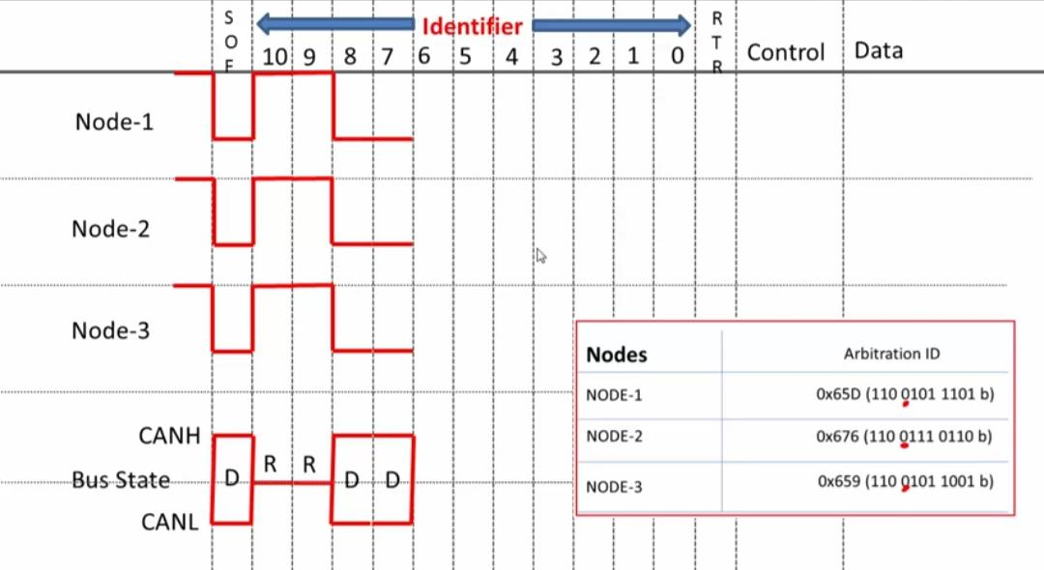 After that they all put 0,0,0 which is actually dominant again
3. 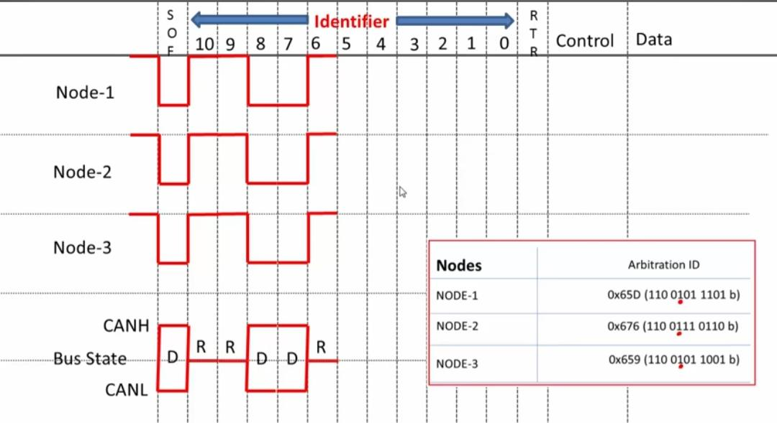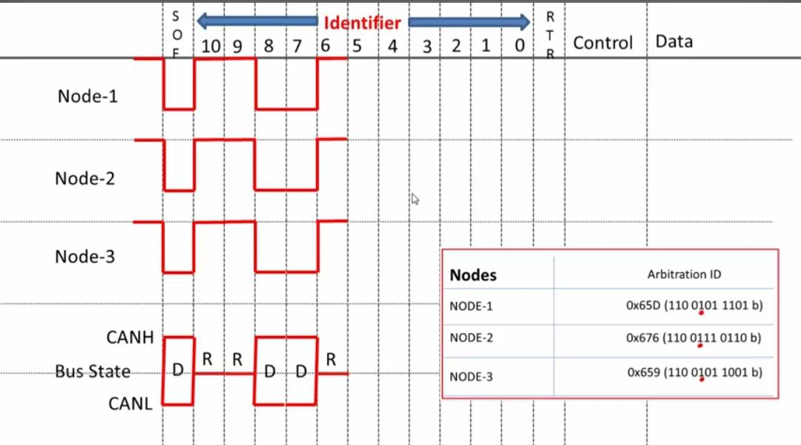They all put recessive bit 1,1,1
4. From figure below, we can see a difference, the ID changes for node2, so closely observe here, node2 looses arbitration because it is trying to put recessive bit but node1 and 3 are putting dominant bit. Which means node2 goes out of arbitration because the birth state has become Dominant so the node2 has put recessive but it hears back dominant

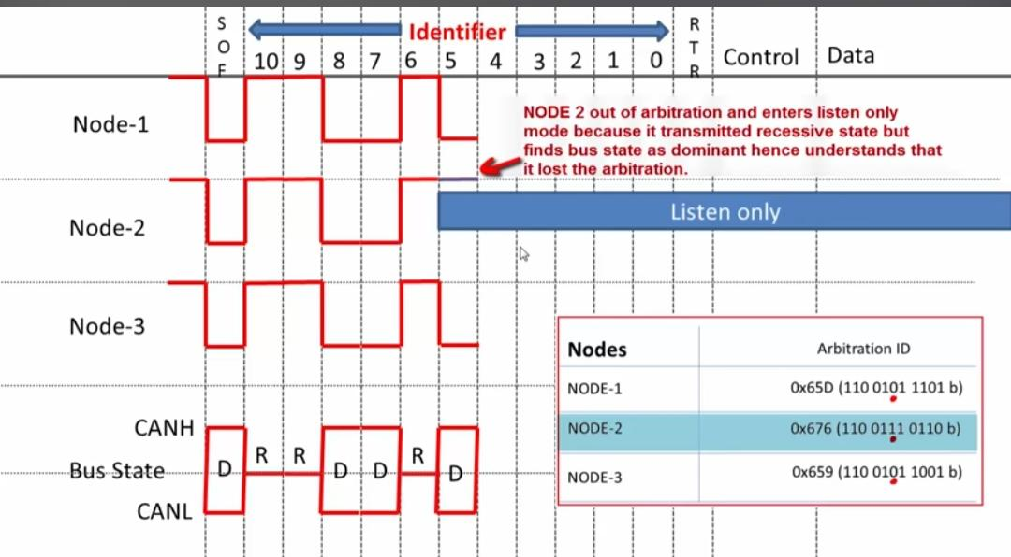

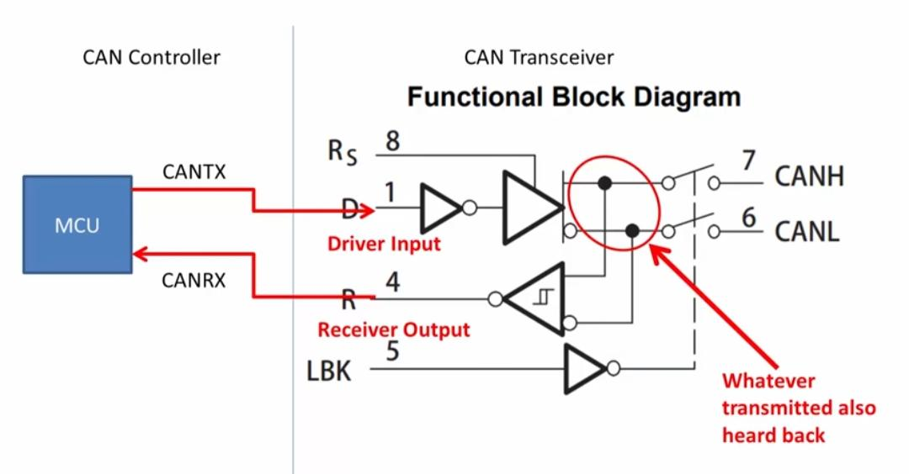Remember in CAN transceiver, whatever our node puts on the bus, it also hears it back so node2 actually put the recessive states(which means the potential difference between CAN H and CAN L is 0 but it hears back the potential difference of 2 and it understands that it has lost the arbitration which means it will just go to the listen-only mode. It will just seat down and not try to compete with node1 and node3.

1. 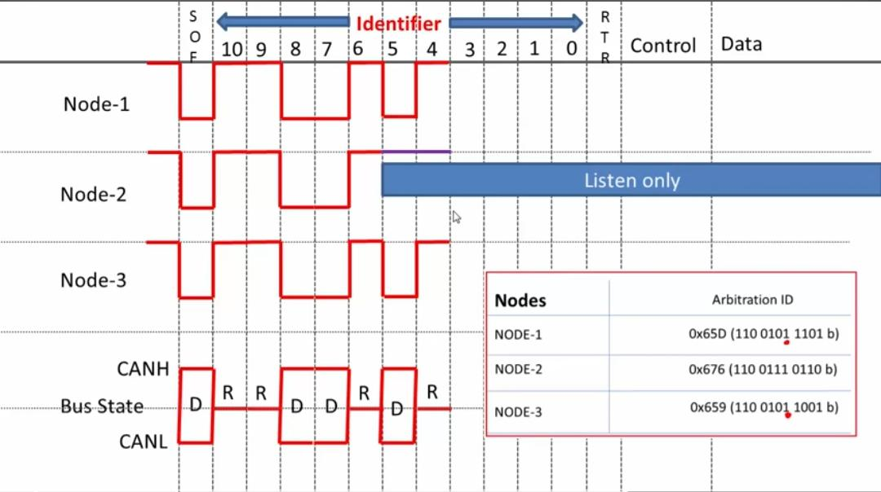Now that the arbitration continues between node 1 and 3. So next both actually put the recessive state so the bus state becomes recessive and after that again recessive bit so the bus state becomes recessive
2. 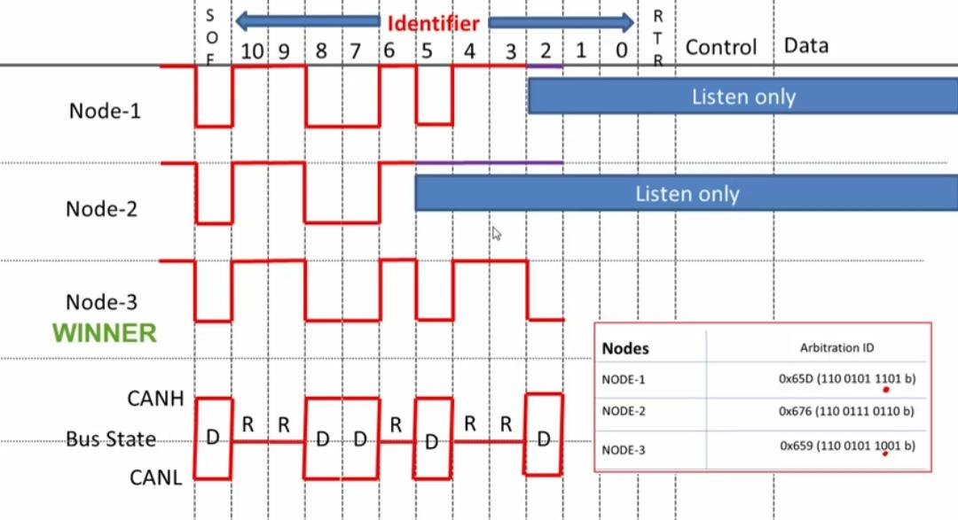Now from the figure below we can see that node1 is trying to put the recessive bit but node3 put the dominant bit so hence, node3 wins the arbitration here and node1 looses the arbitration.

The winner node3 is okay so node1 goes to listen only and after that,there are no more devices so node3 continues and it then put its remaining bits of the identifier field and finally the RTR and after it sends the data. That’s how the arbitration happens and that’s how a node with the lowest identifier value wins the bus arbitration works. This is also how the bitwise arbitration works.

NOTE: the dominant bit always overrides a recessive bit.

All these arbitration will happen automatically by the controller itself so we need not to do anything, we just have to allocate the priority values(identifier values) for different messages.

**2.0 Electronic Control Module and Engine Management System**

Since chapter one covers the insight of how the components operates(i.e sensors, microcontrollers, CAN Bus system), this chapter will relate how that knowledge is incorporated and engineered into our daily vehicle system. It will also cover the roles engineers can play in handling these components(i.e both software and hardware installations). And also Distinctive explanation on how the ECU’s communicate with each other through Can Bus.

In this chapter, we are also going to see the future trends of vehicle electronic system. Since the global trend and the goal of automotive industries is to switch into building autonomous cars if not total autonomous driving cars, we will have insight on how that can be achieved.

**2.1 Electronic Control Unit With CAN Bus System(CAN nodes)**

* The ECU often consist of an 8-bits microcontroller processor, Random Access Memory(RAM),Read Only memory and an input & output interface
* The ECUs basically performs input and output function. When its told to do something directly or indirectly, it has to return an operation as well which serves as the output
* Modern cars consist of a number of different computer components, called Electronic Control Units (ECUs). A typical car contains from 20-100 ECUs and 8-12 communication buses, with each ECU being responsible for one or more particular features of the vehicle. For example, DCU (Door Control Unit) is the ECU that controls and monitors various accessories in the car door. Driver DCU offers features like automatic window movement, close-open door, mirror folding, child lock safety, and mirror adjustment.

**Various communication protocols**

• CAN

• LIN

• Ethernet

• Flexray

CANbus

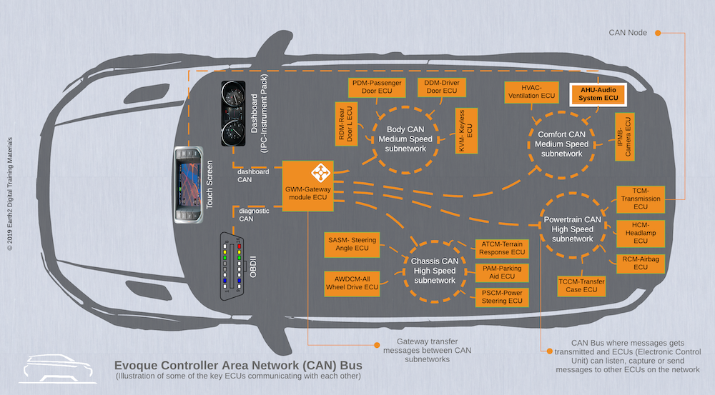

CAN bus is a set of 2 electrical wires (CAN_Low & CAN_High) in the car network where information can be sent to and from ECUs. The network inside the car that allows ECUs to communicate with each other is called CAN (Controller Area Network). In vehicles, the CAN network is divided into subnetworks connected together using a **Gateway Module ECU**. Every ECU with it's CAN controller and CAN Transceiver is called a node.

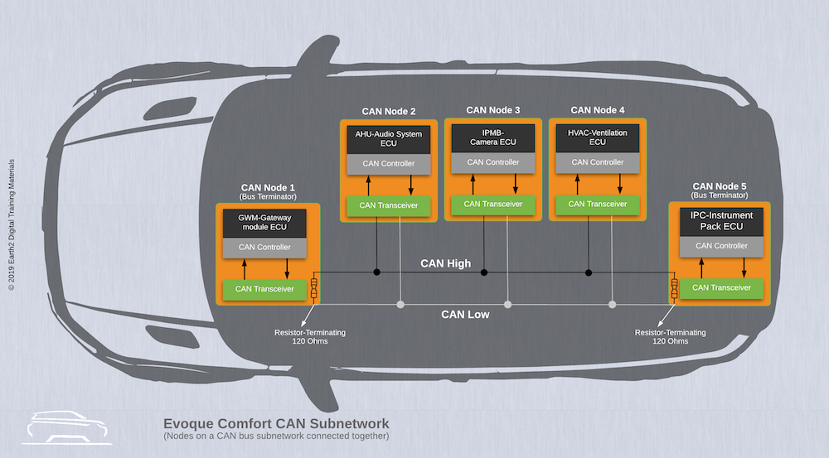

ECUs need to pass data to one another so they can make decisions on how to act. For example, If you open the door of your car, a message would be sent on the Comfort CAN to communicate that the car door is open. Then it would get picked up by AHU-Audio System ECU and get displayed on the Touch Screen and all these will go through the getaway module control which would channel the message to the right ECU(s).

Another example, if reverse gear were to be selected:

* A message would be sent on the CAN bus to tell any interested ECU that reverse gear is selected.
* The message would be picked up by AHU-Audio ECU which would make the rear view camera displayed on the Touch Screen, overriding the currently displayed information.
* The message would also be picked up by the ECU that controls the reverse light to set it on.

**2.2 Vehicle Architecture Network & Automotive Transformation**

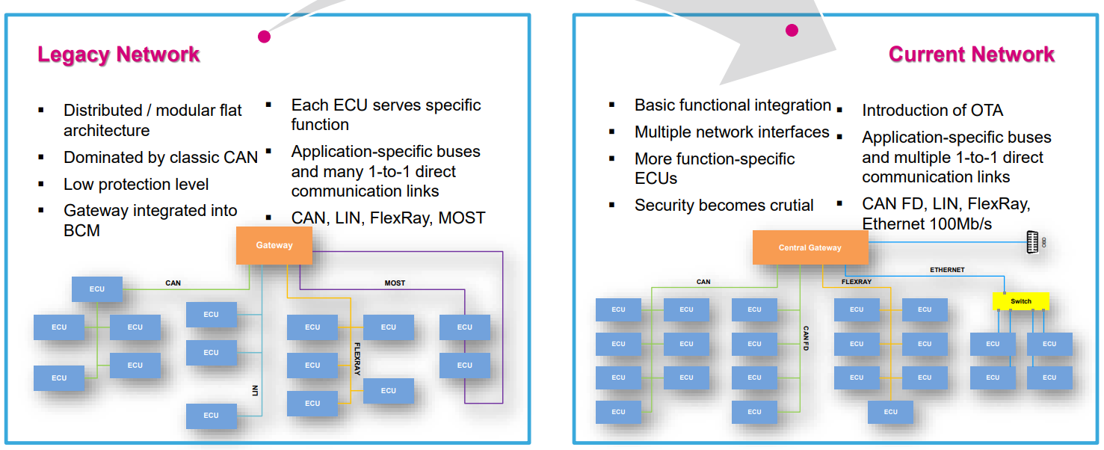

**Automotive Industry Transformation**

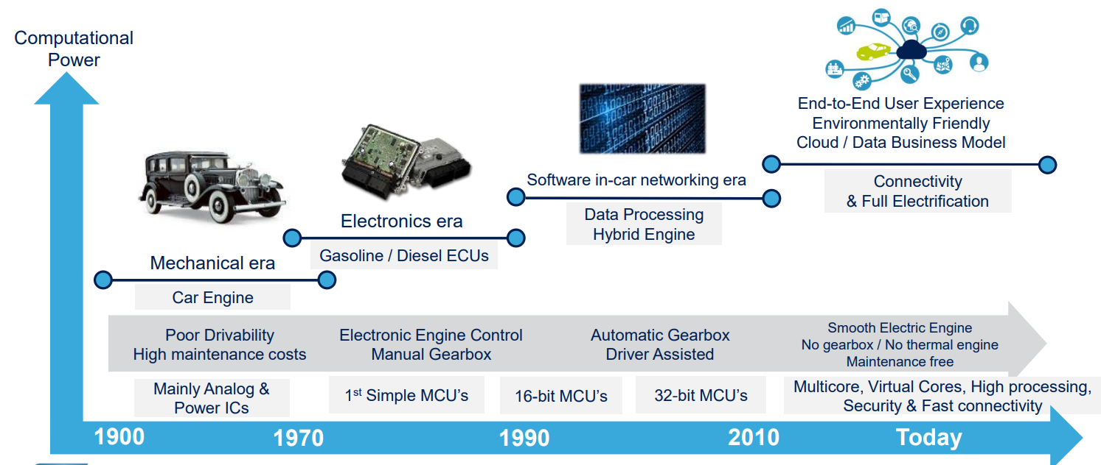

2.2.1 Trends Towards In-Vehicle Architecture

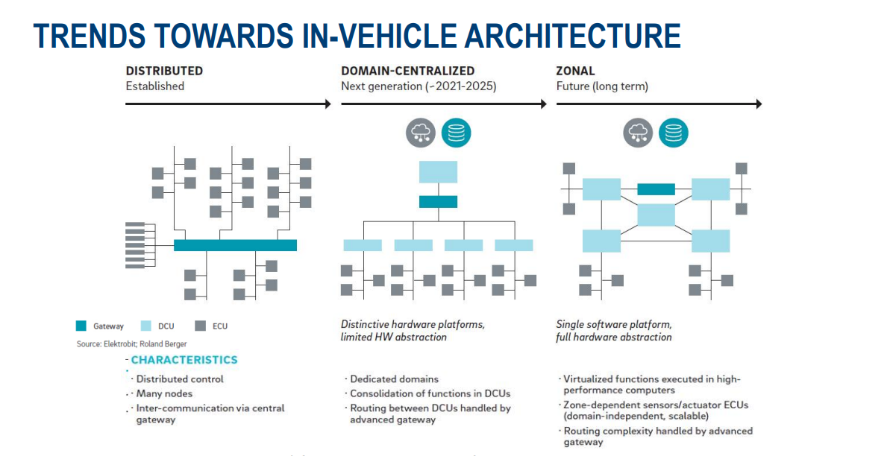

The rising amount of functions available in today's vehicles is leading to both a more complex electronic architecture and to an increasing number of involved electronic control units (ECUs).

We have three stages as we can see from the chart. Namely;

* Distributed – established
* Domain-centralized – 2021- 2025
* Zonal – future(longterm)

Distributed Established Stage

From the above the chart, we can see the present trend of vehicle architecture which we are used to. The distributed system which uses gateway, domain and other ECUs are what our recent and current cars operates on and that’s what we are going to focus on

2.2.2 Gateway Control unit & Domain control Unit

|  |  |
| --- | --- |
| GATEWAY CONTROL UNIT | DOMAIN CONTROL UNIT |
| It could be a generic term or a specific term - Electronic Control Unit, Engine Control Unit, but could also reference the ECM (Electronic/Engine Control Module)  To ensure smooth, safe and correct communication between all ECUs it is necessary to have one master unit to coordinate the data transfer within the vehicle network system.  Gateways are the enabler for communication within a vehicle network system and thereby function as a data router as well as a central computing unit between vehicle network domains (powertrain, body, infotainment, engine management system etc.). In addition to that, the level of security of an in-vehicle architecture can be increased using a Gateway.  o It manages and coordinates the communication between various control modules such as the Engine Control Module, Transmission Control Module, Airbag Control Module, ABS Control Module, and more. This module is responsible for collecting and processing data from different sensors and relaying the information to the appropriate control modules.  It is usually located in the central area of the car, near the dashboard, or under the floor console. Its location may vary depending on the make and model of the vehicle. In some cars, it may be combined with the Body Control Module.  o Gateway ECUs are used to control and facilitate inter bus communication to have seamless communication between different networks in a vehicle. Gateway ECUs can have multiple interfaces with various communication buses such as CAN, LIN, I2C , Flexray, MOST. It interprets messages from one bus for another.  o Gateway ECU provides communication between two different networks, networks with different baud rates. It helps in routing the messages from one network to other. Suppose we have different ECUs on one network and one supplier ECU in other network then gateway will help in routing the messages from supplier ECU and converts the messages that will be understandable by the other ECUs and route on to the another network.  o Basically, it’s the brains of the car. In the age where we’ve done away with carburetors, these units control the timing of the spark, the pulses of fuel sent into the cylinders, and take in the information from your Crankshaft Position Sensors, Oxygen Sensors, air temperature and density, power demand/load (from a sensor attached to the gas pedal - few cars today have a mechanical linkage to the throttle body, so it controls that as well), engine/oil/water temperatures, and can even access and control the temperature in the cabin. As the technology becomes more integrated, through the PCM (powertrain control modules), it can control your shift points; it can even access your brakes.  o The gateway control module is the module on the network that you will directly be communicating with when installing a scan tool. The gateway module in turn is linked to other modules. If multiple communication networks are used on the vehicle, the gateway module will have access to all of them. Knowing which module is the gateway can be helpful when diagnosing network communication faults. There is not a “standard” module that is used on all vehicles, but it is sometimes the Body Control Module.  o Suppose a ECU( Low speed) wants to send a message to another ECU on different CAN network( High speed), Gateway will handle the baud rate conversion and voltage conversion on the bus.  Note:  CGW has to be configured for this type of message transmissions  1. Different sort of rate adaptions  2. Packet routing  3. Diagnostic routing.  4. Flash Function.  5. Supports different Protocols to interconnect | 1. The domain control unit (DCU) is responsible for communicating with all of the electronic components in a car.  2. The DCU gathers data from the various sensors installed in the vehicle.  3. The DCU processes and analyzes the information it gathers, and then sends instructions to the various components to optimize vehicle performance, fuel economy, and safety.  4. The DCU is often referred to as the brain of the car because it controls many vital functions in the vehicle.  5. The DCU is typically found in newer cars with advanced electronic control systems.  6. The DCU is highly specialized hardware that requires expert knowledge to repair or replace.  7. Malfunctioning DCUs can cause issues with vehicle performance, including stalling and poor fuel economy.  8. Many DCUs are designed to monitor and control specific systems in the vehicle, such as engine management, transmission control, and braking systems.  9. Improperly installed or repaired DCUs can cause serious safety issues on the road, so it is important to seek out qualified technicians for any repairs or maintenance.  10. The DCU is a vital component in modern cars and is essential to maintaining safe and reliable vehicle performance. |

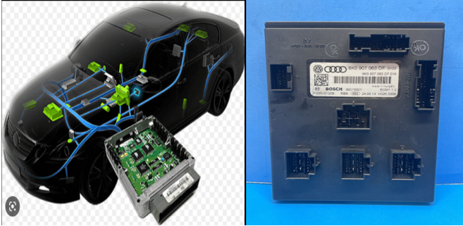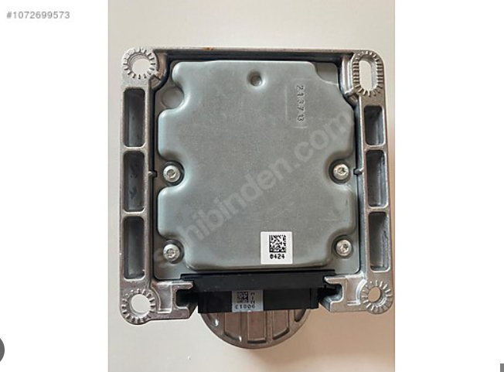

Gateway ECU BMW Domain ECU

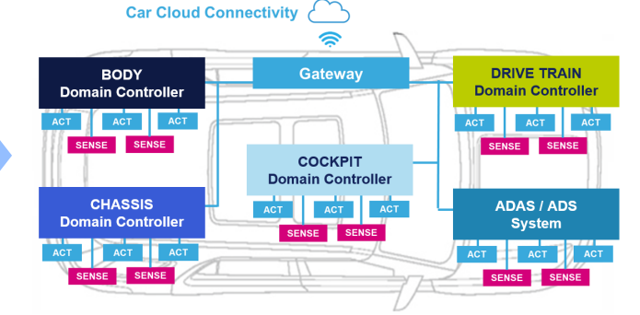Domain Control unit working chart

**2.2.3 Types of other ECU’s(control modules) you can have in a car**

Control units are also referred to as control modules. The table below will show the list of types of modules and their characteristics with their location but for the fact that the location of modules varies in cars but for our illustration(location) in the table, we will be using JEEP Grand Cherokee WJ

|  |  |  |
| --- | --- | --- |
| CONTROL MODULE | CHARACTERISTICS | LOCATION |
| Body Control Body(BCM) | * The BCM utilizes integrated circuitry and information carried on a programmable communication interface(PCI) * Data Bus network and many hard wired inputs to monitor many sensors and switch inputs throughout the vehicle * The BCM supports many body electrical components such as the interior & exterior lighting control, Wiper control, HVAC control, sunroof control, seat control, door control system, user information and status driver | Attached to the junction block, under the driver seat side of the instrument panel |
| Passenger Door Module(PDM) | The door modules control a lot of electrical components such as power door locks, power windows, power mirrors, lock gate motor. It is switch-controlled | Located behind the right door trim panel, integrated within the switch assembly |
| Airbag Control Module(ACM) | The microprocessor in the airbag control module contains the supplementary restrain system logic circuit and controls all of the supplementary restrain system components | Located under the center conceal housing behind the shifter assembly |
| Electronic Vehicle Information center(EVIC) | This is an interactive display system. It gives the driver some information like temperature, compass | Located within overhead console |
| Sunroof Module(SM) | This controls operation of the sunroof opening and closing, event functions | Located in the overhead console as part of sunroof assembly |
| Rain Sense Module(RSM) | The microprocessor base sensor module sensors the moisture in the wide pattern on the outside of the windshield glass and send right commands to the Body Control Module(BCM) | Located inside the windshield between the rear view mirror mounting button and the windshield header(the small plastic housing) |
| Instrument Cluster(IC) | * This provides gauge and indicator controls. * It utilizes the Programmable Communication Interface(PCI) Bus to obtain most but not all the information needed to control all the gauges and indicators | Located in the left side of the dashboard |
| Driver Door Module(DDM) | The door module controls various electronic features such as power door locks, power windows, power mirrors, courtesy lighting. It is switch-controlled | Located behind the left door trim panel, integrated within the switch assembly |
| Heated Seat Module(HSM) | This performs heated seat functions. It is switch-controlled | Located under the driver seat. Mounted on a bracket that is between the power seat track and the seat cushion frame |
| Memory Heated seat module(MSM) | This performs memory seat functions and heated seat functions. It is switch-controlled | Located under the driver seat. Mounted on the bracket that is between the power seat track and the seat cushion frame |
| Adjustable Pedals Module(APM) | This controls the operation of the adjustable pedals to either move inwards or outwards using the switch buttons for the control | Located under the dashboard and above the brake pedal |
| Sentry Key Immobilizer Module(SKIM) | * The sentry key immobilizer module contains a radiofrequency, transceiver and a microprocessor * The SKIM transmits RF signal to and receive RF signal from the sentry key transponder through a tuned and turn-away ring integrated to the SKIM housing * The SKIM is also connected to the Power control module(PCM) | Located under the steering wheel column opening cover attached to the bottom side of the steering column housing |
| Transmission Control Module | * This controls all electronic operations of the transmission * The TCM receives information regarding vehicle operation from both direct and indirect inputs and selects the operation on mode of the transmission | Located on the right side of the engine compartment near the firewall. Mounted in the inner-fender or on the left side of instrument Panel |
| Controller Antilock Brakes(CAB) | * This controls the ABS. * It also controls the electronic brake distribution(EBD) | This is attached to the Hydraulic Control Unit under the hood, in front of the master cylinder |
| Power Control Module(PCM) | The PCM is a preprogrammed tripled microprocessor digital computer  It regulates the ignition timing, air/fuel ratio, emission control devices, charging system, certain transmission features, speed control, air conditioning compressor clutching engagement and idle speed | Located on the power panel at the right rear side of the engine compartment |

From the table, we can deduce that Some modules are switch controlled or sensor command control but in all, most of these modules need to pass information across for example to the body control module to monitor switch and sensor inputs and instrument cluster to get information needed to control the gauges and indicators

Some modules work independently for their output function but sends information across through the Bus communication like the Controller Antilock Brakes, PCM and the transmission Control Module while other modules are base sensor microprocessor which only reads the sensor, take the right command and send it to other control module for support like the rain sensor module

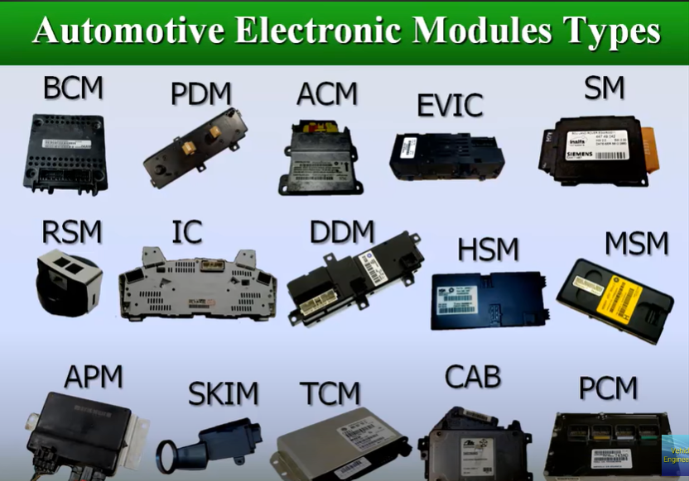

REF: https://www.youtube.com/watch?v=BG4N2dBgJrQ

**2.3 Engine management system(ECU wiring)**

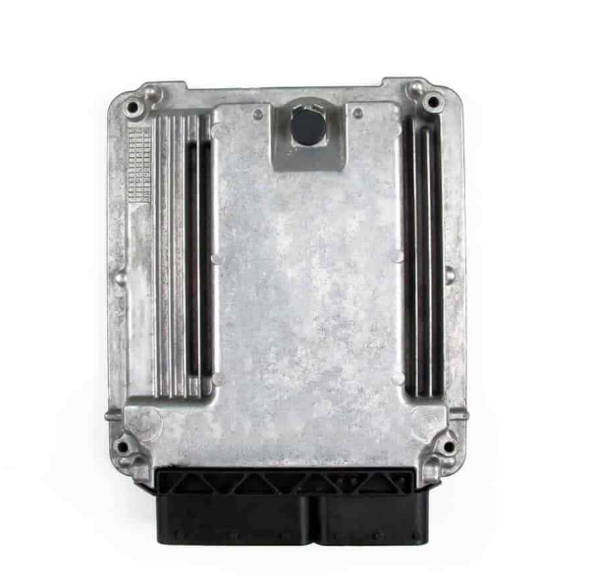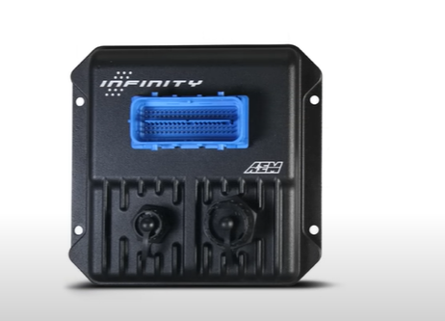

>>> The types, characteristics, advantages and disadvantages

Note :

If you used the wrong ECU not for that particular calibration some of the features in the ECU would not be usable, but the engine will run fine.

Standalone ECU

Here, we will look into how to install a standalone ECU starting from

1. the design of the wiring program
2. Tools and supplies
3. Sensors
4. The wiring process and installation
5. Physical location of the ECU and associated components

Things to know before we start

* A wiring diagram is by far the most important part of the job and it will be something that will be constantly be referencing through out the install.
* The first step towards creating a wiring diagram is to look at the user manual of your ECU (I will be using AEM performance electronics for example and illustration)and reference the Pinout.
* A pinout tells you which pin on the ECU is designated for what. Download the datasheet of the ECU you are using to see all the specifications.

Here using an AEM infinity series 5 ECU and here in its hardware specification sheet, you can find a detailed pinout.

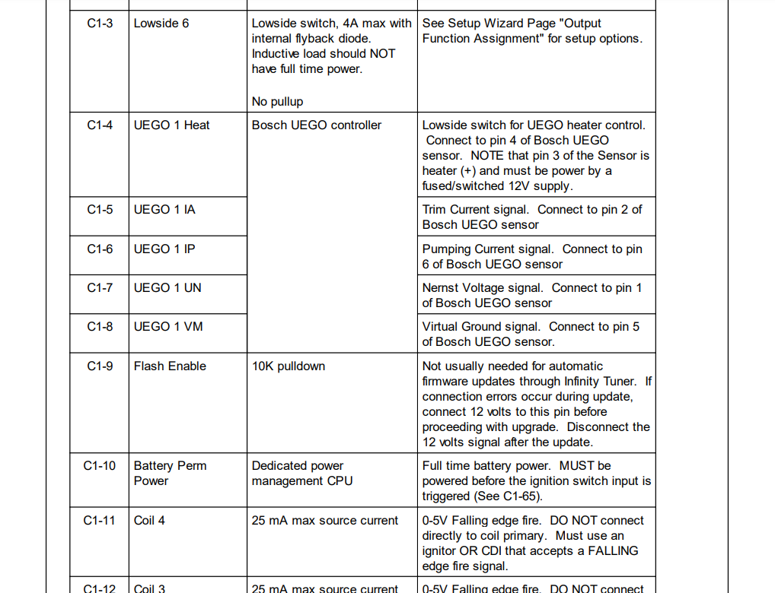

For example, here we can see that pin C1-6, which is simply pin number 6, that’s the trim current signal for your Bosh wideband sensor and you are even told which pin of your sensor should be connected here.

If we scroll down a bit more, we would see which ignition coil should be connected to which pin and below that, we have the cam and crankshaft position sensors incase you are using a variable reluctance and a bit below, we have the pins for Hall effect sensors and so on.

This may seem very intimidating as it contains a lot of unfamiliar words such as lowside switches, falling edge fire signals, 10k pull up etc. And we are going to look into that as we going to build a detailed wiring diagram and a high resolution of the diagram below

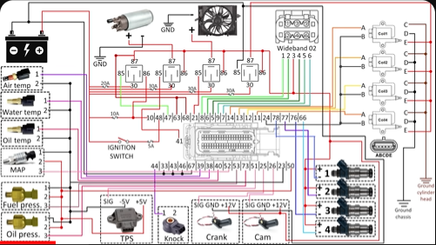

Using this diagram, you will be able to see what can be safely connected where and you can reverse-engineer this diagram, edit it, change pin numbers and adapt it to pretty much any ECU or setup regardless of whether you are running AEM or not because ultimately the basic of logic of an ECU or engine control unit is simply to read signals from sensors and control outputs to injectors, ignition coils and other components based on those signals.

* So with the pinout, we have the basic idea what can be connected where and the next thing to know is which pin is which on the connector itself i.e the logic of pin numbering on the ECU connector which is of course available in the hardware specifications

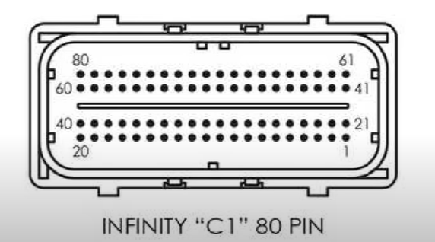

* Here we can see that we start the counting from the bottom right of the connector and continue by jumping the right side for every subsequent row of pins.

So for example, if you are supposed to connect something to pin 26, you will start counting from 21 and if its to connect something to 34, its easier to start counting back from 40.

* This may seem basic and self- explanatory but it’s important to stay focused when you are counting because connecting something to the wrong pin can cost you hours or even days of troubleshooting.
* On the manual, you can find some examples of how to wire different things on different platforms so you can double check that what you are doing actually makes sense.

NOTE:

The ECU side of the pins that you can see in the instructions is useful but you wont actually be working with this, you are not installing wires directly into the ECU. Instead, you will be installing them into the ECU connector

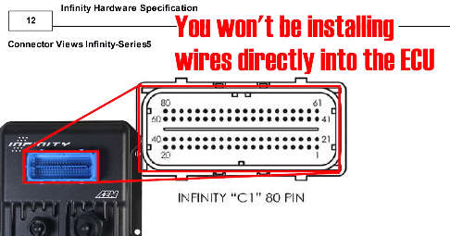

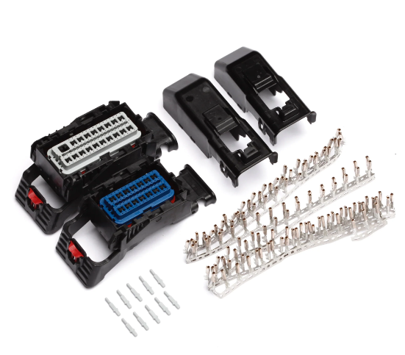

**ECU connector**

1. the design of the wiring program

So for drawing the wiring diagram, I prefer to open the AEM infinity tuner software so as to get the picture of the connector which will be the one you will be working with and touching all the time.

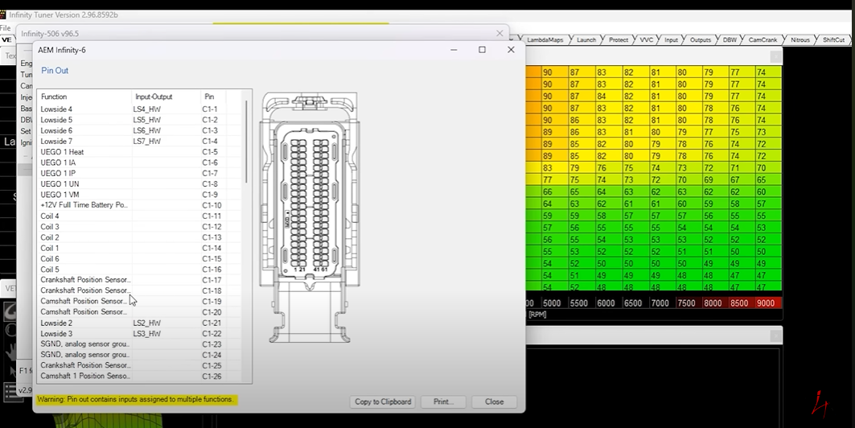

**Steps**

* Download the software
* Select the model of your ECU
* From file, open the pre-installed saved sessions and then go to wizard- setup
* From wizard-setup, select setup wizard > output and click on pinout.

NOTE:

The picture and your physical connector is the back of the ECU connector and this is where you will be installing the wires so it’s a good idea to get familiar with its layout and orientation in connection with the numbering system.

Next is to map out everything that will be connecting to the ECU and that includes the battery, the ignition switch of the car, the injectors, ignition coils, all the sensors, the engine bay fans, the fuel pump and main relay, the fuel pump relay, the ignition coil relay and the fan relay.

Following the wiring diagram, you can use getpoint.net to edit, analyze the wiring diagram into sections so as to simplify the drawing when you are making reference to a part like the injector wiring at any moment.

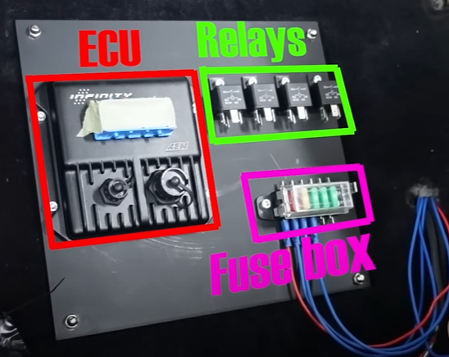

**NOTE:**

* The purpose of relay is to protect your ECU and your entire electronic system by making it possible to control high amperage devices such as fans and fuel pumps and the likes with a low amperage current(i.e you are using a weak current to control a strong current)
* Also, all the cables coming from the positive side of the battery(which is denoted by color red in the wiring diagram) should have fuses on them. You can usually get a small fusebox and install it to your preferred location and bring all the cables to and from this to create a tidy install
* The wire coming from the battery to the ignition switch already exist on every car, so you wont be bringing a new wire from the battery to the ignition switch instead you will just hook up to an existing wire coming out of your ignition switch.
* Make sure the wire has power when the ignition switch is on and when cranking, must have no power when the switch is OFF.
* Whenever you see a dot on the diagram, it means that the wires are joined together. For example, all the sensor ground except for the cam and crank sensor join together into a single wire and then hook up into the sensor ground pin on the ECU
* A low-side switch basically means that the ECU is switching the ground connection to turn something ON or OFF while a high-side switch would be switching the positive connection of whatever its controlling.

1. Tools and supplies

Regardless of whether you are using a flying lead harness or building the harness from scratch, you will need some specialized tools namely;

A set of wire stripping plier



Crimping plier : Suitable for crimping small pins that go onto thin guage wires

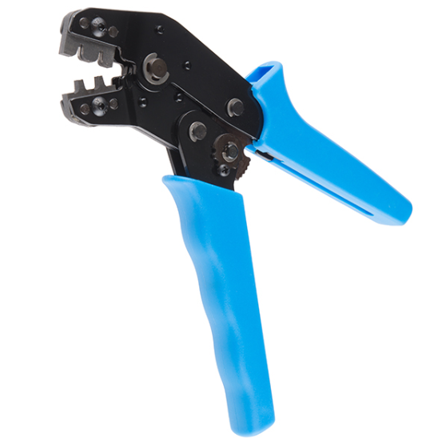

Wiring in multiple different colors : When it comes to the thickness of the wire, 18-22 gauge is typically whats used and recommended for ECUs

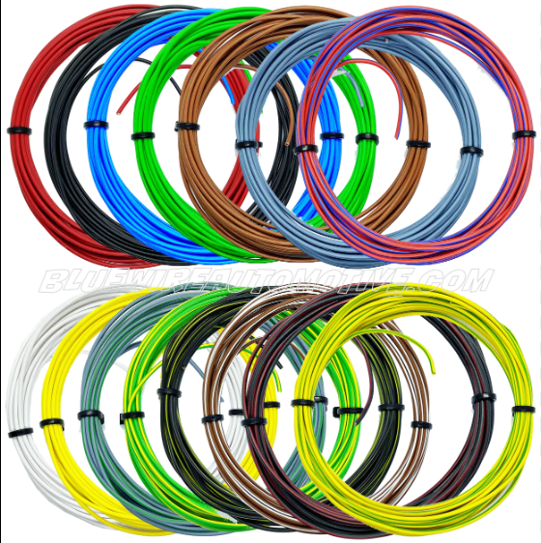

Connectors

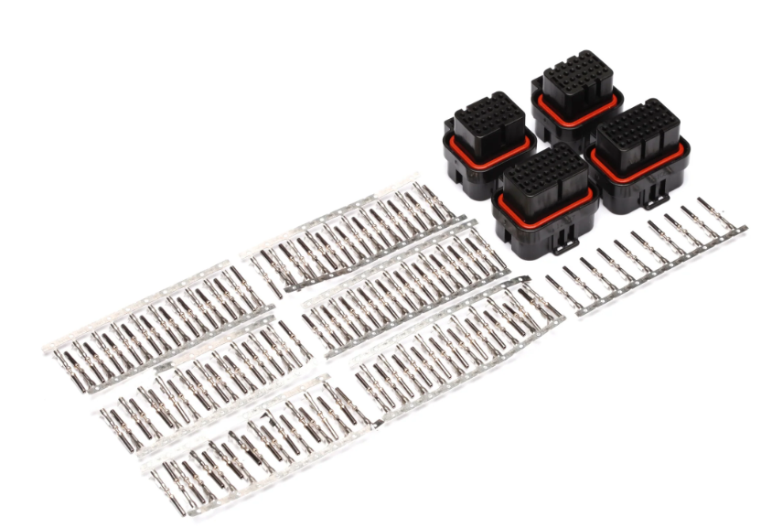

1. Sensors

When it comes to sensor types, you can use different types of sensors but for this, we will stick with AEM sensors because they are cost effective and reliable and they also include the connector as well.

However, this ECU can use a number of different sensors and you will just have to tell it what you are using in the infinity tuner software when you get to the point of configuring.

When it comes to telling Hall effect from Variable reluctance, Cam and crank sensors, you can usually do this by the number of wires

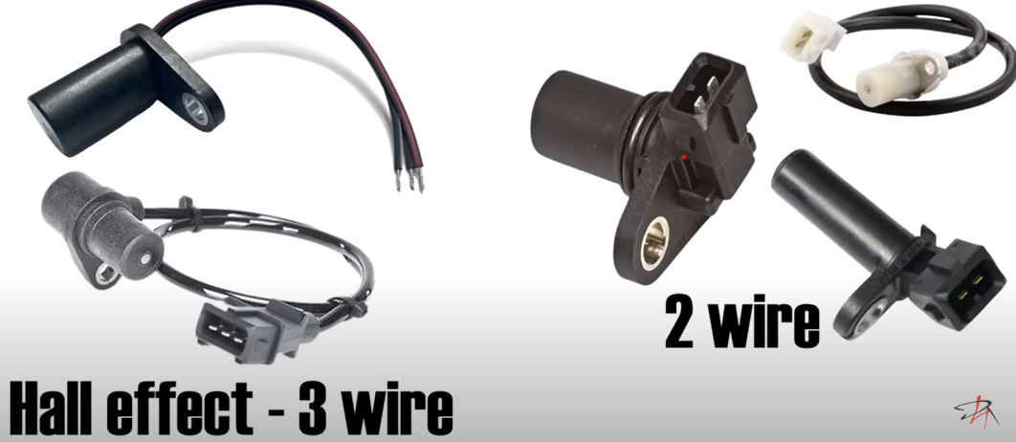

**Note:**

Almost all the aftermarket cam and crank sensors are Hall effect.

2.3.1 Wiring Process and Installation

When it comes to wiring in a standalone ECU, you have 3 options

* A plug and play wiring harness: This is the most expensive approach with the benefit of minimizing the chances of installation error. Making it by far the easiest and least time consuming solution



* A flying lead harness: This will contain the wires already pinned into your ECU plug. Your task will be to cut these wired to length and install sensor connectors on them

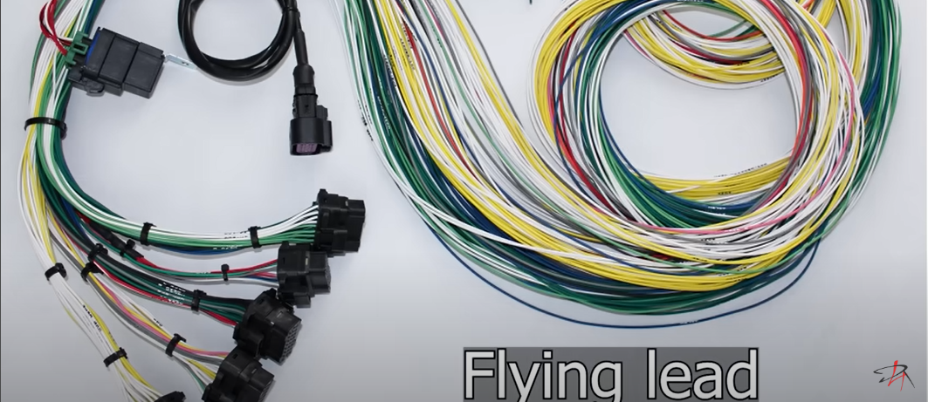

* Building a wurung harness from scratch(DIY) : Here, you will be pinning the wires into connector yourself which does increase the chances of error but it reduces cost and allows you to pick the wire colors yourself

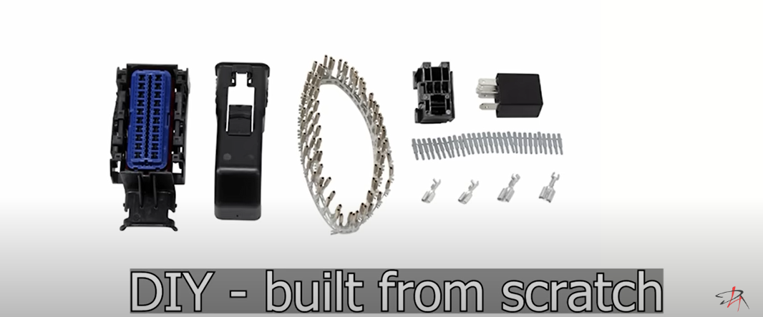

**NOTE**

A plug and play product must first exist for your engine/ ecu combo/ car. In many cases, such a product may not be available so you are left with choosing either between flying leas or a built from scratch.

The most sensible approach is the flying lead harness.

Wiring Process Steps

Once you are ready to start wiring, it’s a good idea to

1. Lay and organize everything on a nice surface
2. Print the wiring diagram for reference on a large format paper because you will be looking at this a lot.
3. What you will essentially be doing during the wiring process is connecting the ECU connector to sensor, injector coil and other connectors
4. When it comes to connectors, you should always first figure out what tyoe of connector you are working with before stripping and crimping anything

* Some connectors are known as pull to seat which means your first pass the corresponding wire through the connector and only strip and crimp after this. And the final step is pulling the wire back until the pin is seated into its slot
* Other connector maybe an opposite process, so you will strip and crimp the wire and then push it into the connector until its seated. So check before crimping anything.

1. When it comes to the direction of wiring, you have two choices. You can start at the engine end or the ECU end. Starting from the engine end, this means you basically wire up all the sensor connectors, organize and group the wires and finally find a suitable place through which you enter the cabin and then connect everything into the ECU connector
2. Go on to install the expandable braided wire sleeves once you are sure everything is connected properly and works as it should. It is recommended to keep the ECU away from the temp. fluctuations and vibrations present inside the engine bay. The cabin is the most convenient location because you will often be hooking up with a usb cable to the ECU for tunning purposes.

NOTE:

A useful tip for minimizing potential for damage when populating this and all similar connectors is to populate in order. Don’t populate randomly as this may lead to a situation where you are supposed to install a pin into a location that is now surrounded by other already populated slots and this make your work harder.

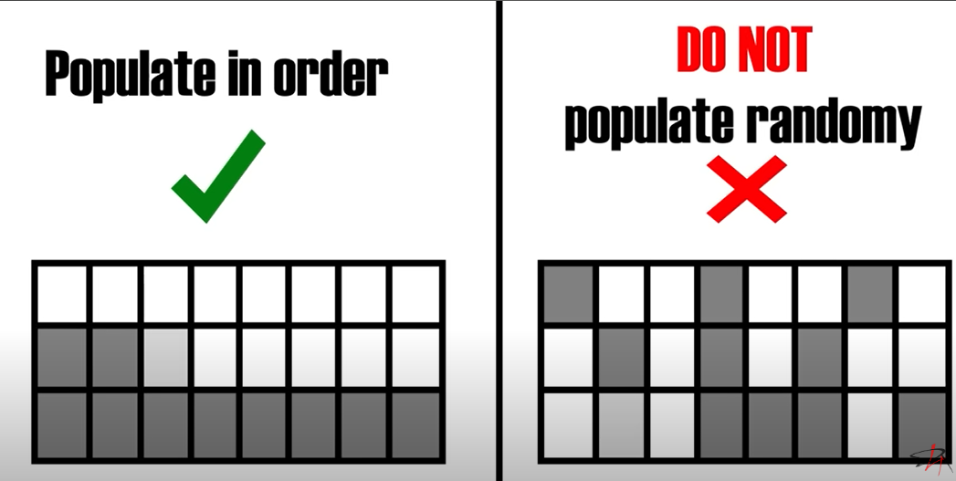

1. The final step for wiring can be seen below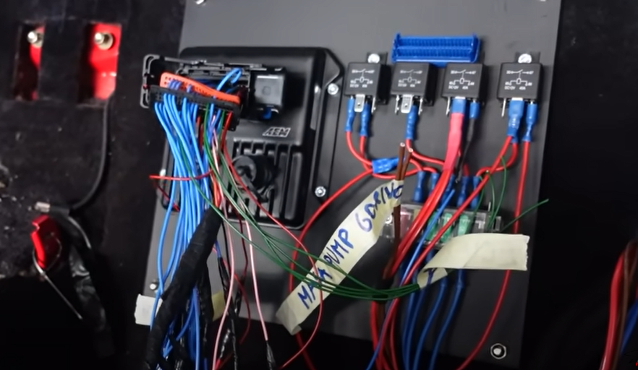
2. The final step involves assigning the correct pins to the correct outputs in the tuner software

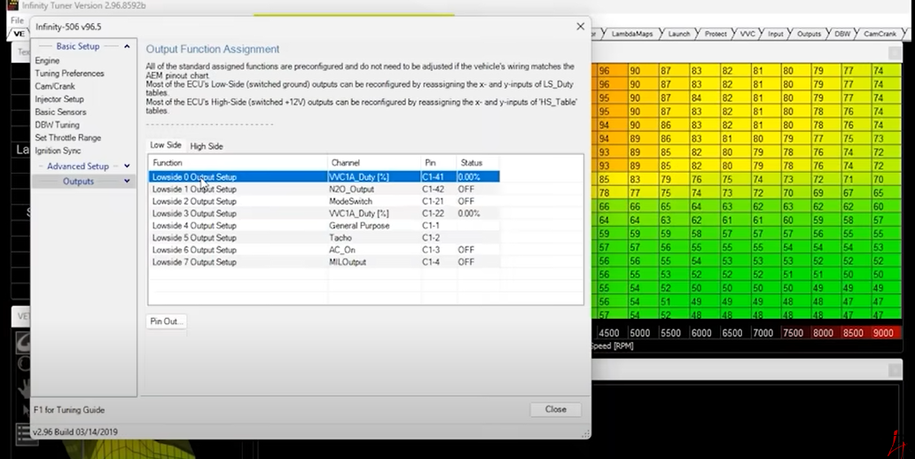

Once that is done, you can configure the rest of the parameters and start your engine.

**2.4 How programming work on an ECU**

* Generally speaking, the OEM (Original Equipment Manufacturer) has created custom bootloaders (firmware) for the majority of ECUs.
* The majority of the programming is carried out in accordance with Unified Diagnostic Services and is the same for all 80 ECUs.
* The UDS enables changes to the ECU ID, seed, and key algorithms, and finally the hex files used to program various ECUs.
* All ECUs that are installed in a vehicle and have UDS services enabled can be contacted by diagnostic tools. UDS makes use of the fifth and seventh layers of the OSI model, as opposed to the CAN bus protocol, which only uses the first and second layers. The payload of a message frame holds the Service ID (SID) and the parameters related to the services.
* Modern vehicles come equipped with a diagnostic interface for off-board diagnostics that enables the connection of a computer (client) or diagnostics tool, also known as a tester, to the vehicle's communication system. UDS requests can therefore be sent to the controllers, who must respond (which could be positively or negatively). In order to diagnose problematic or other undesirable behavior, it is now possible to query the fault memory of the individual control units, update them with new firmware, interact with their hardware at a low level (by, for example, turning a specific output on or off), or use special functions (referred to as routines).

**2.4.1 WHY REPROGRAM?**

* For a variety of reasons, PCMs might need to be reprogrammed. One is to correct factory flaws.It always turns out that Windows OS or a new phone, for instance, has bugs and security holes that were somehow missed but need to be fixed by downloading and installing the most recent patch. The cycle of updates and patches never ends. Fortunately, the situation with automotive PCMs hasn't gotten that bad yet, but it has turned into a crutch for automakers who release products that aren't quite ready. Additionally, this "build it now, fix it later" philosophy results in numerous unnecessary recalls, but at least it provides technicians with a way to correct manufacturing errors without having to replace any parts.
* If the OBD II self-diagnostics factory settings prove to be excessively sensitive, especially after a few years of use, a reflash may also be necessary. The same is true of driving ability. What functions perfectly in a brand-new vehicle might not function as well 50,000 or 100,000 miles or in real-world driving.
* To get rid of a hesitation, spark knock, or other condition that gradually appears, it might be necessary to slightly alter the fuel enrichment curve, spark timing, or some emission control functions. For instance, on some GM vehicles, the Check Engine light illuminates and sets a code P1406 that denotes a problem with the exhaust gas recirculation (EGR) valve's position. The vehicle cannot be fixed by cleaning or replacing the EGR valve and clearing the code because the code frequently reappears. The OBD II programming in the PCM is the real issue.
* The EGR valve doesn't have enough time to respond when the PCM commands it to open to check its functionality. A brand-new valve opens in about 50 milliseconds, but an older valve may take 350 milliseconds or longer, which is long enough to trigger a fault code but not long enough to actually cause a failure in NOX emissions. Reflashing the PCM with fresh instructions that give the EGR valve more time to react is the solution in this case.
* Manufacturers must set a limit for what operating conditions might result in emissions that are 1.5 times higher than the federal limit when calibrating the onboard diagnostics to meet federal emission standards. That's the point at which the Check Engine light and a fault code must both be set. Although it is possible based on laboratory dyno testing and actual field experience, it does not necessarily mean emissions are actually over the limit. The last thing any OEM wants is a costly emissions recall, so depending on the application, the vehicle manufacturer may even set the limit a little lower just to be safe.
* Unfortunately, automakers frequently fail to disclose their diagnostic methods or even their operational methods for computerized engine control systems. Some service manuals provide a fair amount of background information on the system, while others offer little more than a simple diagnostic flow chart. Perhaps the engineers who create this stuff believe that all mechanics today need to fix cars are flow diagrams and assembly instructions. To determine what's setting a specific code, however, frequently requires a much deeper comprehension of the operating logic of the system, especially when the cause isn't immediately apparent.
* The best advice is to look for any Technical Service Bulletins (TSBs) that may have been released when dealing with a problematic code that keeps returning or seems to set for no apparent reason. It may be a programming problem that needs to be fixed with a reflash.

NOTE

* Another thing to keep in mind with regard to all modern flash reprogrammable PCMs is that if the original PCM needs to be replaced for any reason, the replacement unit needs to be reflashed in order to function. The PCM is just a dumb box without an operating system if it is not programmed.
* For certain vehicle applications, some remanufacturers of reconditioned PCMs now flash program PCMs. The vehicle identification number (VIN), the type of transmission (manual or automatic), and the emissions type (federal certification) are three essential pieces of information, though, that they need in order to do this. The PCM can be flashed and manually reprogrammed as an alternative.

CHAPTER 3

This chapter is the most important part of this project because here we will discuss about how the flowcode software is being used, how it is an essential tool for mechanical engineers. There are few mechanical systems without electronic control systems. Till date mechanical engineers, needed to work with an Embedded engineer to realise a system But as Flowcode is syntax independent with a low learning curve mechanical engineers can use Flowcode to develop control systems themselves.

So this chapter will expose us to know what’s there to know about flowcode and how to use that to demonstrate how CAN Bus system actually works using practical experiments with added experimental tasks.

3.0 FLOWCODE

What is flowcode

Flowcode is a graphical based programming language, where flowcharts are the method of creating the program structure rather than the use of a text based programming language. Not only does this provide a method of programming which is free of syntax errors, it also allows for a simple drag and drop of icons and rapid program development.

Flowchart functions are configured by adjusting their parameter properties. For example, when implementing a while loop, users can configure loop conditions such as the number of loop executions or the break condition of the loop, such as when a variable reaches a certain value.

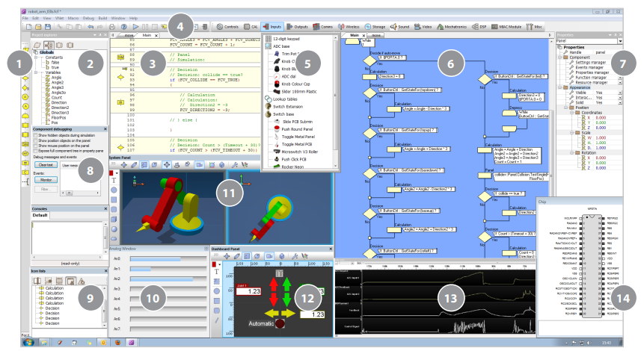

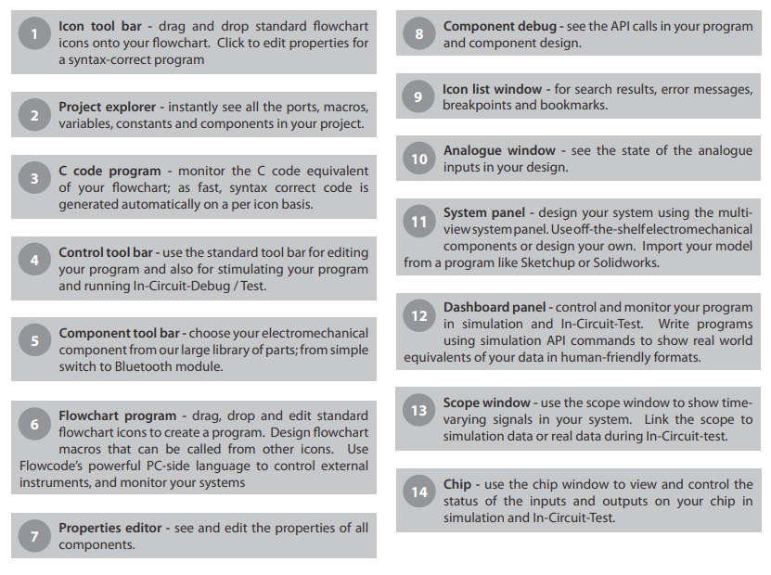

Characteristics and Functions of flowcode

|  |  |
| --- | --- |
|  | CHARACTERISTICS |
| Choice of programming methods | * Being able to use graphical icons to develop your system makes Flowcode easy-to-use * Flowcode will make it easy for you to pick up the fundamentals and run with your designs without getting bogged down in syntax * Users can choose between two graphical methods of programming - flowcharts or Blocks - and two scripted coding modes - Pseudocode or C - making for a very flexible IDE |
| Fast system development | * Programming can be a complex, drawn out process and can often result in errors. Ensuring your code is accurate and precise takes skill and time. With Flowcode, your job becomes easier. * The added advantage of simulation also allows you to check and test your designs prior to compilation to a microcontroller |
| Learn and program using C code | * If you're a more advanced programmer or have pre-written code you want to embed into your design, Flowcode allows you to do just that * if you're using graphical icons, you can view and learn code side-by-side with your design, meaning academic users of Flowcode develop their learning over time. * Convert your C code into graphical programs and your graphical programs into C to develop and grow your understanding |
| Test and debugging | **Simulation debugger**: For many engineers, a key requirement is to ensure the designs you have developed will work when you compile to your microcontroller  **Code profiling**: Code profiling shows the user when icons have been 'hit' when the program is executed, distinguishing between sections of code that may be redundant and other parts which are executed often.  **In-Circuit-Test and In-Circuit-Debugging**: In Circuit Debug (ICD) allows you to control the execution of your Flowcode program on E-blocks & E-blocks2 hardware. This allows you to Run, Step, Pause, use Breakpoints, and monitor and set variable values. ICT mode also allows you to decode communications signals including UART, SPI and I2C packets. |
| Simulation | Prior to deploying your code to a microcontroller, you can simulate in Flowcode, to ensure your design is accurate and will run as you expect. This can be done not only for your flowchart, Blocks or Pseudocode projects, but even for your C code-based developments, too. |
| Create simple design | * Create simple actuators or valves or add simple shapes to your existing designs and use the built in API to control these creations during simulation * You can even use the Flowcode system panel tools to create your own simple 3D models. |
| Import your designs from CAD packages | Flowcode integration with third party drawing packages (such as Solidworks), through support for various file formats, means that you can easily import your 3D drawings and designs into Flowcode |
| Component library | **Pre-developed components macros**: A whole suite of electromechanical components exists in our large library of parts; from simple switches and LED's to more complex communications modules.  **Communication components:** Communications protocols including CAN bus, Bluetooth, USB, Ethernet and Wi-Fi are widely studied across the globe. All of these components are available within the Flowcode environment and come as standard with all academic licences.  **New components added**: Flowcode contains hundreds components that can be used to create a wide range of electrical and electromechanical systems. These components can also be used as a basis for creating your own components or simulations |
| Variables | * As the name implies, this is a varying number which can be inform of integer, float, bool, long, byte * Variables can be declared and defined as an input & output and can also be used as expression in the component macros |

**FLOWCODE SUPPORTED DEVICES**

* Ardruino programming
* 8-bit PIC
* 16-bit AND 32-bit PIC
* E-blocks AND E-blocks2
* Raspberry Pi
* MIAC
* AVR AND ARM

**FLOWCODE USER CASES**

* Those working at a circuit level
* Those working at an electromechanical level
* Those working at a systems level
* Embedded engineers
* Test engineers
* Mechanical engineers
* Chemical/ other engineers
* Education/ learning to program

**FLOWCODE PROCESS**

Flowcode offers an easy way to program microcontroller chips, as you will see. Once the flowchart is designed on-screen, one press of a button causes the software to translate it into numerical code!

Flowcode passes the program through a number of processes before it gets sent into the microcontroller. The flowchart is processed:

* first into C code,
* then into Assembler,
* and finally into hexadecimal numbers or 'Hex', which the microcontroller 'understands'.

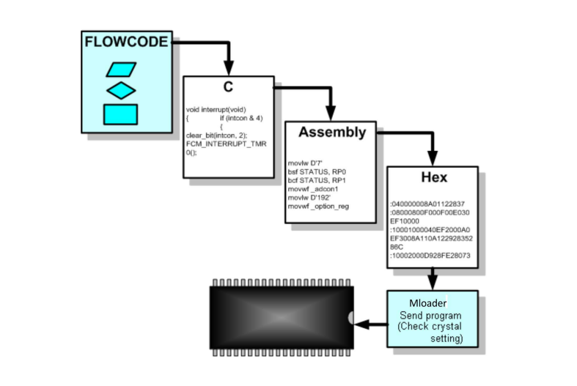

**Running the program**

As soon as the microcontroller is powered up and is supplied with clock pulses, it will start to run whatever program is stored in program memory (Flash).

When you press the reset button on the microcontroller programming board, the program restarts from the beginning.

During programming the microcontroller stops while the program is being loaded. When that is completed, it then restarts and runs the downloaded program

3.1.1 How to Operate On Flowcode

Here, we will use pictorial illustration to explain each point

1 How to connect your board

Download the latest driver of your hardware

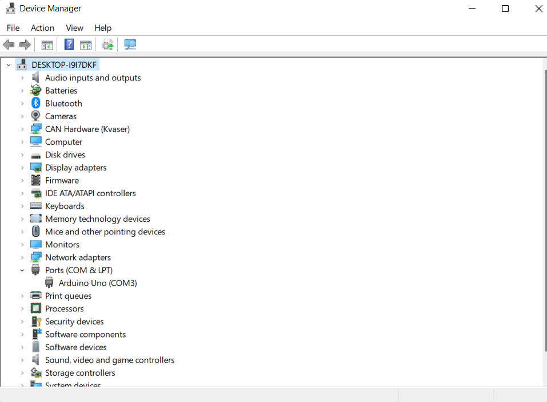

Open device manager on your computer and you should see the your hardware port highlighted under ports. If its not highlighted, then you must confirm if your usb is well connected with the computer and the hardware and also confirm if you installed the correct and latest drive

2 How to select your target

1 Open flowcode



2 Select new project

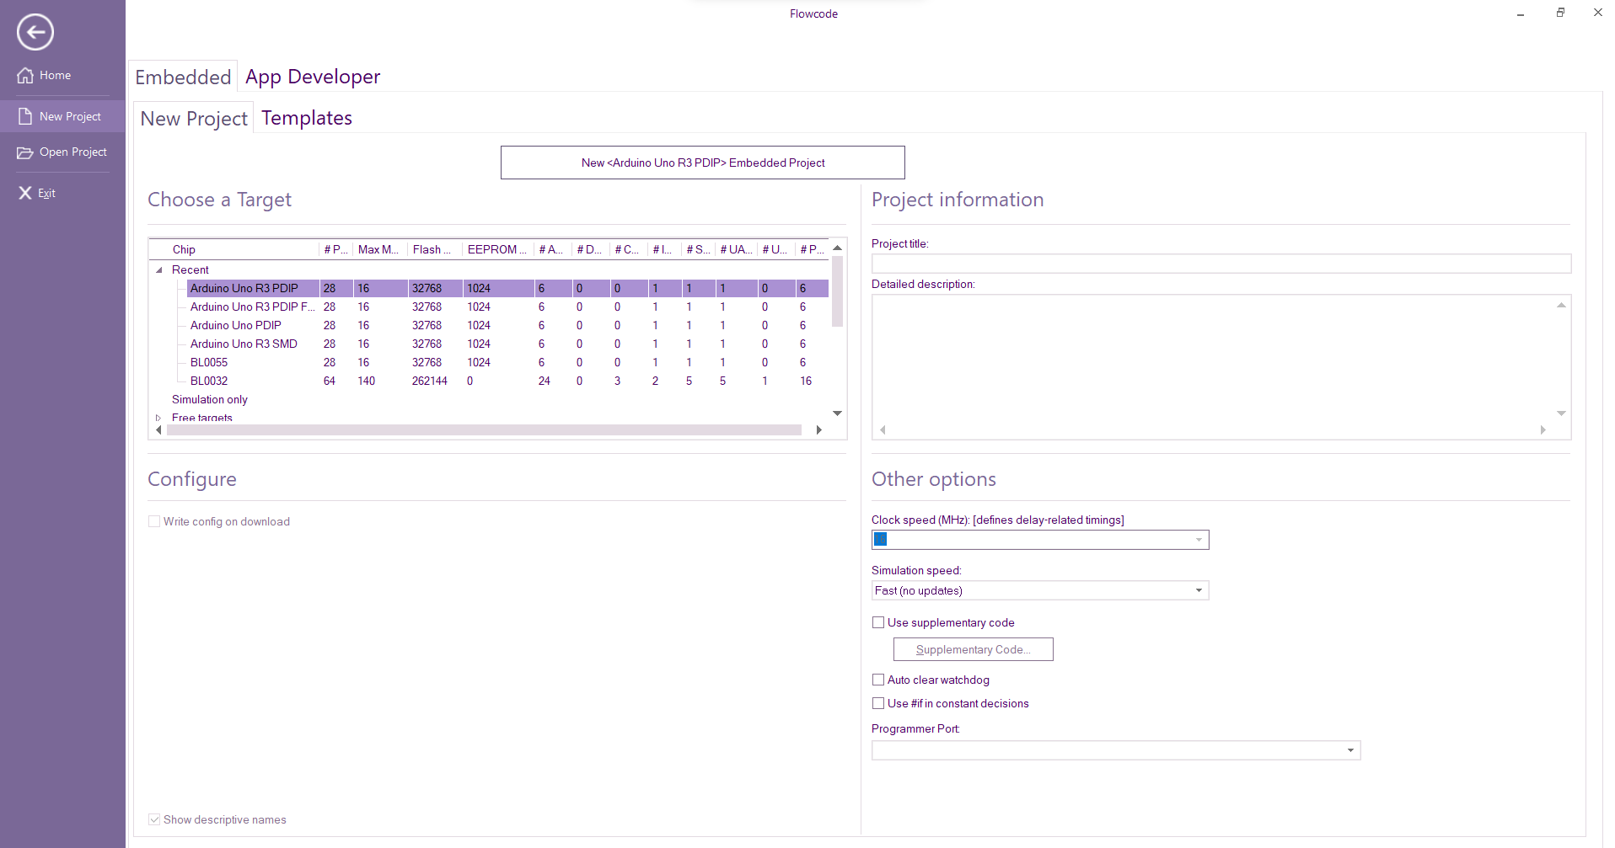

* Under choose target, select your hardware type
* Click on embedded project
* Set your clock speed to 16
* Select your hardware port under programmer port

3 Click on modify

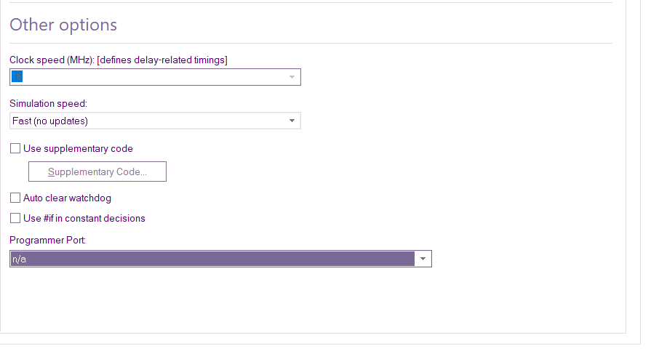

NOTE: Hardware target name differs on flowcode versions. So make sure you research the name of your hardware on the version of flowcode you are using. The research can be made on different online forums

3 How to interface

After step 1 and 2, and assuming you are through with your flowchart programming and want to interface it to your hardware or target

1 Go to build



2 select project option, under programmer port, select your hardware port and modify

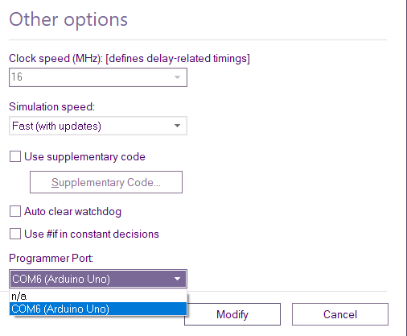

3 Select compile to target

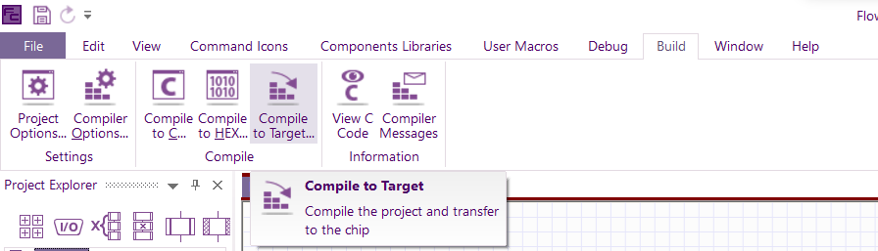

4 Compiling successful

4 HOW TO SIMULATE AND TAKE READINGS

After step 1 and 2, and assuming you are through with your flowchart programming and also selected your components hardware you are using for the program and want to simulate ;

1 Go to debug

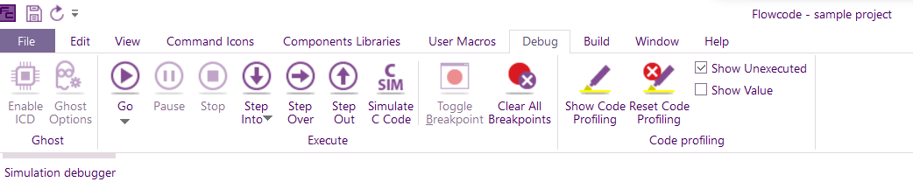

2 Select Go to start simulation

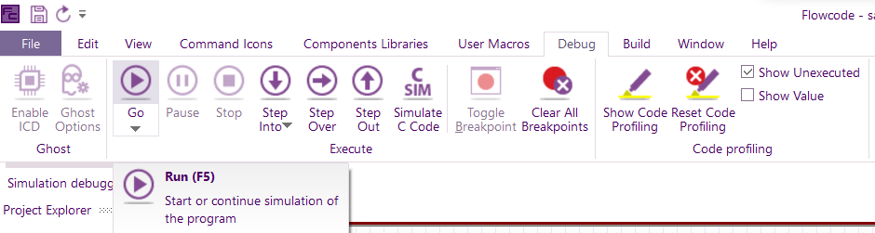

3 To take readings

* After you start your simulation, this page will pop out

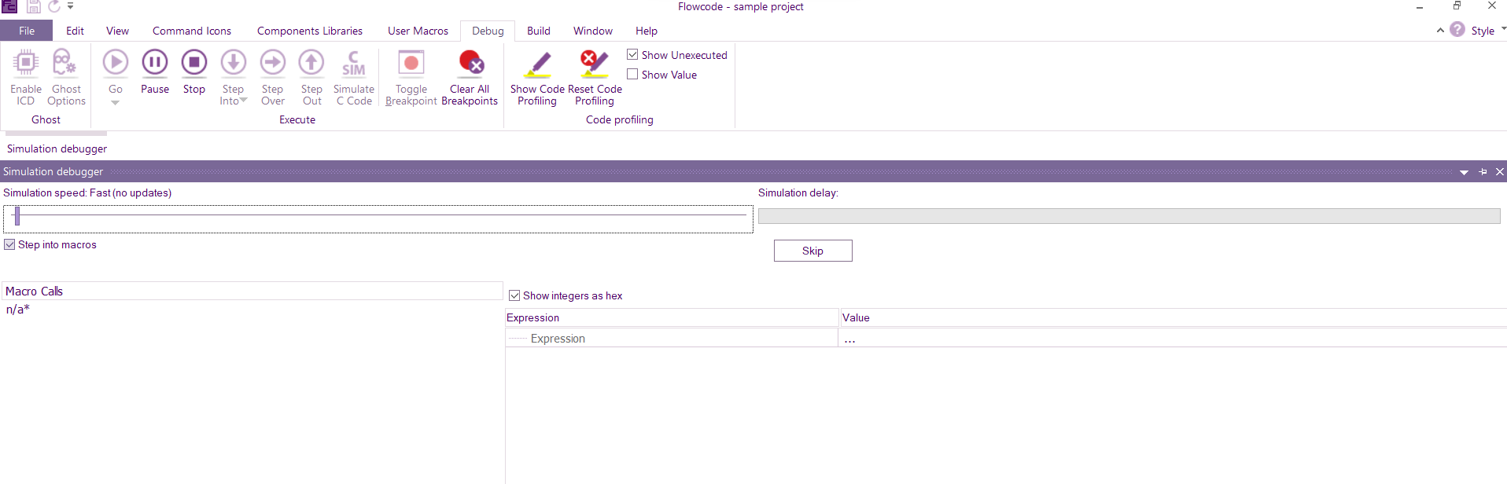

* Click on pause so as to be able to declare the variable you want to read

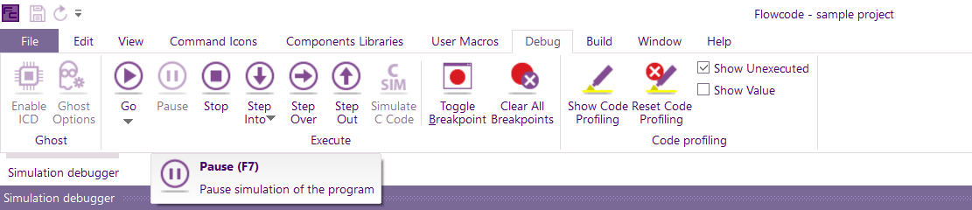

* Next is to click on Expression and add the variable you want to take the reading

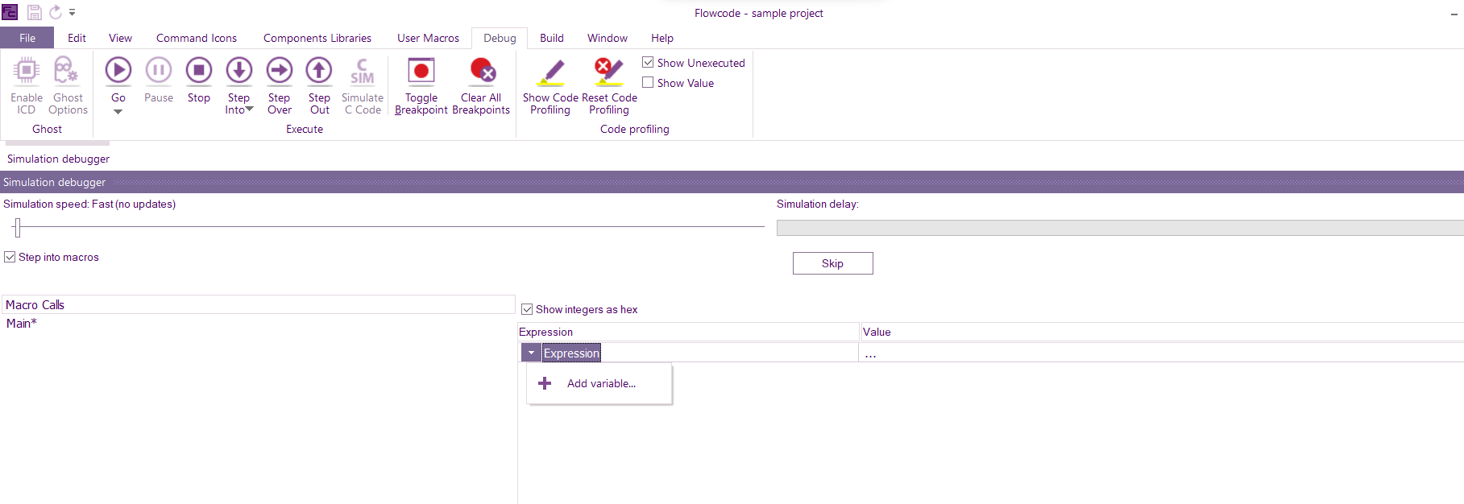

* Here is a variable, POT selected for illustration

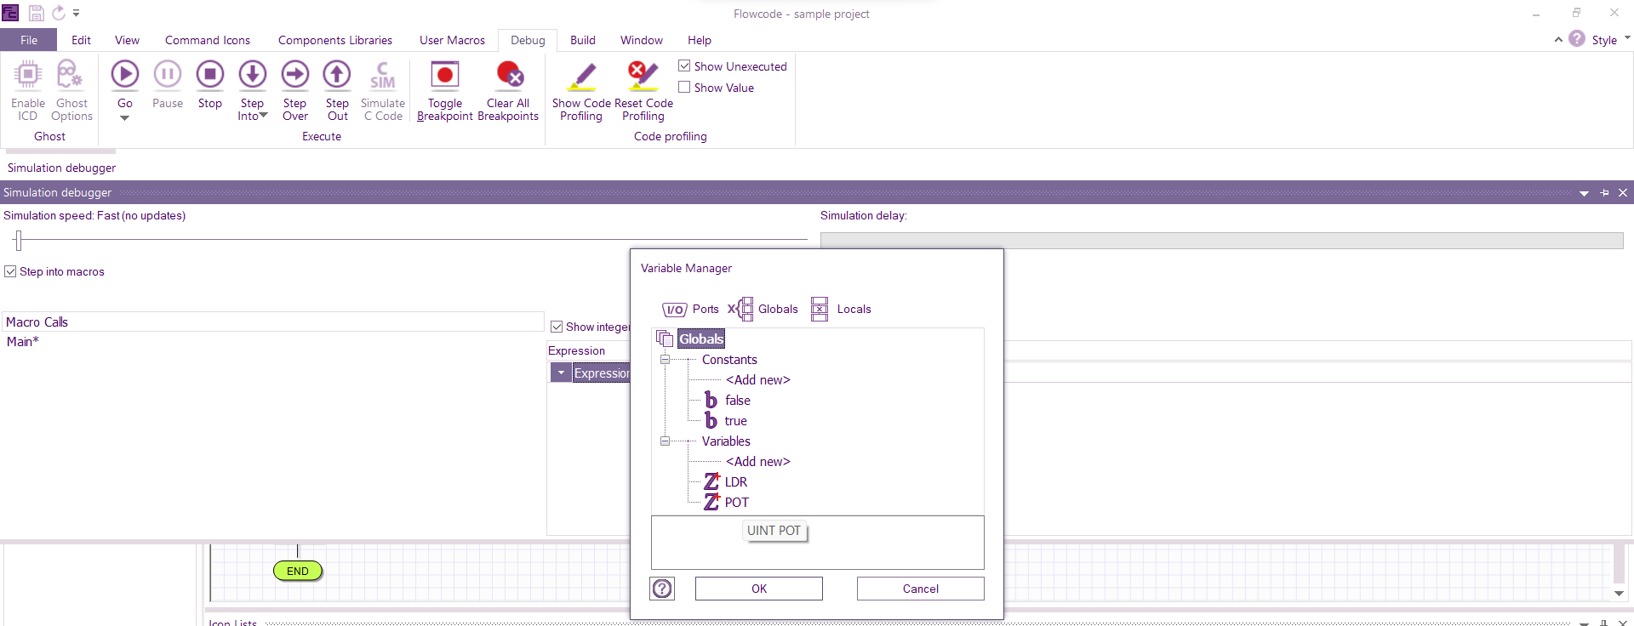

* To see the reading taken when the potentiometer is tuned on, pause the simulation and you will see the value which is 0x13a in HEX file and that is equivalent to 314 decimal number as seen on the Liquid Crystal Display (LCD) on the combo board

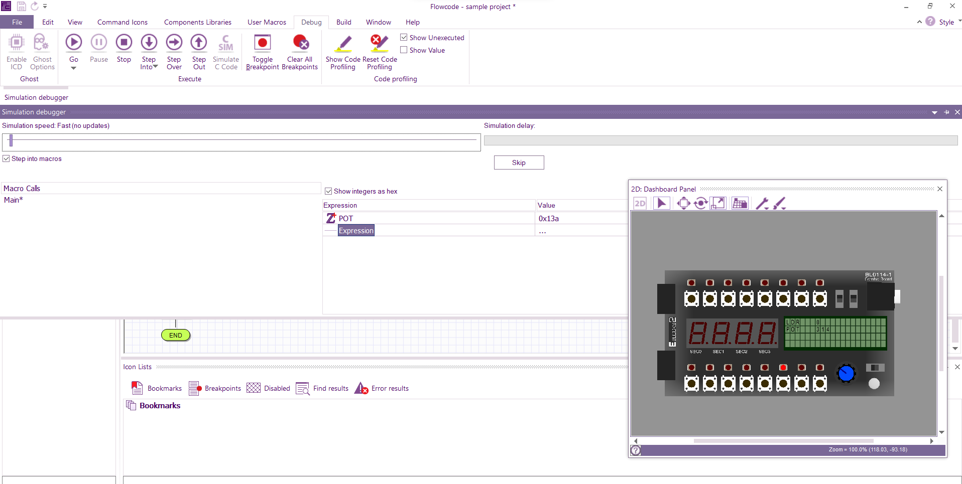

4 Select Stop to end simulation

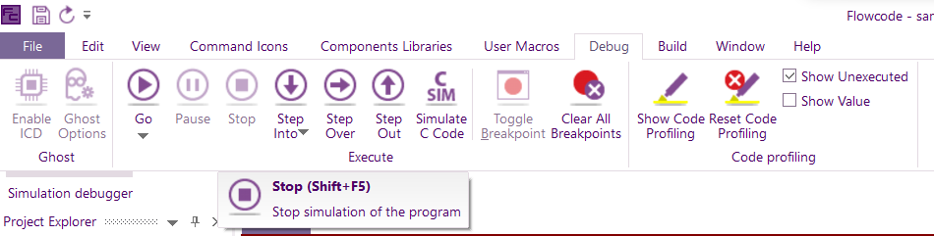

5 How to select hardware component

After selecting our target, we have to choose the component hardware(s) that we will be using for our project either as input or output or communication in some cases. This is where you will get to select the component you want under respective category.

* Select component libraries

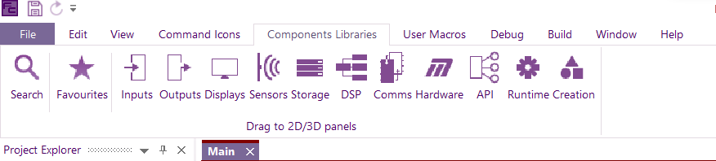

* Components under input and output can be used with different types of target while we use hardware component libraries with E-block target as the downstream boards.

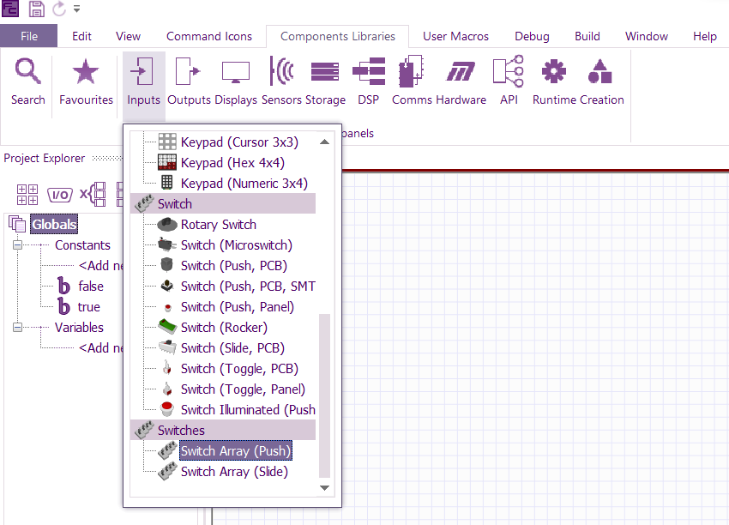 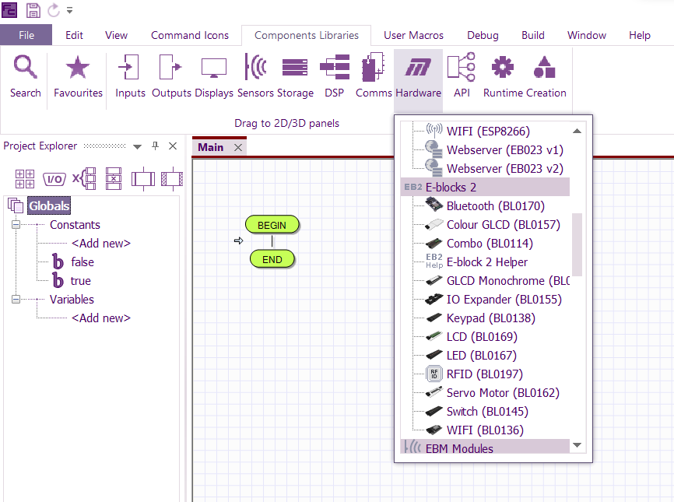

* You select your component by double-clicking on it and then the 2D dashboard panel pops up

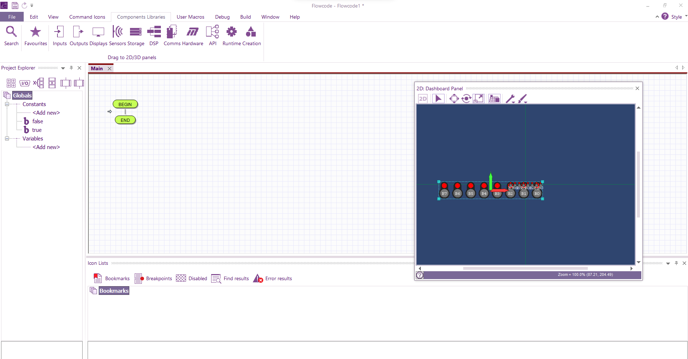

* Incase you want to view the 2D dashboard panel. Go to View and select 2D Dashboard panel

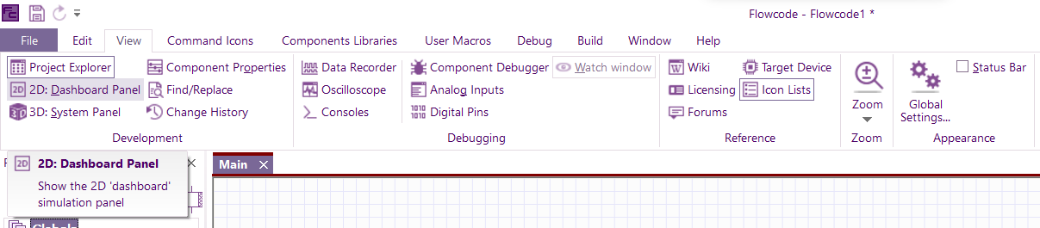

8 How to open and use component properties

* Go to view and select component properties

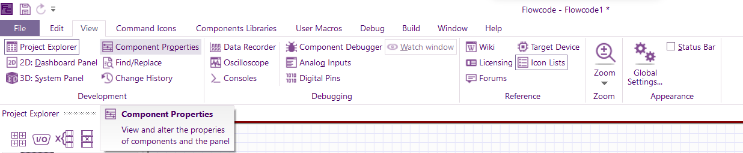

* The properties page will pop up

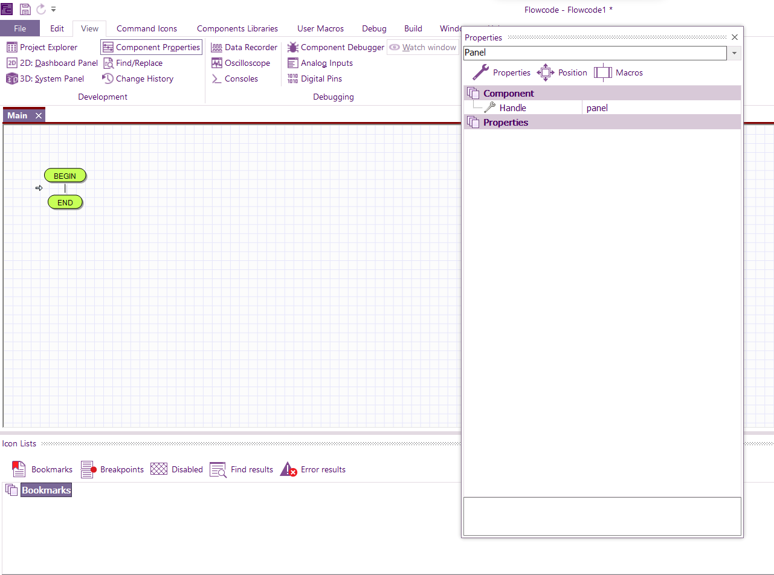

* To select your component properties. Select the arrow to open the folder

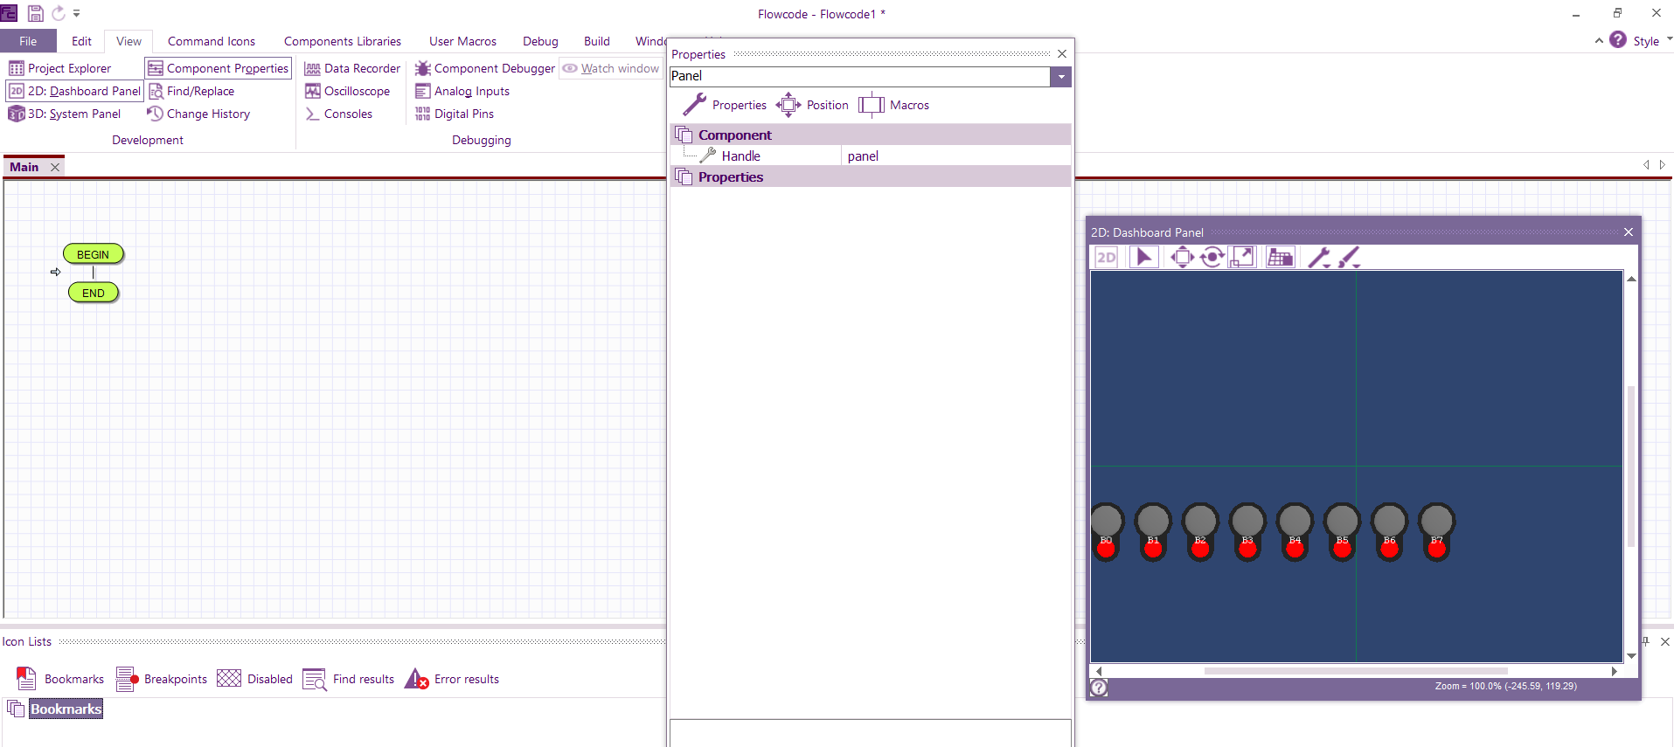

* The components selected will highlighted here like the switch array we selected earlier on to demonstrate how to use the component library

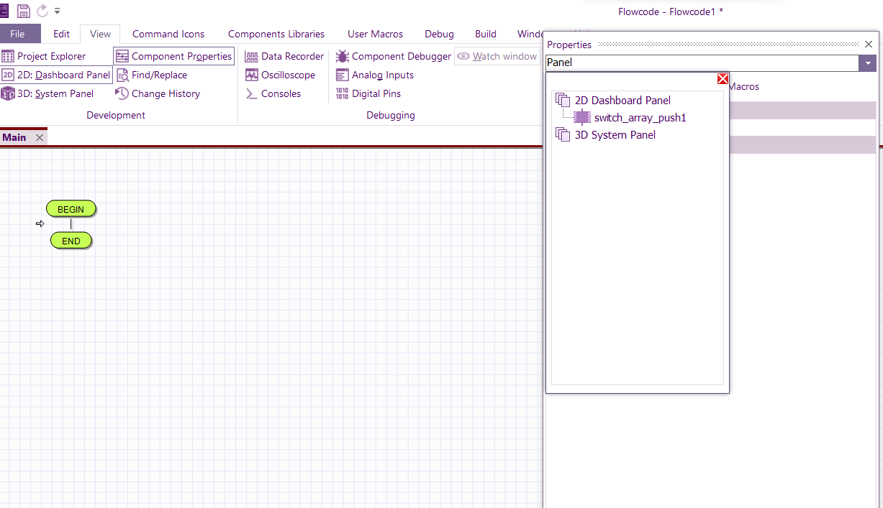

9 How to make the connection and configuration of component properties

* After opening component libraries, select your component

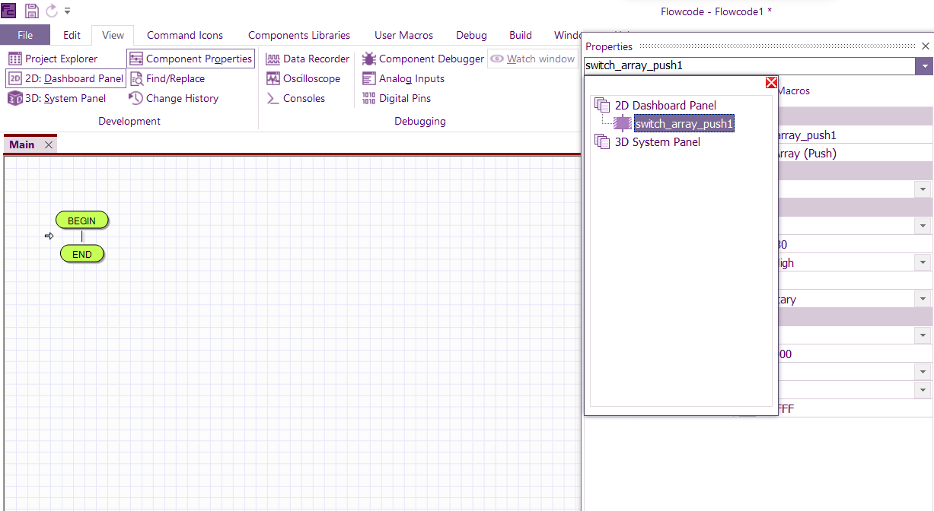

* The component properties will be displayed as seen below. 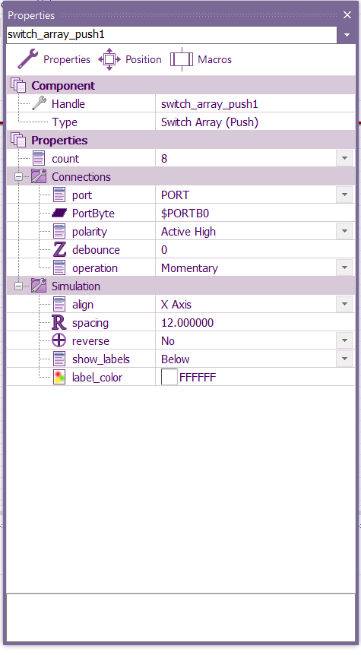
* From here you can configure the properties to suit your project. Like the ports connection for the switch array, you can either use port or custom pins. You can choose a single port for all pins or custom pins to assign each pin individually.

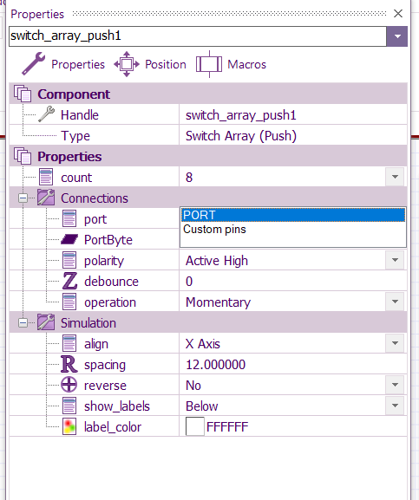

Also under macros, you will see the list of predefined functions called macros. Here are the list of macros for this switch array

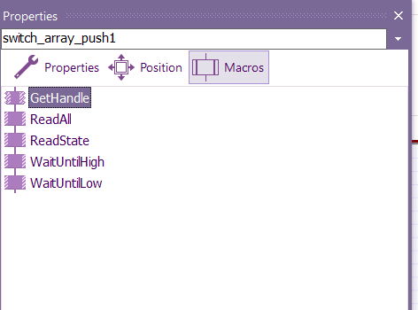

10 How to open and use project explorer

* Under view, select project explorer

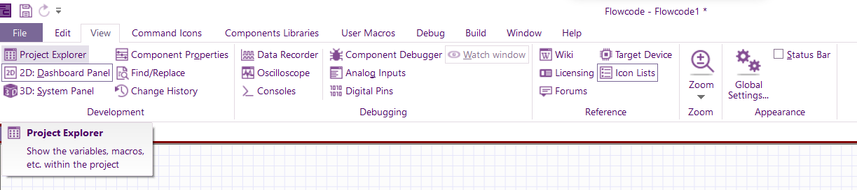

* And this will pop up beside the flowchart space

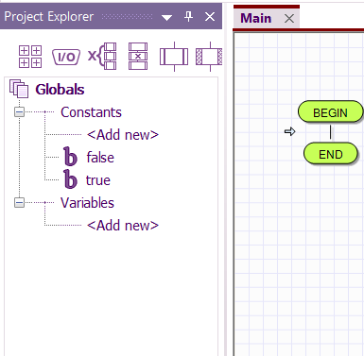

NOTE : You can do so many things under the project explorer

1 open the command icons which you can drag into your flowchart

2 select the ports and pins

3 declare your global variables and constants

4 declare your main variables and constants

5 Macros

6 Component macros that can be dragged into the flowchart

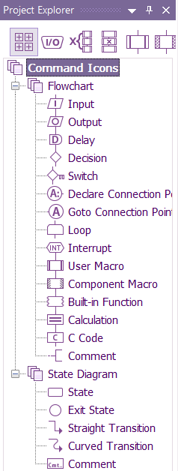 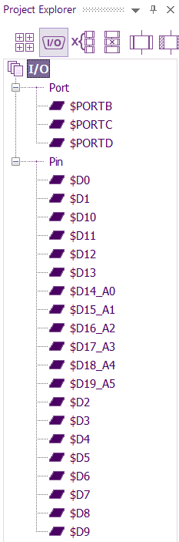 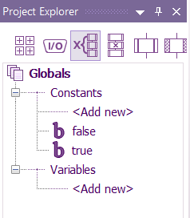 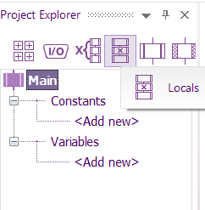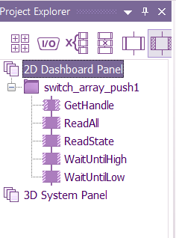

11. **Flowcode compatibility with Computer Aided Design software(solidworks)**

Using fan cooler assembly for illustration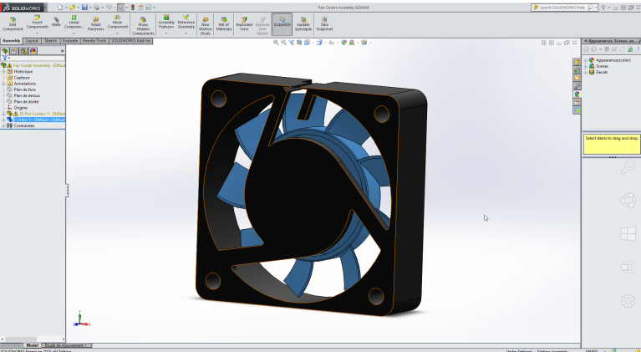

Flowcode supports STEP, IGES, OBJ and STL file formats, however, STL files do not work as assemblies. Save your model in any of the appropriate file formats and remember the saved location

1. Save your project

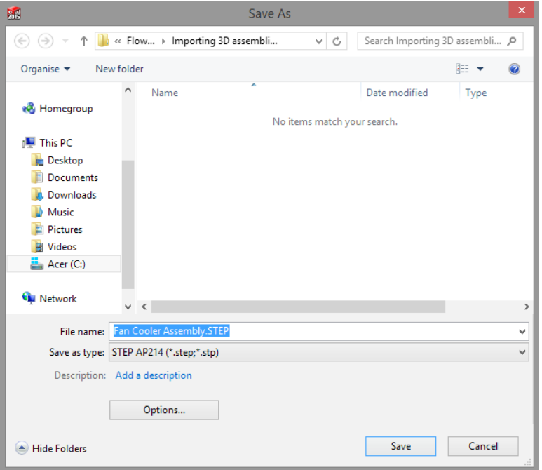

1. After you save your design, open flowcode🡪 Go to file where you will see import 3D, select that

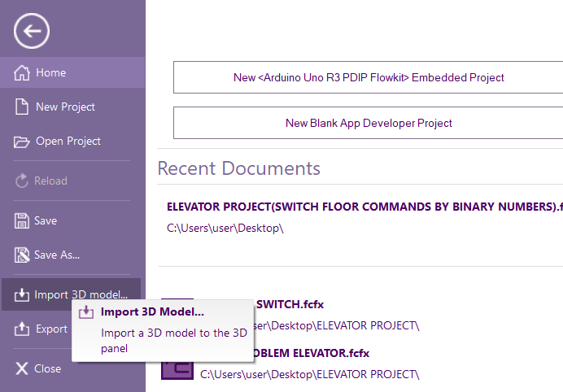

3.1.1 Flowcode keywords And Functions

3.1.2 How to use the keywords/parameters in our Program using the Flowchart Analysis Table



|  |  |  |  |
| --- | --- | --- | --- |
| COMPONENT 3 | COMPONENT 2 | COMPONENT 1 |  |
| NAME FL n  EXP/VAR  RETURN VAL. | NAME FL n  EXP/VAR  RETURN VAL. | NAME FL n  EXP/VAR  RETURN VAL. | INPUT  (variable, macros) |
| NAME FL n  EXP/VAR  RETURN VAL. | NAME FL n  EXP/VAR  RETURN VAL. | NAME FL n  EXP/VAR  RETURN VAL. | OUTPUT  (variable, macros) |
| NAME FL n  EXP/VAR  RETURN VAL. | NAME FL n  EXP/VAR  RETURN VAL. | NAME FL n  EXP/VAR  RETURN VAL. | COMMAND ICONS |
| NAME FL n  EXP/VAR  RETURN VAL. | NAME FL n  EXP/VAR  RETURN VAL. | NAME FL n  EXP/VAR  RETURN VAL. |
| NAME FL n  EXP/VAR  RETURN VAL. | NAME FL n  EXP/VAR  RETURN VAL. | NAME FL n  EXP/VAR  RETURN VAL. |
| NAME FL n  EXP/VAR  RETURN VAL. | NAME FL n  EXP/VAR  RETURN VAL. | NAME FL n  EXP/VAR  RETURN VAL. | COMONENT MACROS |
| NAME FL n  EXP/VAR  RETURN VAL. | NAME FL n  EXP/VAR  RETURN VAL. | NAME FL n  EXP/VAR  RETURN VAL. |
| NAME FL n  EXP/VAR  RETURN VAL. | NAME FL n  EXP/VAR  RETURN VAL. | NAME FL n  EXP/VAR  RETURN VAL. |

**How to use The Analysis Table**

1. Write your input and output(which might be variable or macros) in the input and output cells
2. List the flow of the macros under each respective component with arrow↓ to indicate the movement of the flowchart AND || to indicate the flow under LOOP and ||| to indicate the flow inside the switch decision



1. Number the flow accordingly (in respect to the icons and macros usage) which will indicate the algorithm of the flowchart
2. Under each selected icons and macros, indicate the Expression and Return value

**IMPORTANCE OF THE ANALYSIS TABLE**

* This will be used to analyze how the flowchart will be like with their properties configuration, position number on the flowchart. This will be helpful in knowing how our flowchart will be even before programming and also in reading and breaking down programmed projects.
* Open the properties of the macros and command icons to configure their respective parameters and expressions in your flowchart on flowcode as the illustration on the analysis table will be used to explain that.
* It will also will be useful in our experiment exercises.

**NOTE:**

Configuration of the command icons and macros parameter(s) is where the LOGIC of programming of flowchart on flowcode and that comes with experience and practice.

EXAMPLES

Now that we’ve understood how to choose our target, component library, project explorer, component display, how to simulate and interface, we use examples to see how macros, variables and their configurations are being made and also with exercises

**SAMPLE PROJECT**

Task : Using the LCD as display board

The switch as doors

The LED as warning light

LCD will display the switch pressed on the LCD – DOOR OPEN: (these actions should be carried);

* When switch 1 is pressed, DOOR OPEN: FRONT LEFT DOOR – LED 1 ON
* When switch 1 is pressed, DOOR OPEN: FRONT RIGHT DOOR – LED 2 ON
* When switch 3 is pressed, DOOR OPEN: REAR RIGHT DOOR – LED 3 ON
* When switch 4 is pressed, DOOR OPEN: REAR LEFT DOOR – LED 4 ON

And also, the corresponding LED will turn ON.

The LED will be ON for 10 seconds(time the door will automatically close itself) then the LCD should display nothing.

Analysis:

* After selecting your embedded target, your downstream hardware components (for simulation and mostly for connection configuration) and selecting your hardware port for interfacing on flowcode as we have discussed earlier. (**Reference: chapter 3.1**), we go into the flowchart
* Number of bits that will be used in the switch- 1,2,4,8 (binary numbering sequence).
* Let’s decide to use LED macro- LEDon as our output
* Since the switch serve as the input, that makes use of the binary number system which is understood by the computer (**REFERENCE: CHAPTER 1 under microcontroller**) i.e it uses the power of 2 sequence(numbering)
* Note that any input going into the controller for example from this switch above, will be programmed with binary numbering where as you can use natural numbers as your output if you use the component macro but if you use it directly in your output icon, you use binary numbers as that it is the language the computer understands.
* Macros are functions that uses integers, so whenever you use macros as either your input or output, you use integer values in their expression.
* And the LED will use decimal(integer) numbering. Using the binary sequence here will only work on the basis of the combination distribution under each bit of the resolution for example of 32 in 8-bits binary, it will have the combination of 0010 0000 which means only LED 5 will turn ON if it is referenced in the first bit of the switch decision command icon. So instead, we use the natural numbering in this scenario.

Analysis table :

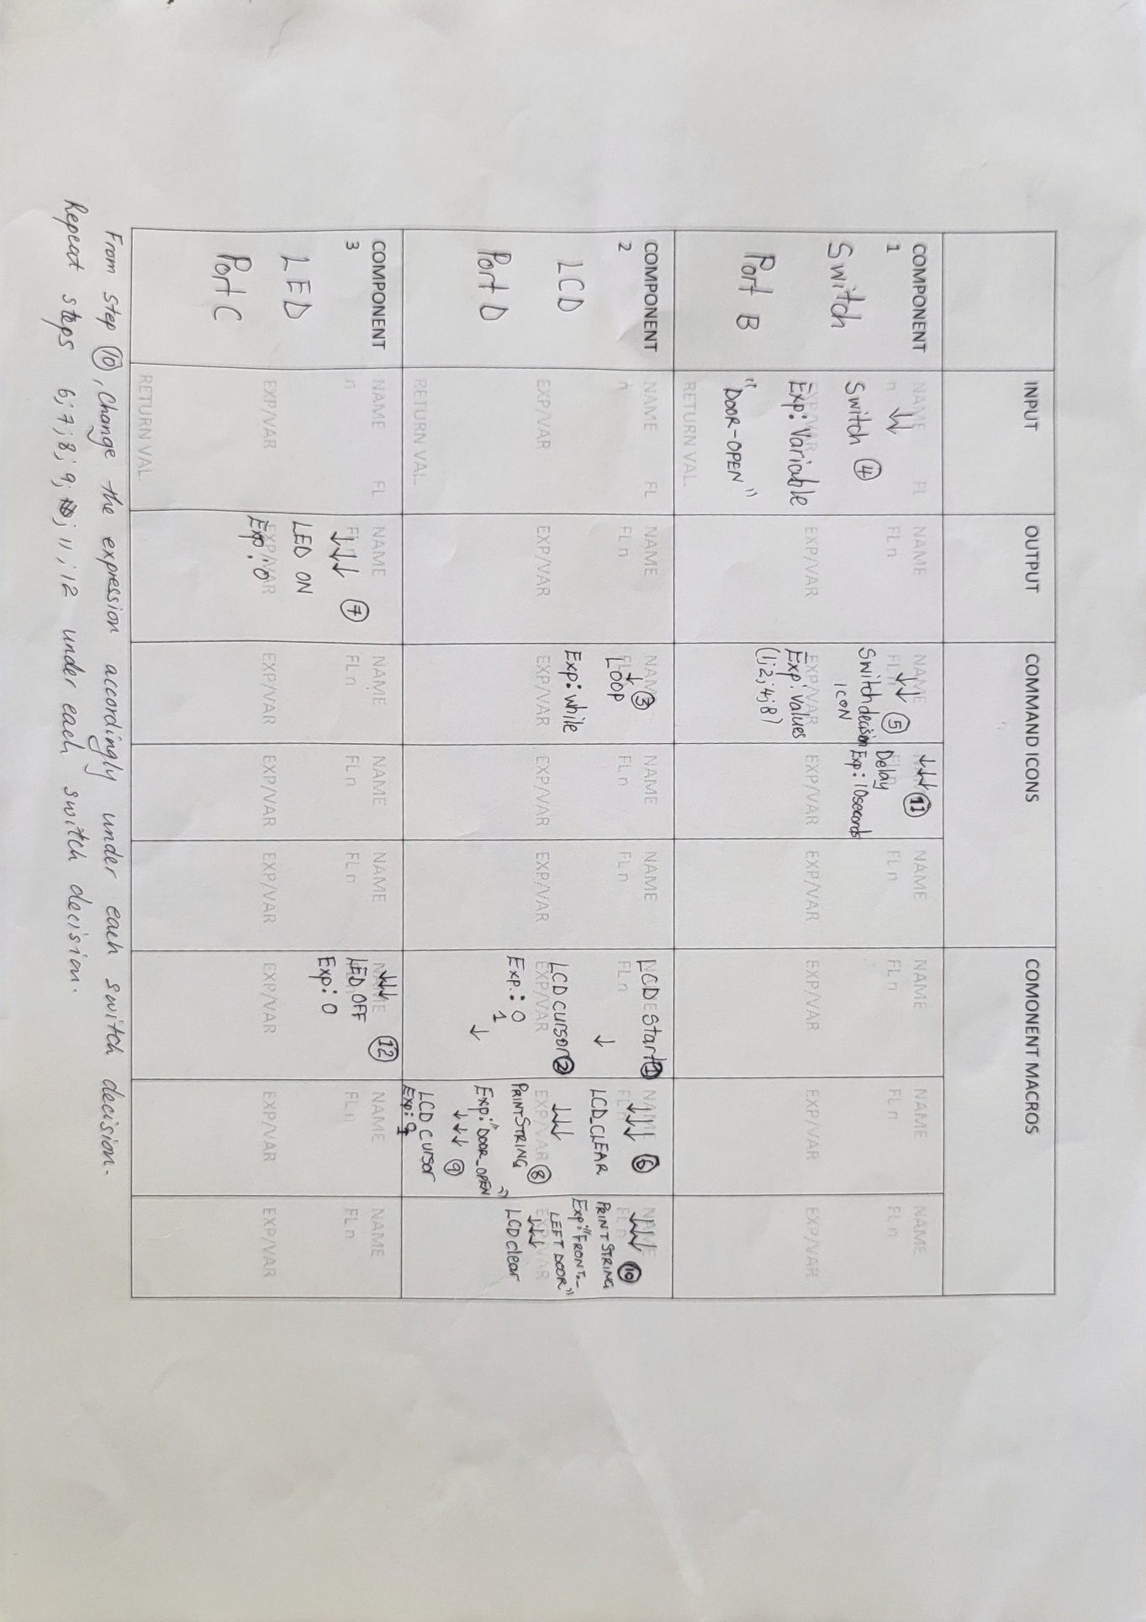

3.1.3 **Troubleshooting Exercise**

From the running program, some changes has been made.[state the changes]. The aim is to select the wrong ports and changes in the expression of the command icons so as to see how it will affect the setup. Assuming all things are being equal ,the embedded board is correct and also the physical connection.

TASKS

* Upload the xoxo-changed file
* Load the program to verify the changes compared to the real time picture provided in the exercise and make the correction
* Interface the program to the boards
* Report

Note: Use the analysis table and the real time picture provided in the example analysis and result for reference when carrying out this exercise.

3.2 CAN training on Flowcode [13]

3.2.1 MAJOR PARAMETERS DEFINITIONS & NOTES

**CAN Properties Parameters Definition Table to look into the meaning and for better understanding of the parameters in the CAN properties.**

**GENERAL SETTINGS**

|  |  |  |  |  |  |  |  |
| --- | --- | --- | --- | --- | --- | --- | --- |
| Component | | Definition | | | | | Expresssion/ Note |
| Handle |  | | | | | |  |
| Type |  | | | | | |  |
| PROPERTIES | | | | | | | |
|  | | | DEFFINITON | | | EXPRESSION/NOTE | |
| CHANNEL.CANEXT.OSC | | |  | | |  | |
| BUS RATE | | |  | | |  | |
| SJW | | |  | | |  | |
| SAMPLE | | |  | | |  | |
| EXID | | |  | | |  | |
| OSM | | |  | | |  | |
| CONNECTIONS | | | | | | | |
|  | | | | DEFINITION | EXPRESSION/ NOTE | | |
|  | | | |  |  | | |
|  | | | |  |  | | |
|  | | | |  |  | | |

CAN PROPERTIES

TX buffer : The 3 TX Buffer sections allow you to set the default details for the three transmit buffers (TX Buffer 0 to TX Buffer 2) used in the CAN component. Unless modified in the program by macros, these default settings will be the Message ID values and data (D0 to D7) values sent

|  |  |  |  |  |
| --- | --- | --- | --- | --- |
| TX BUFFER | | DEFINITION | | EXPRESSION / NOTE |
| TX BO ID | |  | |  |
| TX BO LEN | |  | |  |
| TX B0- B7 | |  | |  |
| RX BUFFER  RX buffer: The 2 RX Buffer sections allow you to set Masks and Filters to process and select Message IDs to be received (more on this later). As well as the ability to configure the Settings of each buffer individually. | | | | |
|  | | DEFINITION | | EXPRESSION / NOTE |
| ACCEPT ALL | |  | |  |
| REJECT ALL | |  | |  |
| MASK & FILTER | |  | |  |
| MASK & FILTER | | | | |
| RX BUFFER | DEFINITON | | EXPRESSION / NOTE | |
| RXBICFG |  | |  | |
| RXM0 - X |  | |  | |
| RXF0 - X |  | |  | |
| FILTER 0 - X |  | |  | |

3.2.2 How to setup the CAN properties using the CAN component tables

|  |  |  |  |  |  |  |  |  |  |  |  |  |  |  |  |  |  |  |  |  |  |  |  |  |  |  |  |  |  |  |  |
| --- | --- | --- | --- | --- | --- | --- | --- | --- | --- | --- | --- | --- | --- | --- | --- | --- | --- | --- | --- | --- | --- | --- | --- | --- | --- | --- | --- | --- | --- | --- | --- |
| BUFFER 1  { } | | | BUFFER 0  { } | | | MASK & FILTER | | MASK & FILTER | MASK & FILTER | | REJECT ALL | | ACCEPT ALL | | | RX BUFFER | RX BUFFER | | TX Buffer 2 { } | | | TX Buffer 1 { } | | | TX Buffer 0 { } | | TX BUFFER | | | F  CAN COMPONENT PROPERTIES (SENDER { } / RECEIVER { } )  J | |
|  | | |  | | | RXBICFG | | { } | | { } | | { } | | | BUFFER 0 |  | | |  | | |  | | Tx B0 ID | | |
|  | | |  | | | RXM 1 | |  | | |  | | |  | | Tx B0 LEN | | |
|  | | |  | | | RXF 2 | |  | | |  | | |  | | TX B0 | | |
|  | | |  | | | FILTER 2 | |  | | |  | | |  | | TX B1 | | |
|  | | |  | | |  | | TX B2 | | |
|  | | |  | | | RXF3 | |  | | |  | | |  | | TX B3 | | |
| { } | | { } | | { } | | | BUFFER 1 |
|  | | |  | | | FILTER 3 | |
|  | | |  | | |  | | TX B4 | | |
|  | | |  | | | RXF4 | |
|  | | |  | | | FILTER 4 | |  | | |  | | |  | | TX B5 | | |
|  | | |  | | | RXF5 | |
|  | | |  | | |  | | TX B6 | | |
|  | | |  | | | FILTER 5 | |  | | |  | | |  | | TX B7 | | |
| CONFIG- DELAY | DATA BIT READ SAMPLE POINT | | PRESCALE OPTION SELECTOR | CHP SELECT/ SLAVE SELECT PIN | | SPI CLOCK PIN CLK | SPI DATA OUT PIN SDI | | SPI CHENNEL SELECTOR(also master out slave when used in master mode) | | SPI CHANNEL SELECTOR | CONNECTIONS (SPI) | | OSM | | EXID | SAMPLE | | | SJW | | BUS.RATE | EXT.OSC | | CHANNEL.CAN | PROPERTIES | | TYPE | | HANDLE | GENERAL SETTINGS  COMPONENTS | |
| YES { } | MIDDLE { } | | Fosc/2 { } | PORT { } | | PORT { } | PORT { } | | PORT { } | | CHANNEL 1 { } | ENABLED { } | | STANDARD ONLY { } | 50% { } | | | 1 { } | | 125 { } | 20MHz { } | | EXTERNAL { } |  | |  |
| FOSC/4 { } |
| 60% { } | | | 2 { } | | 250 { } |
| /8 { } |
| /16 { } |
| NO { } | END { } | | /32 { } | PIN { } | | PIN { } | PIN { } | | PIN { } | | SOFTWARE { } | DISABLED { } | | STANDARD & EXTENDED { } | 70 % { } | | | 3 { } | | 500 { } | 8 MHz { } | | NO CAN DEVICE { } |
| /64{} |
| /128 { } |
| 80% { } | | | 4 { } | | 1000 { } |
| /256 { } |

How to use the CAN properties configuration

* Fill in the empty space and mark the boxes

3.3 PROJECT EXAMPLE 2(BRAKE SYSTEM DEMO)

Example to explain how to configure the CAN component properties in a project where node 1 which is the switch node serve as the brake and node2 which is the LED node, serve as the receiver. When the switched is pressed, the LED will turn ON

PHYSICAL CONNECTION ANALYSIS

3.3.1 PROJECT ANAYSIS

* To achieve this objective, we need to consider various parameters, including the TX buffer, TX B0 ID, TX B0 LEN, TX B0-B7, RX buffer, mask, filter, and CAN message.
* For node 1 (the switch), we need to configure the TX buffer to transmit the brake signal. We also need to set the TX B0 ID to identify the message and set the TX B0 LEN to indicate the length of the message. Additionally, we need to configure the RX buffer to receive messages from the LED node and set the mask and filter to ensure only relevant messages are received.
* For node 2 (the LED), we need to configure the RX buffer to receive the brake signal from the switch node. We also need to set the TX B0 ID and TX B0 LEN to send a confirmation message back to node 1 indicating that the brake signal has been received.
* To ensure accurate and reliable data transmission and reception, we need to implement buffer management and error handling. This includes monitoring the buffer status and clearing any errors that may occur during transmission or reception.
* Overall, the plan for configuring the CAN component properties on Flowcode for node 1 and node 2 involves a step-by-step approach to ensure all necessary parameters are properly configured, buffer management and error handling are implemented, and accurate and reliable data transmission and reception is achieved between the two nodes.
* To set up the project with two nodes, one acting as a switch and the other as an LED, we will need to develop a flowchart that enables message transmission and reception, buffer management, and error handling.
* To set up the project with two nodes, one acting as a switch and the other as an LED, we will need to develop a flowchart that enables message transmission and reception, buffer management, and error handling. Once you have completed the flowchart, we can proceed to test the CAN communication between the two nodes.
* After selecting your embedded target, your downstream hardware component ( CAN component) and selecting our hardware port for interfacing on flowcode as we have discussed earlier. (**Reference: chapter 3.1**), we go into the properties configuration settings

Node 1 CAN property configuration settings

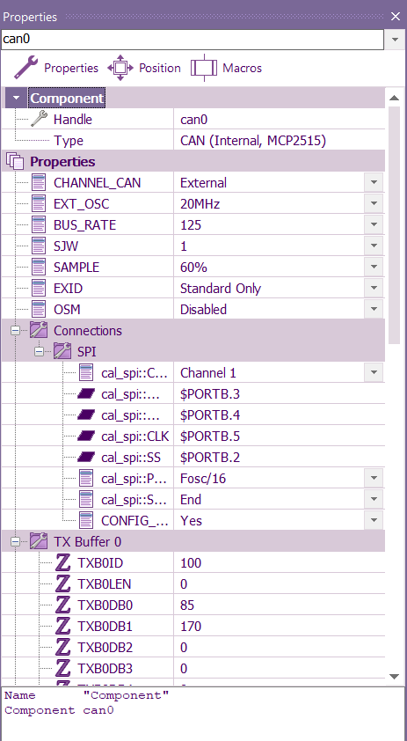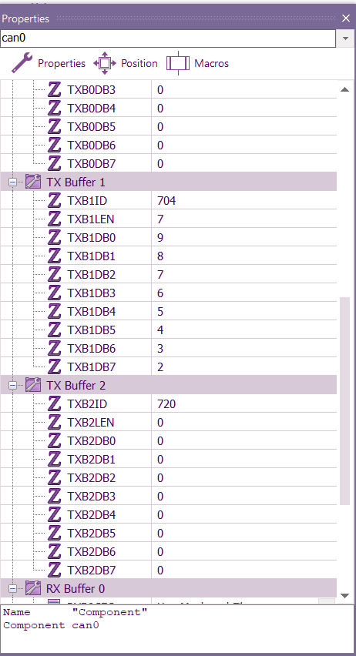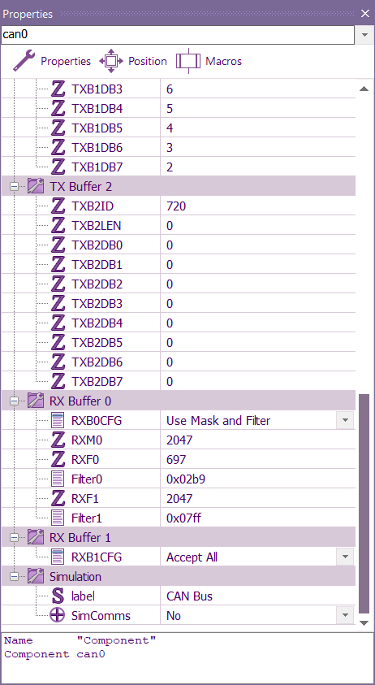

Node 2 CAN configuration settings

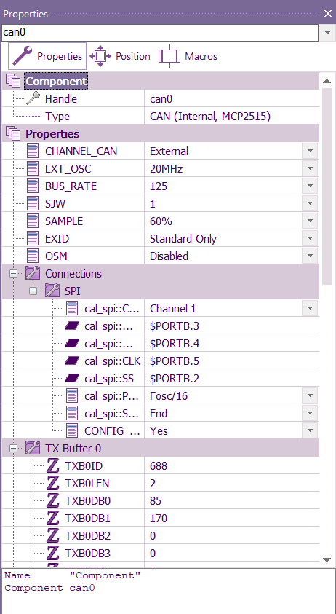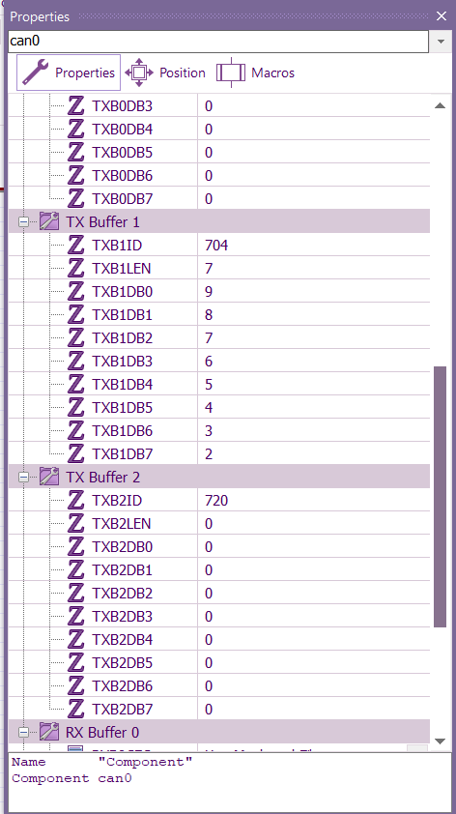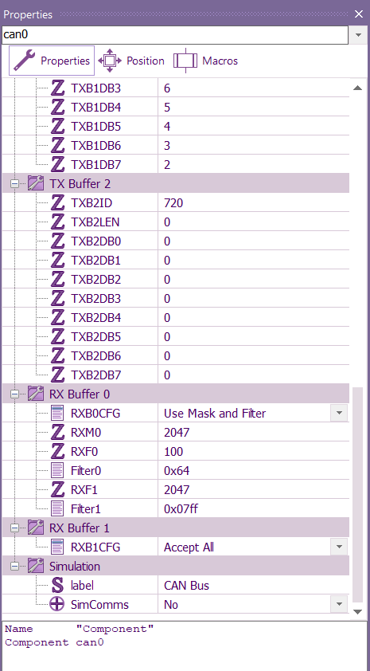

3.3.3 Flowchart Analysis

NODE 1 flowchart analysis

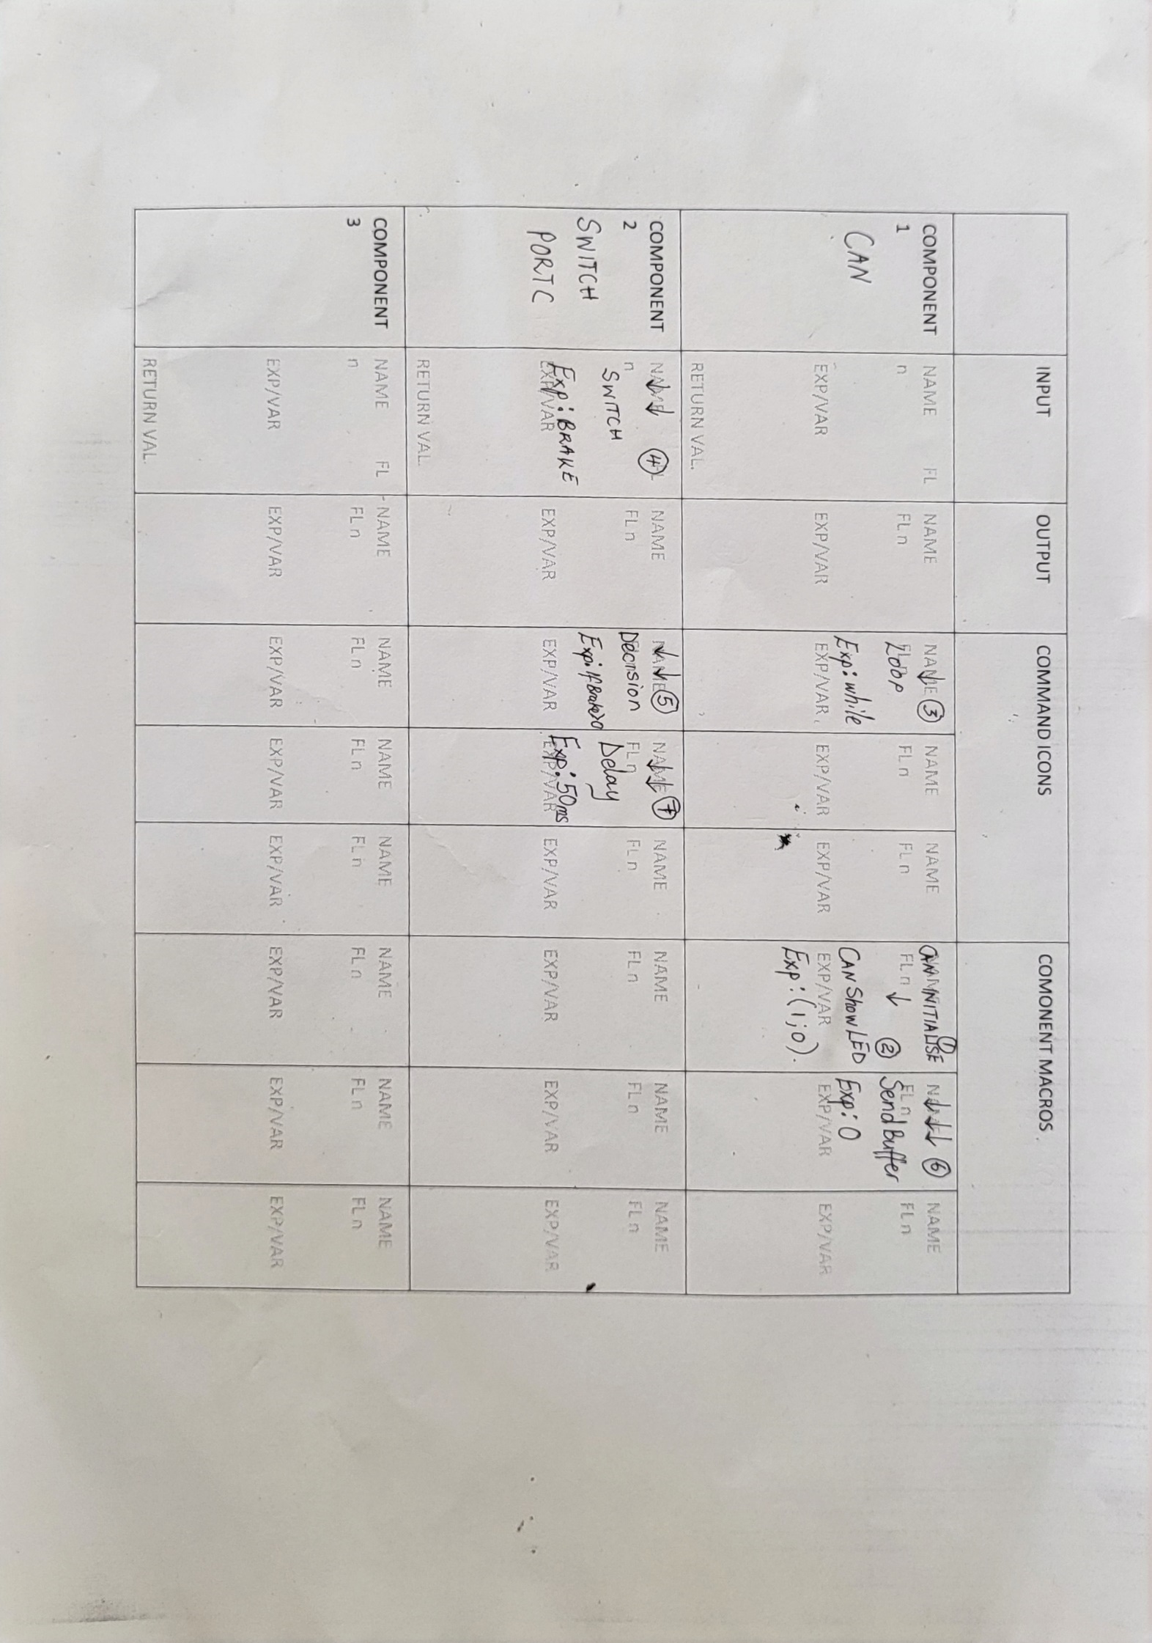

Analysis table

Real time picture

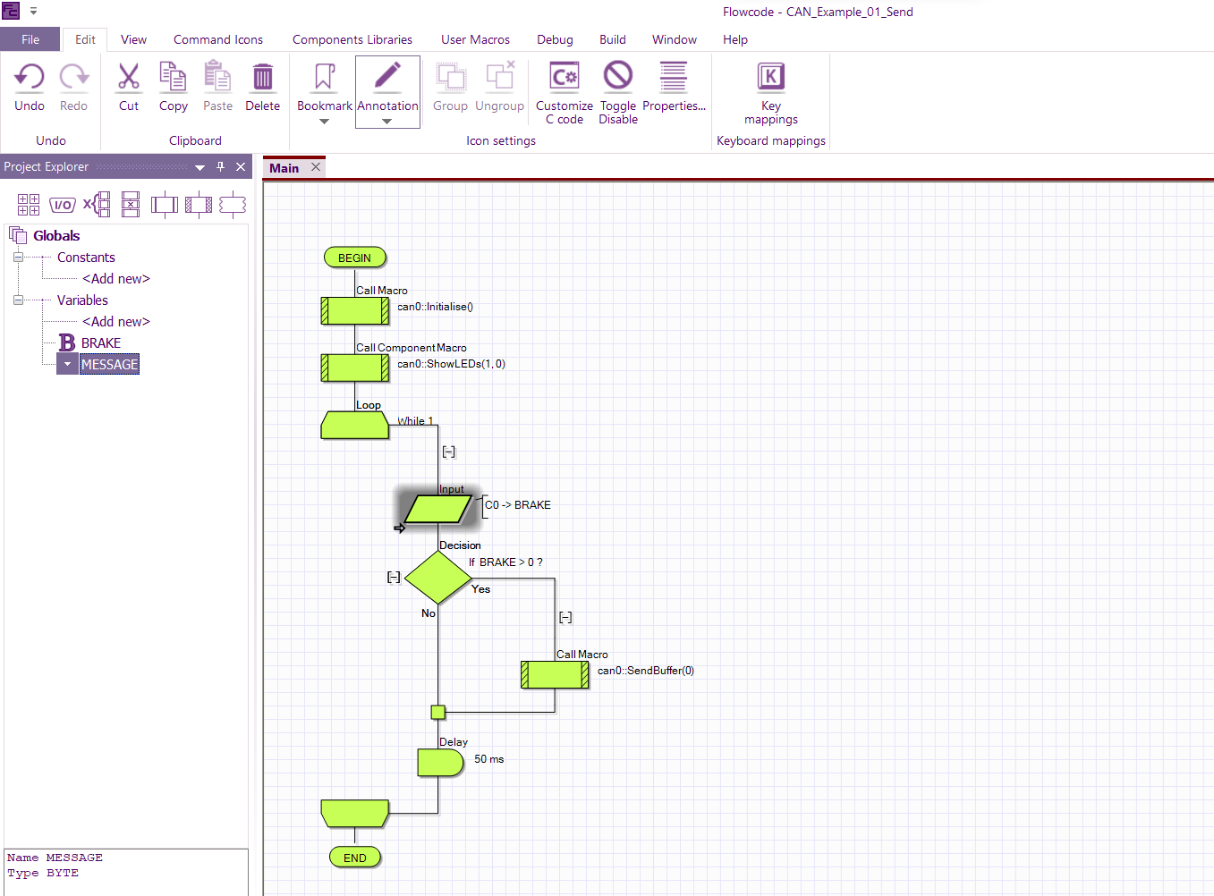

NODE 2 flowchart analysis

Analysis table

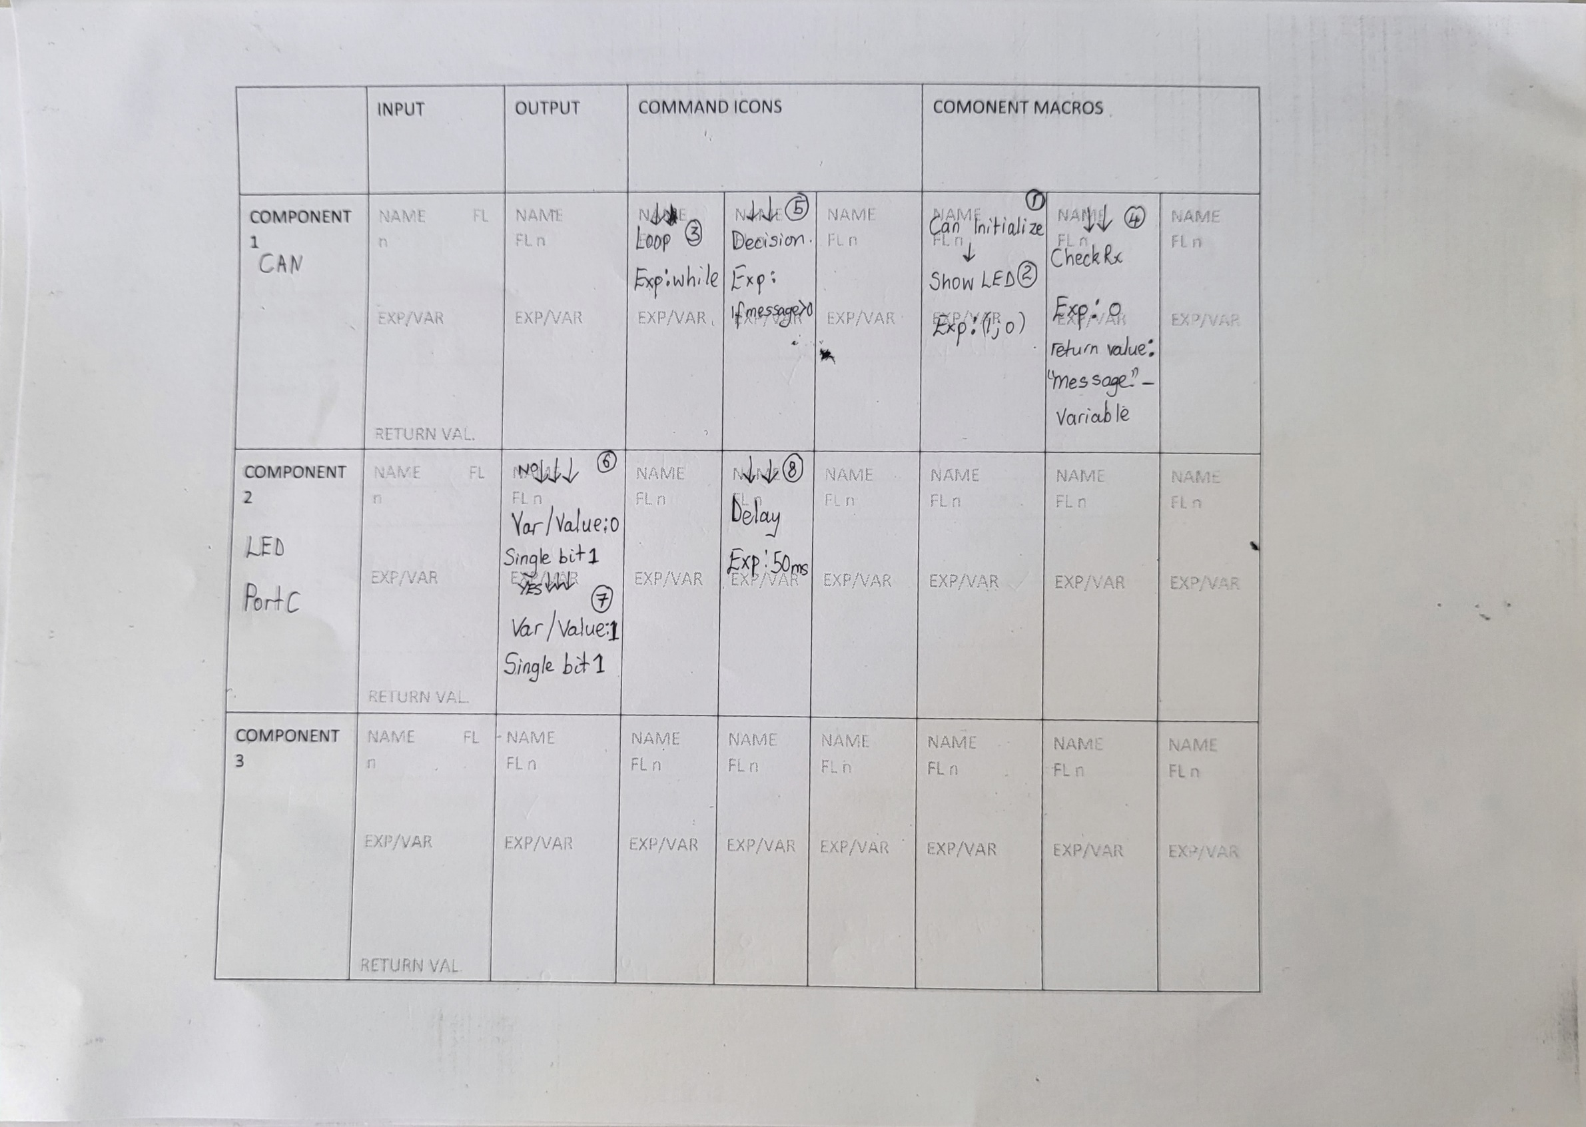

Real time picture

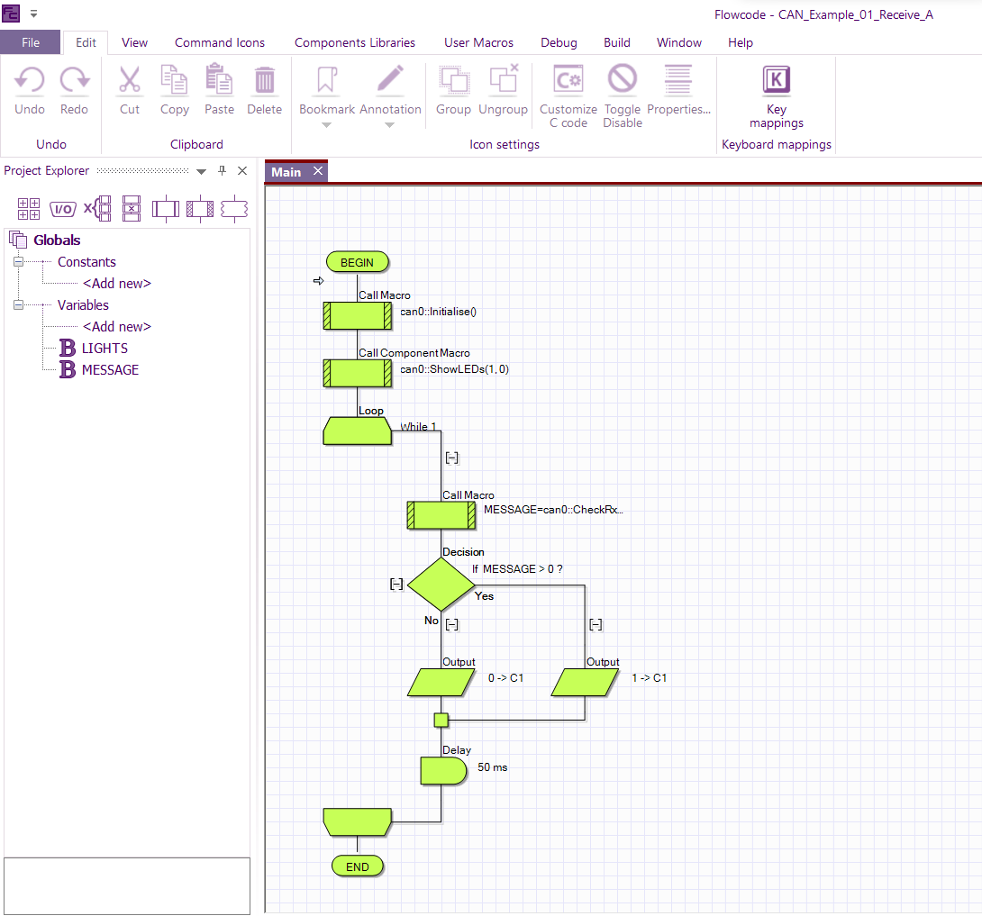

**3.3.4 Troubleshooting Exercise**

From the running program, some changes has been made.[state the changes]. The aim is to change the expressions of the CAN macros so as to see how it will affect the setup. Assuming all things are being equal ,the CAN properties settings are correct and also the physical connection.

TASKS

* Upload the xoxo-changed file
* Load the program to verify the changes compared to the real time picture provided in the exercise and make the correction
* Interface the program to the boards
* Report

Note: Use the analysis table and the real time picture provided in the example analysis and result for reference when carrying out this exercise

Project Sample 3 [13]

From sample 2, we’ve seen how to connect and program two CAN nodes together. Now in this project sample, we will see how to connect 4nodes together so as to perform some tasks.

Node 1= display node

Node 2 = switch node(brake)

Node 3 = LED node( brake light)

Node 4 = sensors node

ANALYSIS

* The scan works on a simple message/response system. The whole system is broken up into 4 separate units, called Nodes, which function independently. They are all however connected to the CAN bus, which allows them to listen for signals on the CAN bus and to send signals as well.
* The Control panel node - N1 - sends a sequence of messages with a pre-set ID number, to the other nodes in the system.
* The messages are not sent to a specific node. They are simply put on the CAN bus for all the nodes to listen for.
* The other nodes on the system are listening for messages. They have been set up to look at the ID of the message and only respond to one specific ID message. When a node spots a message it can respond to it sends a message of its own i.e. it responds to the initial message.
* The control node N1 node then waits for this response. If it does not get one in a set time it records the node as not present and moves on to the next item to check. If node N1 receives a message it then knows that that particular node is present on the system
* When using CAN component macro, expressions are mostly values and the return value will be the variable
* Basically, CAN bus uses the same principle as that of the sensors in the sense of returning the value to the variable
* From node 1;

1. It takes reading of the sensors, potentiometer and temperature and display their reading on the LCD
2. Node 1 will accept the message ID from node 4 in which the sensors are connected
3. TX buffer 1 will carry the MESSAGE variable which means RX buffer 1 will use mask and filter to receive the MESSAGE.
4. When you are taking the reading of a sensor, you set the parameters and return the value of the reading to the variable like POT, TEMP etc

* From node 2;

1. Serve as sending node for brake switch
2. Set(declare) the TX buffer in the properties and define the switch input numbers in the TΧdata component macro
3. Sendbuffer will be used to send the command to the next node(LED node)

* From node 3;

1. GetRX component macro serve as the input

* From node 4;

1. Sensors are defined and programmed in this node and declared in node 1

Node 1 configuration settings

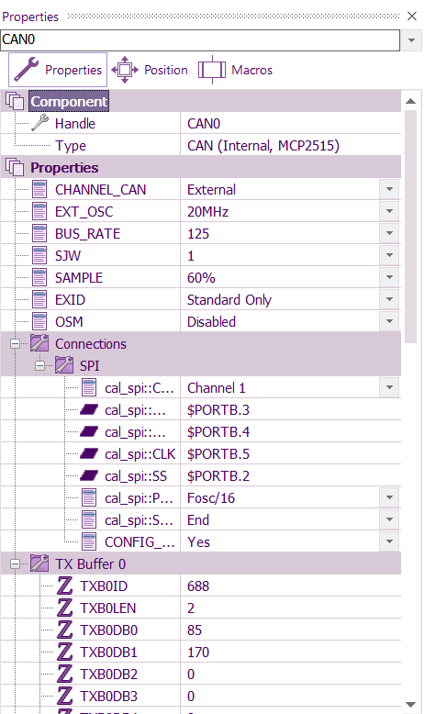 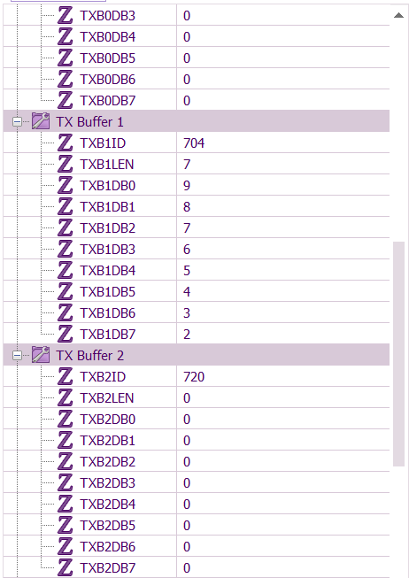 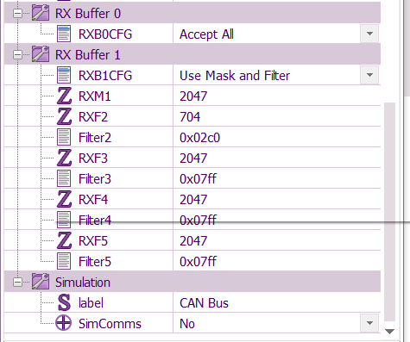

Node 1 Analysis table

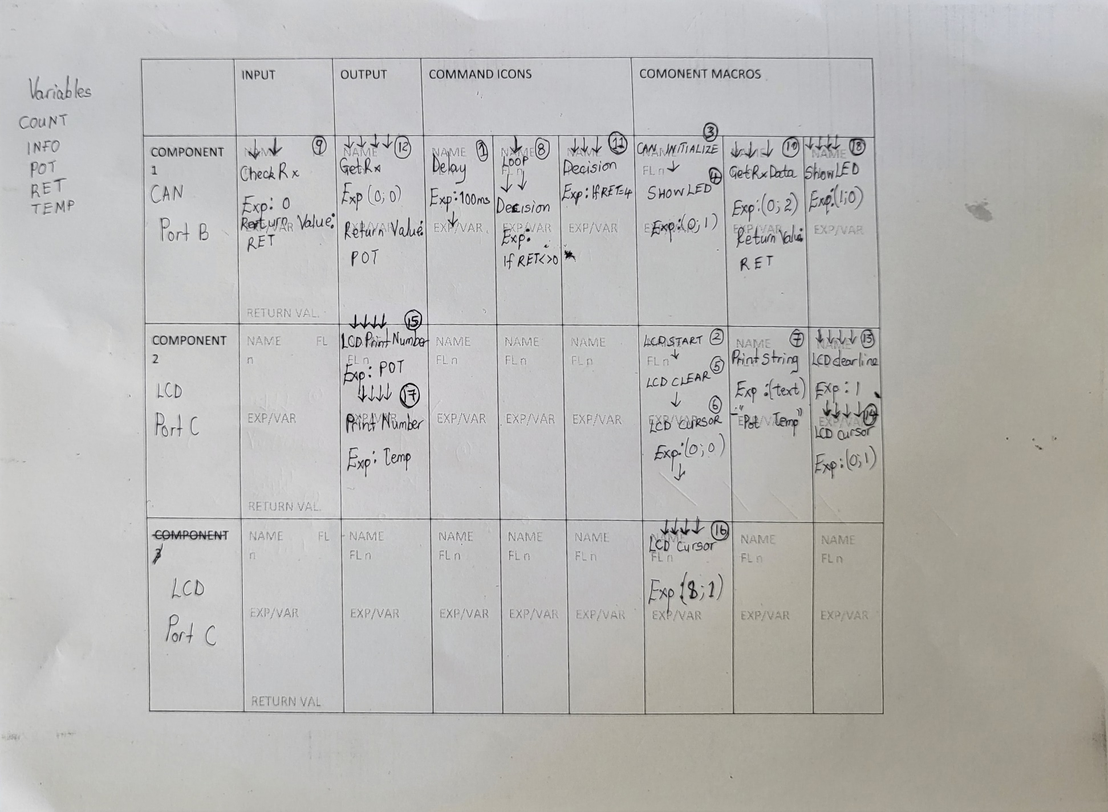

Node 2 configuration settings

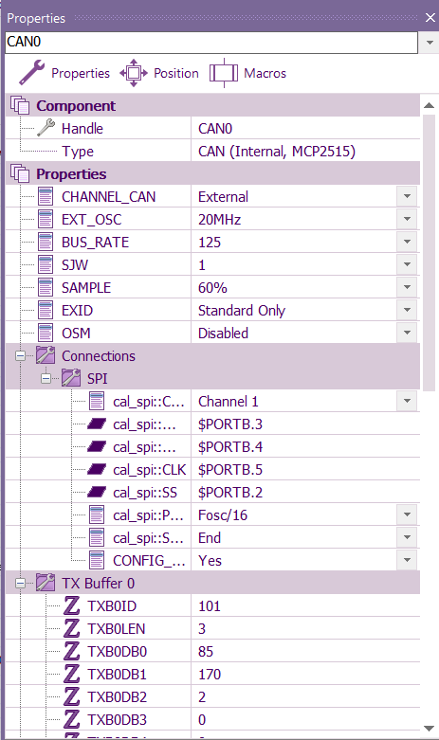 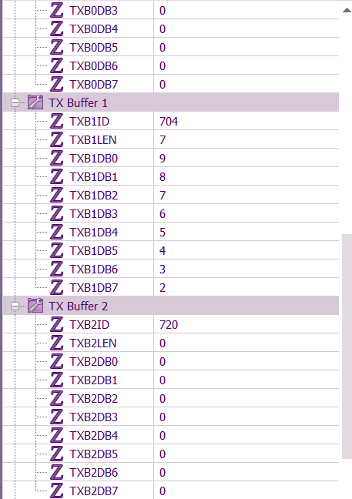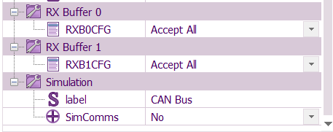

Node 2 Analysis Table

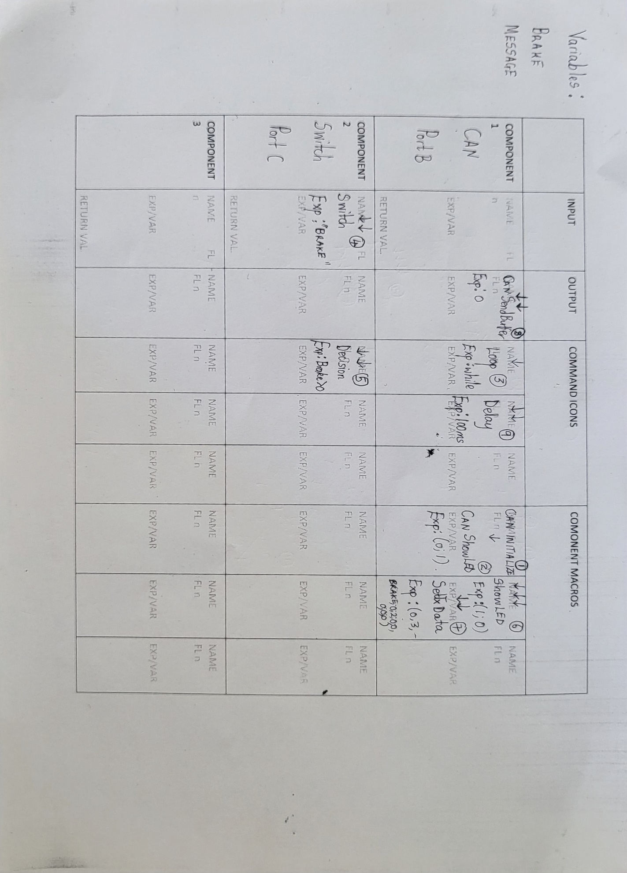

Node 3 configuration settings

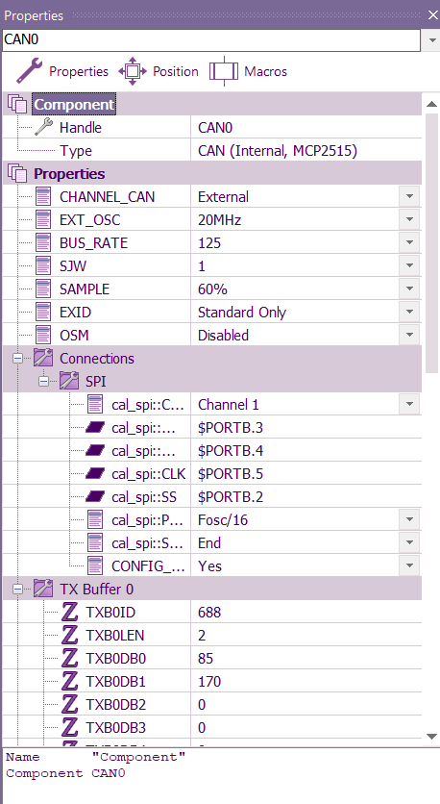 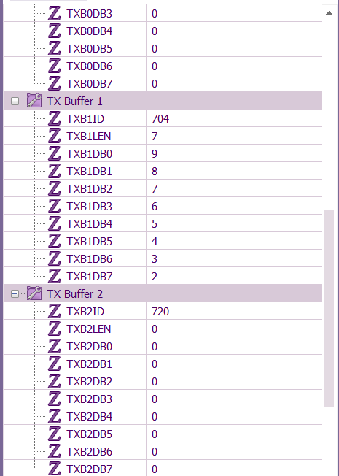 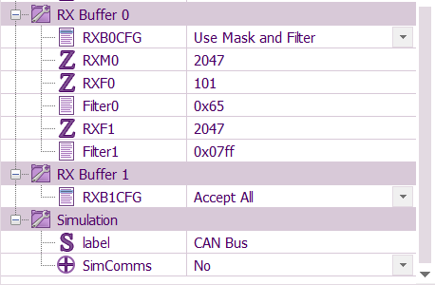

Node 3 Analysis Table

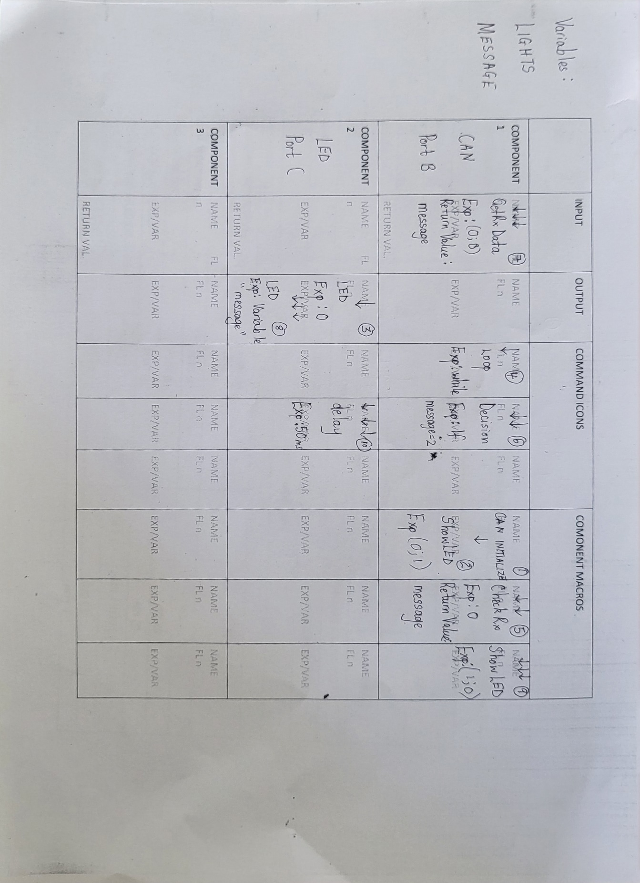

Node 4 configuration settings

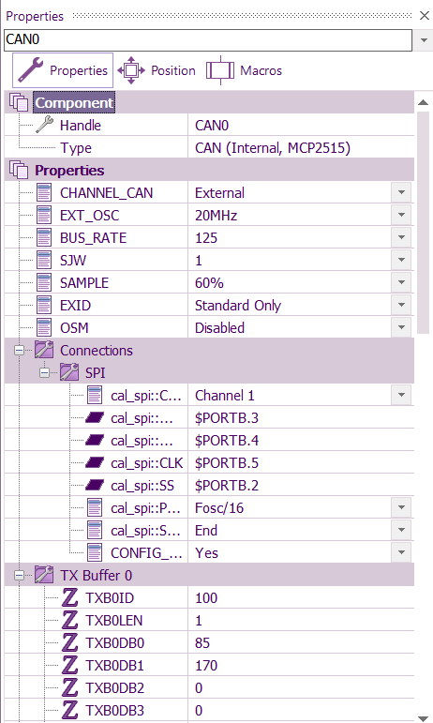 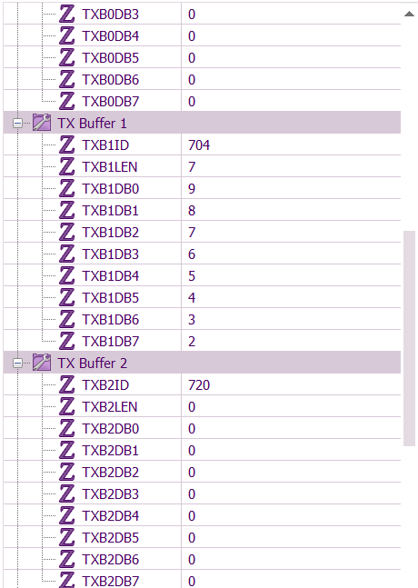 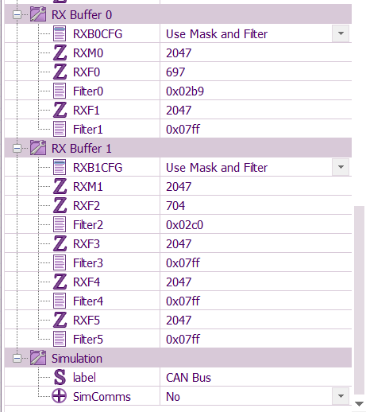

Node 4 Analysis Table

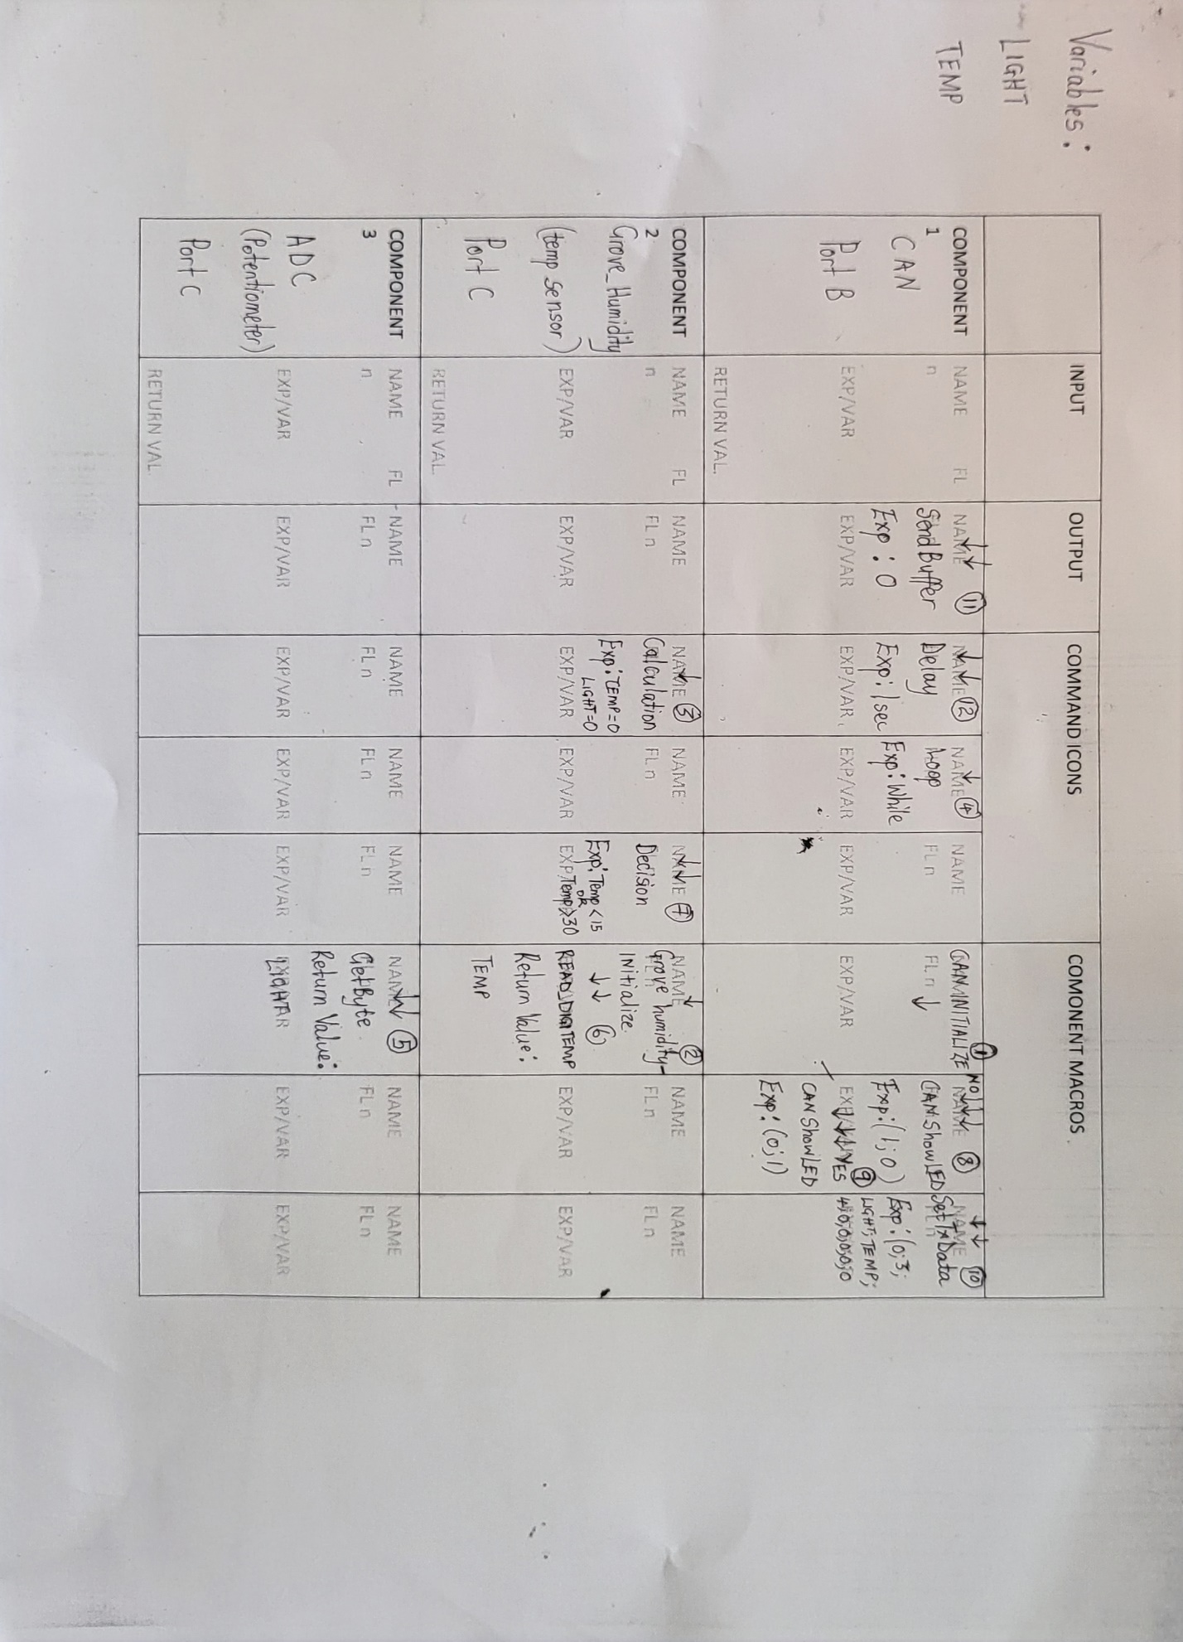

**Troubleshooting Exercise**

From the running program, some changes has been made;

1. Return value of the CAN component macro
2. The ports of the switch component in node2 is incorrect
3. Wrong value for the TX BO ID under the CAN properties of node 4

The aim is to change the values of the CAN component properties so as to see how it will affect the setup. Assuming all things are being equal ,the flowchart is correct and also the physical connection.

TASKS

* Upload the changed file
* Load the program to verify the changes compared to the real time picture provided in the exercise and make the correction
* Interface the program to the boards
* Report

.

ANALYZER

CONCLUSION

As an automotive engineer, it is important to have a basic understanding of the working principles and functionality of the various electronic components used in vehicles. This knowledge is essential when it comes to fault-finding and decoding the programming of electronic modules. Furthermore, knowledge of microcomputers, A/D converters and CAN buses is also beneficial. I consider myself to be a complete automotive engineer and system engineer, as the knowledge acquired is not limited to automotive electronics alone, but to other digital electronic fields as well.

The complexity of the vehicle structure, ranging from mechanical systems to electronic systems, requires that one not only knows how to detect and fix errors, but also has a comprehensive understanding of how the entire system works, allowing for tuning, rebuilding, configuration and integration of components.

The CAN communication demo experiments will provide a better understanding of how to set up a CAN system, program using FLOWCODE, and analyze CAN messages. The added tasks for practice serve as a template for readers to gain the necessary knowledge to understand the working principles. Finally, this project covers a wide range of topics in automotive studies, making it a useful reference for other students.

REFERENCES

[1] *EVERY ENGINE SENSOR EXPLAINED - MAF, MAP, IAT, TPS, 02, NOx, EGT - How it works, location, OBD2 code*-https://www.youtube.com/watch?v=dK4mb1yS0dY&t=429s[Accessed October 2022]

[2] *Major automotive actuators*-https://clr.es/blog/en/major-automotive-actuators/ [Accessed October 2022]

[3] *Numerical on Analog to digital (ADC) Conversion using Successive Approximation Registery (SAR)* – [Video].YouTube.https://www.youtube.com/watch?v=vlDoCeu5Mw8 [Accessed May 2023]

[4] *What is a microcontroller and how microcontroller works* [Video].YouTube.https://www.youtube.com/watch?v=JwCTkm43CxQ&t=1s [Accessed December 2022]

[5] CAN Protocol Tutorial | Controller Area Network | CAN bus- [Video].YouTube. <https://www.youtube.com/watch?v=kS0d4GfCuVk&list=PLcbIZiT62e1gKGBxVBY3AKXmQBdGGvTQB> [Accessed December 2022]

[6] *Controller Area Network (CAN) programming Tutorial 10: bit wise bus arbitration animation*- [Video].YouTube.https://www.youtube.com/watch?v=XdtdBUHEdOI&t=359s [Accessed December 2022]

[7] <https://www.st.com/content/dam/AME/2019/developers-conference-2019/presentations/STDevCon19_7.1_Smart-Auto-Domain-Gateways.pdf> [Accessed April 2023]

[8] *Automotive Electronic Modules Types*-[Video].YouTube.https://www.youtube.com/watch?v=BG4N2dBgJrQ [ Accessed May 2023]

[9] *Beginner guide to ECU install and wiring + editable wiring diagram download*- [Video].YouTube.youtube.com/watch?v=z-onJjFyE3E&t=12s[Accessed May 2023]

[10] How to Tune and Modify Automotive Engine Management Systems (Hartmann)

[11]

[12] *Flowcode*- <https://www.matrixtsl.com/flowcode/features/> [Accessed April 2023]

[13] *E-Block2 CAN Bus communication*- <https://www.matrixtsl.com/resources/files/datasheets/CP2793-01%20CAN%20Bus.pdf> [Accessed April 2023]

[14]

[15]